Machine Learning Prediction Model Report
Outcome: Atherogenic dyslipidemia (high TG + low HDL) · KNHANES · 3 models compared · tuning, full metrics, threshold, SHAP, PDP
[ML] outcome = atherogenic_dyslipidemia

Data summary
Item | Value
N | 6000
Outcome prevalence (%) | 15.4
Features | 44
Models compared | 3
Train/test | 4200/1800 (70/30 stratified)
Auto-excluded leakage | None

Hyperparameter search space
Model | Search space
LogisticRegression | {'C': [0.01, 0.1, 1, 10], 'penalty': ['l1', 'l2']}
HistGradientBoosting | {'learning_rate': [0.03, 0.1], 'max_iter': [200, 400], 'max_depth': [3, 6, None]}
XGBoost | {'n_estimators': [300, 500], 'max_depth': [3, 5], 'learning_rate': [0.03, 0.1], 'subsample': [0.8, 1.0]}

Tuning and model selection — training-partition cross-validation
Hyperparameter search and between-model selection both use these training-partition cross-validated scores. The selection criterion is CV_combined, the mean of the cross-validated auROC and auPRC. The held-out partition is not consulted at this stage.
model | CV_auROC | CV_auPRC | CV_combined | best_params
LogisticRegression | 0.742 | 0.3121 | 0.527 | {'penalty': 'l2', 'C': 0.01}
HistGradientBoosting | 0.7537 | 0.3315 | 0.5426 | {'max_iter': 400, 'max_depth': 3, 'learning_rate': 0.03}
XGBoost | 0.7572 | 0.3411 | 0.5492 | {'subsample': 1.0, 'n_estimators': 300, 'max_depth': 3, 'learning_rate': 0.03}

Held-out performance metrics
Reported for every candidate for transparency; only the model selected by CV_combined above is the prespecified final model. Rows are ordered by the CV selection criterion.
model | CV_combined | TP | TN | FP | FN | sensitivity | specificity | PPV | NPV | accuracy | balanced_accuracy | f1 | MCC | kappa | auROC | auPRC | logloss | brier | combined
XGBoost | 0.5492 | 12 | 1512 | 10 | 266 | 0.0432 | 0.9934 | 0.5455 | 0.8504 | 0.8467 | 0.5183 | 0.08 | 0.1204 | 0.0587 | 0.7536 | 0.3496 | 0.3747 | 0.1163 | 0.5516
HistGradientBoosting | 0.5426 | 19 | 1506 | 16 | 259 | 0.0683 | 0.9895 | 0.5429 | 0.8533 | 0.8472 | 0.5289 | 0.1214 | 0.1514 | 0.09 | 0.7503 | 0.3518 | 0.3761 | 0.1167 | 0.551
LogisticRegression | 0.527 | 12 | 1509 | 13 | 266 | 0.0432 | 0.9915 | 0.48 | 0.8501 | 0.845 | 0.5173 | 0.0792 | 0.1069 | 0.0551 | 0.7208 | 0.3049 | 0.3965 | 0.1217 | 0.5129

ROC · Precision-Recall
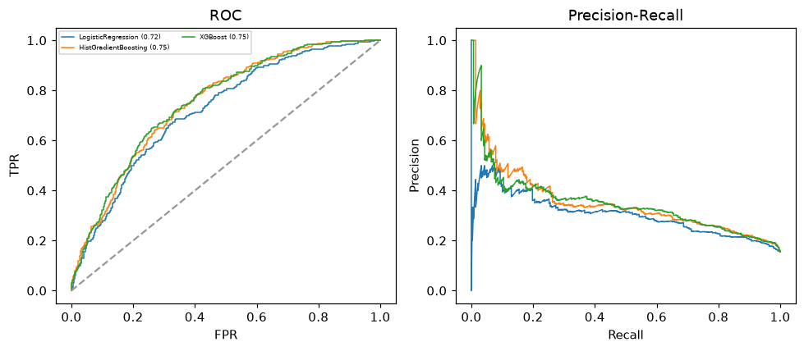

Selected final model — XGBoost (CV combined=0.5492; held-out auROC=0.7536)
Among 3 candidate models, XGBoost achieved the highest cross-validated combined score (0.5492) within the training partition and was selected on that basis. Refitted on the complete training partition and evaluated once on the untouched held-out partition, it reached an area under the receiver operating characteristic curve of 0.7536 and an area under the precision-recall curve of 0.3496.

Threshold analysis (0.1-0.9)
threshold | TP | TN | FP | FN | sensitivity | specificity | PPV | NPV | f1 | accuracy
0.1 | 243.0 | 691.0 | 831.0 | 35.0 | 0.874 | 0.454 | 0.226 | 0.952 | 0.359 | 0.519
0.2 | 182.0 | 1109.0 | 413.0 | 96.0 | 0.655 | 0.729 | 0.306 | 0.92 | 0.417 | 0.717
0.3 | 91.0 | 1365.0 | 157.0 | 187.0 | 0.327 | 0.897 | 0.367 | 0.88 | 0.346 | 0.809
0.4 | 35.0 | 1472.0 | 50.0 | 243.0 | 0.126 | 0.967 | 0.412 | 0.858 | 0.193 | 0.837
0.5 | 12.0 | 1512.0 | 10.0 | 266.0 | 0.043 | 0.993 | 0.545 | 0.85 | 0.08 | 0.847
0.6 | 4.0 | 1521.0 | 1.0 | 274.0 | 0.014 | 0.999 | 0.8 | 0.847 | 0.028 | 0.847
0.7 | 0.0 | 1522.0 | 0.0 | 278.0 | 0.0 | 1.0 | nan | 0.846 | 0.0 | 0.846
0.8 | 0.0 | 1522.0 | 0.0 | 278.0 | 0.0 | 1.0 | nan | 0.846 | 0.0 | 0.846
0.9 | 0.0 | 1522.0 | 0.0 | 278.0 | 0.0 | 1.0 | nan | 0.846 | 0.0 | 0.846

Calibration
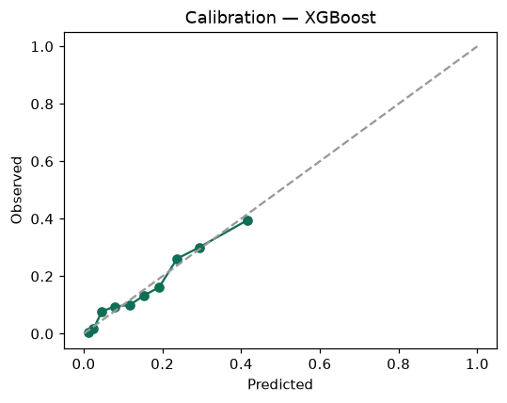

SHAP feature contributions
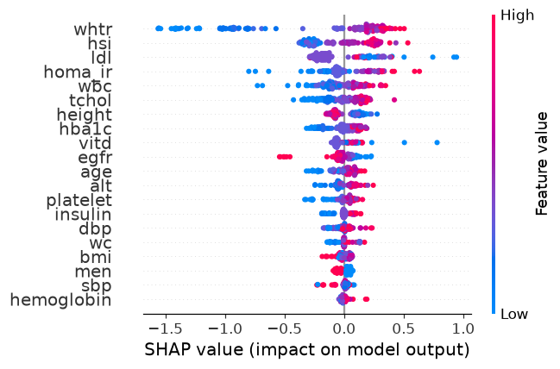

Partial dependence (PDP)
