Machine Learning Prediction Model Report
Outcome: Dyslipidemia (KSoLA composite) · KNHANES · 3 models compared · tuning, full metrics, threshold, SHAP, PDP
[ML] outcome = dyslipidemia

Data summary
Item | Value
N | 6000
Outcome prevalence (%) | 51.6
Features | 41
Models compared | 3
Train/test | 4200/1800 (70/30 stratified)
Auto-excluded leakage | None

Hyperparameter search space
Model | Search space
LogisticRegression | {'C': [0.01, 0.1, 1, 10], 'penalty': ['l1', 'l2']}
HistGradientBoosting | {'learning_rate': [0.03, 0.1], 'max_iter': [200, 400], 'max_depth': [3, 6, None]}
XGBoost | {'n_estimators': [300, 500], 'max_depth': [3, 5], 'learning_rate': [0.03, 0.1], 'subsample': [0.8, 1.0]}

Tuning and model selection — training-partition cross-validation
Hyperparameter search and between-model selection both use these training-partition cross-validated scores. The selection criterion is CV_combined, the mean of the cross-validated auROC and auPRC. The held-out partition is not consulted at this stage.
model | CV_auROC | CV_auPRC | CV_combined | best_params
LogisticRegression | 0.7404 | 0.7277 | 0.734 | {'penalty': 'l1', 'C': 0.1}
HistGradientBoosting | 0.7325 | 0.7193 | 0.7259 | {'max_iter': 400, 'max_depth': 3, 'learning_rate': 0.03}
XGBoost | 0.7366 | 0.7241 | 0.7304 | {'subsample': 1.0, 'n_estimators': 300, 'max_depth': 3, 'learning_rate': 0.03}

Held-out performance metrics
Reported for every candidate for transparency; only the model selected by CV_combined above is the prespecified final model. Rows are ordered by the CV selection criterion.
model | CV_combined | TP | TN | FP | FN | sensitivity | specificity | PPV | NPV | accuracy | balanced_accuracy | f1 | MCC | kappa | auROC | auPRC | logloss | brier | combined
LogisticRegression | 0.734 | 652 | 585 | 286 | 277 | 0.7018 | 0.6716 | 0.6951 | 0.6787 | 0.6872 | 0.6867 | 0.6984 | 0.3736 | 0.3736 | 0.7378 | 0.7241 | 0.6043 | 0.2079 | 0.731
XGBoost | 0.7304 | 673 | 547 | 324 | 256 | 0.7244 | 0.628 | 0.675 | 0.6812 | 0.6778 | 0.6762 | 0.6989 | 0.3543 | 0.3533 | 0.7415 | 0.7278 | 0.5987 | 0.206 | 0.7346
HistGradientBoosting | 0.7259 | 682 | 552 | 319 | 247 | 0.7341 | 0.6338 | 0.6813 | 0.6909 | 0.6856 | 0.6839 | 0.7067 | 0.37 | 0.3688 | 0.7421 | 0.7295 | 0.5982 | 0.2057 | 0.7358

ROC · Precision-Recall
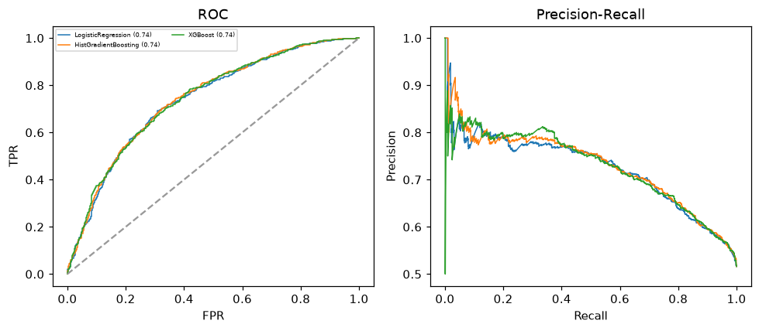

Selected final model — LogisticRegression (CV combined=0.734; held-out auROC=0.7378)
Among 3 candidate models, LogisticRegression achieved the highest cross-validated combined score (0.734) within the training partition and was selected on that basis. Refitted on the complete training partition and evaluated once on the untouched held-out partition, it reached an area under the receiver operating characteristic curve of 0.7378 and an area under the precision-recall curve of 0.7241.

Threshold analysis (0.1-0.9)
threshold | TP | TN | FP | FN | sensitivity | specificity | PPV | NPV | f1 | accuracy
0.1 | 929.0 | 7.0 | 864.0 | 0.0 | 1.0 | 0.008 | 0.518 | 1.0 | 0.683 | 0.52
0.2 | 916.0 | 100.0 | 771.0 | 13.0 | 0.986 | 0.115 | 0.543 | 0.885 | 0.7 | 0.564
0.3 | 857.0 | 260.0 | 611.0 | 72.0 | 0.922 | 0.299 | 0.584 | 0.783 | 0.715 | 0.621
0.4 | 754.0 | 439.0 | 432.0 | 175.0 | 0.812 | 0.504 | 0.636 | 0.715 | 0.713 | 0.663
0.5 | 652.0 | 585.0 | 286.0 | 277.0 | 0.702 | 0.672 | 0.695 | 0.679 | 0.698 | 0.687
0.6 | 477.0 | 715.0 | 156.0 | 452.0 | 0.513 | 0.821 | 0.754 | 0.613 | 0.611 | 0.662
0.7 | 293.0 | 787.0 | 84.0 | 636.0 | 0.315 | 0.904 | 0.777 | 0.553 | 0.449 | 0.6
0.8 | 138.0 | 836.0 | 35.0 | 791.0 | 0.149 | 0.96 | 0.798 | 0.514 | 0.25 | 0.541
0.9 | 20.0 | 866.0 | 5.0 | 909.0 | 0.022 | 0.994 | 0.8 | 0.488 | 0.042 | 0.492

Calibration
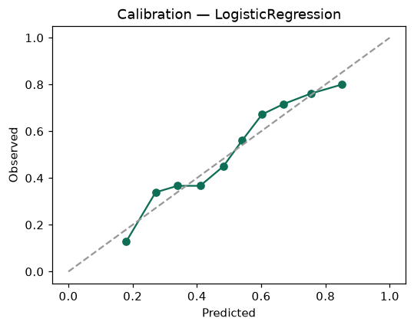

SHAP feature contributions
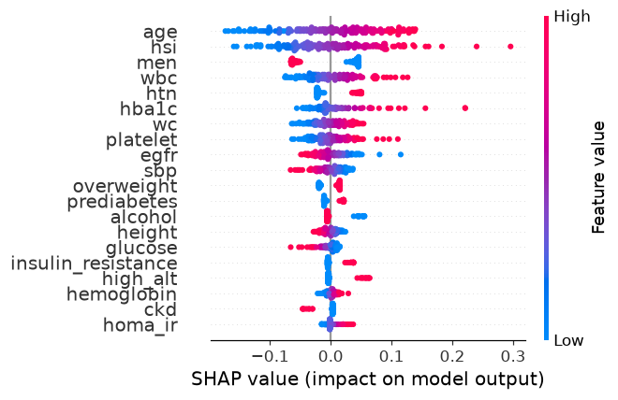

Partial dependence (PDP)
