Machine Learning Prediction Model Report
Outcome: Elevated AST (>40 IU/L) · KNHANES · 3 models compared · tuning, full metrics, threshold, SHAP, PDP
[ML] outcome = high_ast

Data summary
Item | Value
N | 6000
Outcome prevalence (%) | 4.7
Features | 45
Models compared | 3
Train/test | 4200/1800 (70/30 stratified)
Auto-excluded leakage | None

Hyperparameter search space
Model | Search space
LogisticRegression | {'C': [0.01, 0.1, 1, 10], 'penalty': ['l1', 'l2']}
HistGradientBoosting | {'learning_rate': [0.03, 0.1], 'max_iter': [200, 400], 'max_depth': [3, 6, None]}
XGBoost | {'n_estimators': [300, 500], 'max_depth': [3, 5], 'learning_rate': [0.03, 0.1], 'subsample': [0.8, 1.0]}

Tuning and model selection — training-partition cross-validation
Hyperparameter search and between-model selection both use these training-partition cross-validated scores. The selection criterion is CV_combined, the mean of the cross-validated auROC and auPRC. The held-out partition is not consulted at this stage.
model | CV_auROC | CV_auPRC | CV_combined | best_params
LogisticRegression | 0.723 | 0.1403 | 0.4316 | {'penalty': 'l1', 'C': 0.1}
HistGradientBoosting | 0.7015 | 0.1185 | 0.41 | {'max_iter': 400, 'max_depth': 3, 'learning_rate': 0.03}
XGBoost | 0.725 | 0.1269 | 0.4259 | {'subsample': 1.0, 'n_estimators': 300, 'max_depth': 3, 'learning_rate': 0.03}

Held-out performance metrics
Reported for every candidate for transparency; only the model selected by CV_combined above is the prespecified final model. Rows are ordered by the CV selection criterion.
model | CV_combined | TP | TN | FP | FN | sensitivity | specificity | PPV | NPV | accuracy | balanced_accuracy | f1 | MCC | kappa | auROC | auPRC | logloss | brier | combined
LogisticRegression | 0.4316 | 1 | 1715 | 0 | 84 | 0.0118 | 1.0 | 1.0 | 0.9533 | 0.9533 | 0.5059 | 0.0233 | 0.1059 | 0.0222 | 0.7917 | 0.1942 | 0.1657 | 0.0418 | 0.4929
XGBoost | 0.4259 | 2 | 1715 | 0 | 83 | 0.0235 | 1.0 | 1.0 | 0.9538 | 0.9539 | 0.5118 | 0.046 | 0.1498 | 0.0439 | 0.797 | 0.2031 | 0.1622 | 0.0414 | 0.5001
HistGradientBoosting | 0.41 | 2 | 1714 | 1 | 83 | 0.0235 | 0.9994 | 0.6667 | 0.9538 | 0.9533 | 0.5115 | 0.0455 | 0.1193 | 0.0424 | 0.7983 | 0.1962 | 0.1627 | 0.0416 | 0.4973

ROC · Precision-Recall
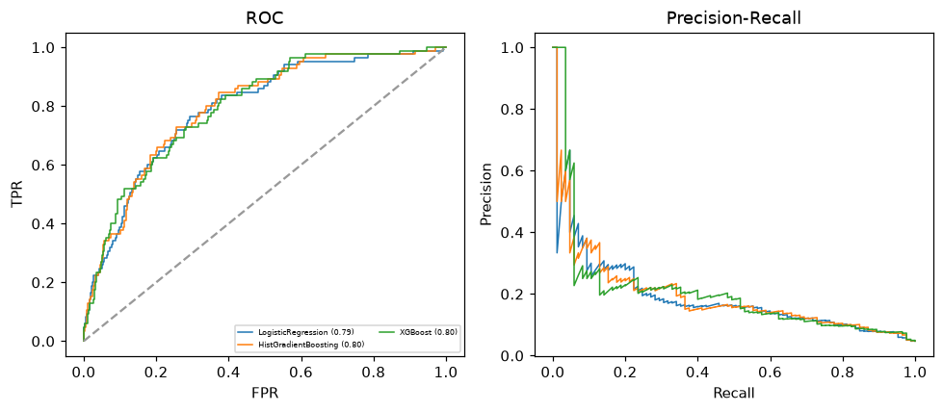

Selected final model — LogisticRegression (CV combined=0.4316; held-out auROC=0.7917)
Among 3 candidate models, LogisticRegression achieved the highest cross-validated combined score (0.4316) within the training partition and was selected on that basis. Refitted on the complete training partition and evaluated once on the untouched held-out partition, it reached an area under the receiver operating characteristic curve of 0.7917 and an area under the precision-recall curve of 0.1942.

Threshold analysis (0.1-0.9)
threshold | TP | TN | FP | FN | sensitivity | specificity | PPV | NPV | f1 | accuracy
0.1 | 30.0 | 1561.0 | 154.0 | 55.0 | 0.353 | 0.91 | 0.163 | 0.966 | 0.223 | 0.884
0.2 | 9.0 | 1694.0 | 21.0 | 76.0 | 0.106 | 0.988 | 0.3 | 0.957 | 0.157 | 0.946
0.3 | 5.0 | 1708.0 | 7.0 | 80.0 | 0.059 | 0.996 | 0.417 | 0.955 | 0.103 | 0.952
0.4 | 1.0 | 1713.0 | 2.0 | 84.0 | 0.012 | 0.999 | 0.333 | 0.953 | 0.023 | 0.952
0.5 | 1.0 | 1715.0 | 0.0 | 84.0 | 0.012 | 1.0 | 1.0 | 0.953 | 0.023 | 0.953
0.6 | 1.0 | 1715.0 | 0.0 | 84.0 | 0.012 | 1.0 | 1.0 | 0.953 | 0.023 | 0.953
0.7 | 0.0 | 1715.0 | 0.0 | 85.0 | 0.0 | 1.0 | nan | 0.953 | 0.0 | 0.953
0.8 | 0.0 | 1715.0 | 0.0 | 85.0 | 0.0 | 1.0 | nan | 0.953 | 0.0 | 0.953
0.9 | 0.0 | 1715.0 | 0.0 | 85.0 | 0.0 | 1.0 | nan | 0.953 | 0.0 | 0.953

Calibration
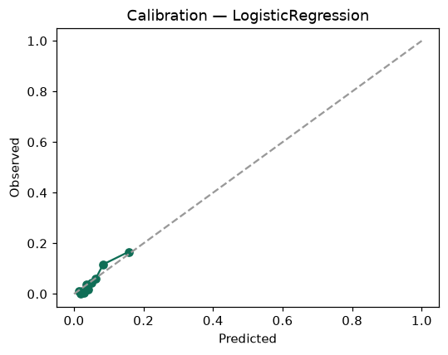

SHAP feature contributions
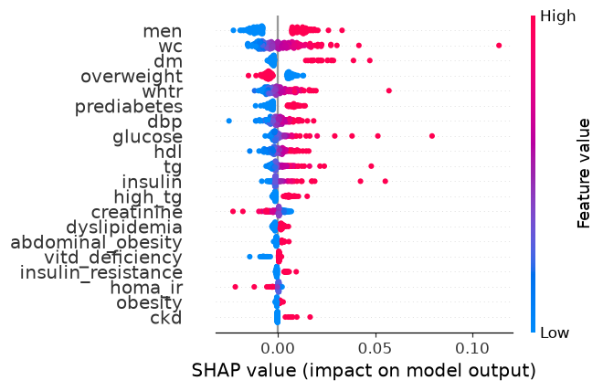

Partial dependence (PDP)
