Machine Learning Prediction Model Report
Outcome: Hepatic steatosis · KNHANES · 3 models compared · tuning, full metrics, threshold, SHAP, PDP
[ML] outcome = steatosis

Data summary
Item | Value
N | 6000
Outcome prevalence (%) | 23.2
Features | 19
Models compared | 3
Train/test | 4200/1800 (70/30 stratified)
Auto-excluded leakage | None

Hyperparameter search space
Model | Search space
LogisticRegression | {'C': [0.01, 0.1, 1, 10], 'penalty': ['l1', 'l2']}
HistGradientBoosting | {'learning_rate': [0.03, 0.1], 'max_iter': [200, 400], 'max_depth': [3, 6, None]}
XGBoost | {'n_estimators': [300, 500], 'max_depth': [3, 5], 'learning_rate': [0.03, 0.1], 'subsample': [0.8, 1.0]}

Tuning and model selection — training-partition cross-validation
Hyperparameter search and between-model selection both use these training-partition cross-validated scores. The selection criterion is CV_combined, the mean of the cross-validated auROC and auPRC. The held-out partition is not consulted at this stage.
model | CV_auROC | CV_auPRC | CV_combined | best_params
LogisticRegression | 0.9071 | 0.7731 | 0.8401 | {'penalty': 'l2', 'C': 1}
HistGradientBoosting | 0.9053 | 0.7726 | 0.839 | {'max_iter': 200, 'max_depth': None, 'learning_rate': 0.03}
XGBoost | 0.9075 | 0.7792 | 0.8433 | {'subsample': 0.8, 'n_estimators': 500, 'max_depth': 3, 'learning_rate': 0.03}

Held-out performance metrics
Reported for every candidate for transparency; only the model selected by CV_combined above is the prespecified final model. Rows are ordered by the CV selection criterion.
model | CV_combined | TP | TN | FP | FN | sensitivity | specificity | PPV | NPV | accuracy | balanced_accuracy | f1 | MCC | kappa | auROC | auPRC | logloss | brier | combined
XGBoost | 0.8433 | 244 | 1295 | 88 | 173 | 0.5851 | 0.9364 | 0.7349 | 0.8822 | 0.855 | 0.7608 | 0.6515 | 0.5673 | 0.5615 | 0.9031 | 0.7445 | 0.3243 | 0.1022 | 0.8238
LogisticRegression | 0.8401 | 248 | 1299 | 84 | 169 | 0.5947 | 0.9393 | 0.747 | 0.8849 | 0.8594 | 0.767 | 0.6622 | 0.5809 | 0.5749 | 0.9005 | 0.7519 | 0.3258 | 0.1013 | 0.8262
HistGradientBoosting | 0.839 | 242 | 1291 | 92 | 175 | 0.5803 | 0.9335 | 0.7246 | 0.8806 | 0.8517 | 0.7569 | 0.6445 | 0.5576 | 0.5522 | 0.9007 | 0.7535 | 0.3269 | 0.1036 | 0.8271

ROC · Precision-Recall
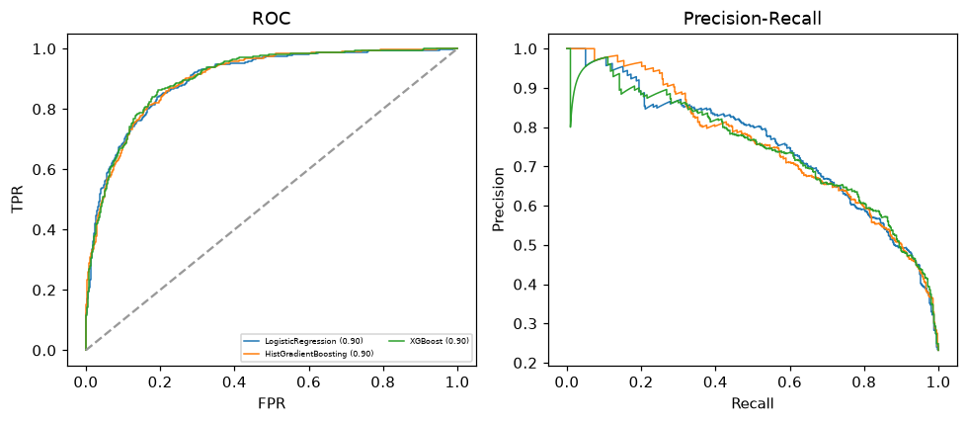

Selected final model — XGBoost (CV combined=0.8433; held-out auROC=0.9031)
Among 3 candidate models, XGBoost achieved the highest cross-validated combined score (0.8433) within the training partition and was selected on that basis. Refitted on the complete training partition and evaluated once on the untouched held-out partition, it reached an area under the receiver operating characteristic curve of 0.9031 and an area under the precision-recall curve of 0.7445.

Threshold analysis (0.1-0.9)
threshold | TP | TN | FP | FN | sensitivity | specificity | PPV | NPV | f1 | accuracy
0.1 | 389.0 | 937.0 | 446.0 | 28.0 | 0.933 | 0.678 | 0.466 | 0.971 | 0.621 | 0.737
0.2 | 360.0 | 1113.0 | 270.0 | 57.0 | 0.863 | 0.805 | 0.571 | 0.951 | 0.688 | 0.818
0.3 | 315.0 | 1207.0 | 176.0 | 102.0 | 0.755 | 0.873 | 0.642 | 0.922 | 0.694 | 0.846
0.4 | 276.0 | 1259.0 | 124.0 | 141.0 | 0.662 | 0.91 | 0.69 | 0.899 | 0.676 | 0.853
0.5 | 244.0 | 1295.0 | 88.0 | 173.0 | 0.585 | 0.936 | 0.735 | 0.882 | 0.652 | 0.855
0.6 | 210.0 | 1319.0 | 64.0 | 207.0 | 0.504 | 0.954 | 0.766 | 0.864 | 0.608 | 0.849
0.7 | 177.0 | 1339.0 | 44.0 | 240.0 | 0.424 | 0.968 | 0.801 | 0.848 | 0.555 | 0.842
0.8 | 136.0 | 1358.0 | 25.0 | 281.0 | 0.326 | 0.982 | 0.845 | 0.829 | 0.471 | 0.83
0.9 | 71.0 | 1375.0 | 8.0 | 346.0 | 0.17 | 0.994 | 0.899 | 0.799 | 0.286 | 0.803

Calibration
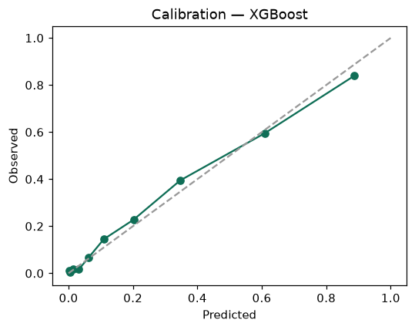

SHAP feature contributions
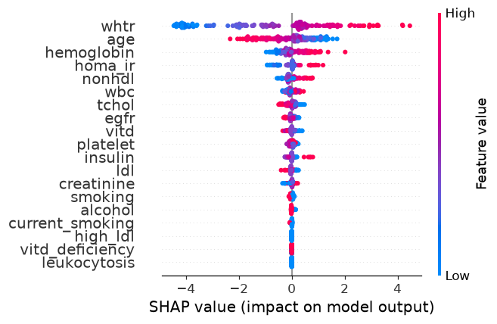

Partial dependence (PDP)
