Machine Learning Prediction Model Report
Outcome: High LDL cholesterol (>=160) · KNHANES · 3 models compared · tuning, full metrics, threshold, SHAP, PDP
[ML] outcome = high_ldl

Data summary
Item | Value
N | 6000
Outcome prevalence (%) | 10.3
Features | 45
Models compared | 3
Train/test | 4200/1800 (70/30 stratified)
Auto-excluded leakage | None

Hyperparameter search space
Model | Search space
LogisticRegression | {'C': [0.01, 0.1, 1, 10], 'penalty': ['l1', 'l2']}
HistGradientBoosting | {'learning_rate': [0.03, 0.1], 'max_iter': [200, 400], 'max_depth': [3, 6, None]}
XGBoost | {'n_estimators': [300, 500], 'max_depth': [3, 5], 'learning_rate': [0.03, 0.1], 'subsample': [0.8, 1.0]}

Tuning and model selection — training-partition cross-validation
Hyperparameter search and between-model selection both use these training-partition cross-validated scores. The selection criterion is CV_combined, the mean of the cross-validated auROC and auPRC. The held-out partition is not consulted at this stage.
model | CV_auROC | CV_auPRC | CV_combined | best_params
LogisticRegression | 0.715 | 0.2383 | 0.4766 | {'penalty': 'l2', 'C': 0.1}
HistGradientBoosting | 0.7224 | 0.2305 | 0.4764 | {'max_iter': 400, 'max_depth': 3, 'learning_rate': 0.03}
XGBoost | 0.7303 | 0.2371 | 0.4837 | {'subsample': 1.0, 'n_estimators': 300, 'max_depth': 3, 'learning_rate': 0.03}

Held-out performance metrics
Reported for every candidate for transparency; only the model selected by CV_combined above is the prespecified final model. Rows are ordered by the CV selection criterion.
model | CV_combined | TP | TN | FP | FN | sensitivity | specificity | PPV | NPV | accuracy | balanced_accuracy | f1 | MCC | kappa | auROC | auPRC | logloss | brier | combined
XGBoost | 0.4837 | 1 | 1614 | 1 | 184 | 0.0054 | 0.9994 | 0.5 | 0.8977 | 0.8972 | 0.5024 | 0.0107 | 0.0436 | 0.0085 | 0.7169 | 0.2288 | 0.3034 | 0.0865 | 0.4728
LogisticRegression | 0.4766 | 2 | 1611 | 4 | 183 | 0.0108 | 0.9975 | 0.3333 | 0.898 | 0.8961 | 0.5042 | 0.0209 | 0.0439 | 0.0146 | 0.6994 | 0.2166 | 0.3076 | 0.0877 | 0.458
HistGradientBoosting | 0.4764 | 0 | 1614 | 1 | 185 | 0.0 | 0.9994 | 0.0 | 0.8972 | 0.8967 | 0.4997 | 0.0 | -0.008 | -0.0011 | 0.7152 | 0.2297 | 0.3052 | 0.0868 | 0.4724

ROC · Precision-Recall
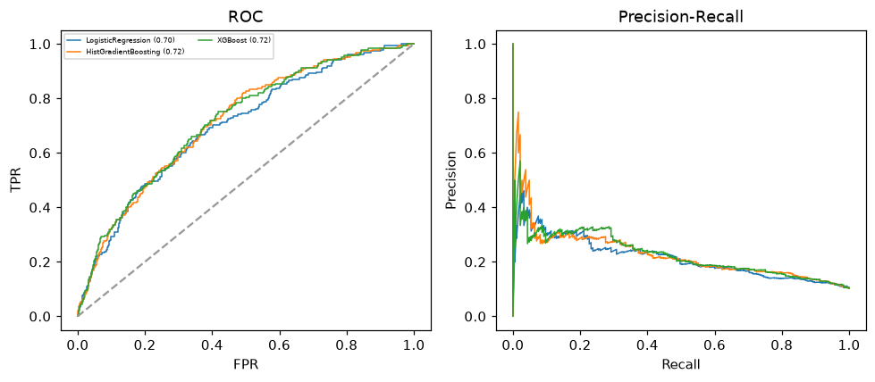

Selected final model — XGBoost (CV combined=0.4837; held-out auROC=0.7169)
Among 3 candidate models, XGBoost achieved the highest cross-validated combined score (0.4837) within the training partition and was selected on that basis. Refitted on the complete training partition and evaluated once on the untouched held-out partition, it reached an area under the receiver operating characteristic curve of 0.7169 and an area under the precision-recall curve of 0.2288.

Threshold analysis (0.1-0.9)
threshold | TP | TN | FP | FN | sensitivity | specificity | PPV | NPV | f1 | accuracy
0.1 | 128.0 | 1015.0 | 600.0 | 57.0 | 0.692 | 0.628 | 0.176 | 0.947 | 0.28 | 0.635
0.2 | 57.0 | 1465.0 | 150.0 | 128.0 | 0.308 | 0.907 | 0.275 | 0.92 | 0.291 | 0.846
0.3 | 10.0 | 1590.0 | 25.0 | 175.0 | 0.054 | 0.985 | 0.286 | 0.901 | 0.091 | 0.889
0.4 | 3.0 | 1612.0 | 3.0 | 182.0 | 0.016 | 0.998 | 0.5 | 0.899 | 0.031 | 0.897
0.5 | 1.0 | 1614.0 | 1.0 | 184.0 | 0.005 | 0.999 | 0.5 | 0.898 | 0.011 | 0.897
0.6 | 0.0 | 1615.0 | 0.0 | 185.0 | 0.0 | 1.0 | nan | 0.897 | 0.0 | 0.897
0.7 | 0.0 | 1615.0 | 0.0 | 185.0 | 0.0 | 1.0 | nan | 0.897 | 0.0 | 0.897
0.8 | 0.0 | 1615.0 | 0.0 | 185.0 | 0.0 | 1.0 | nan | 0.897 | 0.0 | 0.897
0.9 | 0.0 | 1615.0 | 0.0 | 185.0 | 0.0 | 1.0 | nan | 0.897 | 0.0 | 0.897

Calibration
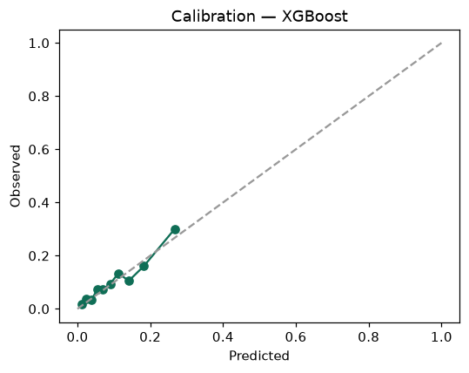

SHAP feature contributions
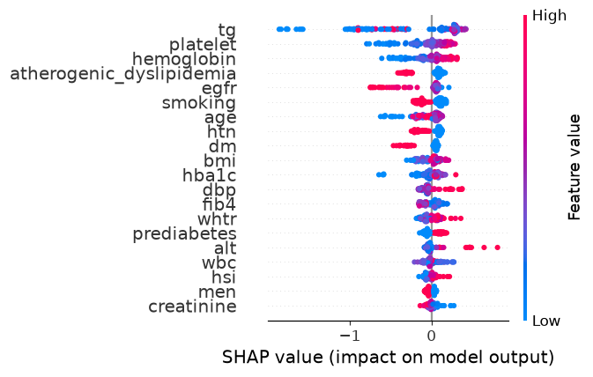

Partial dependence (PDP)
