Machine Learning Prediction Model Report
Outcome: Hypertension · KNHANES · 3 models compared · tuning, full metrics, threshold, SHAP, PDP
[ML] outcome = htn

Data summary
Item | Value
N | 6000
Outcome prevalence (%) | 32.5
Features | 49
Models compared | 3
Train/test | 4200/1800 (70/30 stratified)
Auto-excluded leakage | None

Hyperparameter search space
Model | Search space
LogisticRegression | {'C': [0.01, 0.1, 1, 10], 'penalty': ['l1', 'l2']}
HistGradientBoosting | {'learning_rate': [0.03, 0.1], 'max_iter': [200, 400], 'max_depth': [3, 6, None]}
XGBoost | {'n_estimators': [300, 500], 'max_depth': [3, 5], 'learning_rate': [0.03, 0.1], 'subsample': [0.8, 1.0]}

Tuning and model selection — training-partition cross-validation
Hyperparameter search and between-model selection both use these training-partition cross-validated scores. The selection criterion is CV_combined, the mean of the cross-validated auROC and auPRC. The held-out partition is not consulted at this stage.
model | CV_auROC | CV_auPRC | CV_combined | best_params
LogisticRegression | 0.821 | 0.6447 | 0.7329 | {'penalty': 'l1', 'C': 0.1}
HistGradientBoosting | 0.8149 | 0.6368 | 0.7259 | {'max_iter': 400, 'max_depth': 3, 'learning_rate': 0.03}
XGBoost | 0.8181 | 0.6447 | 0.7314 | {'subsample': 0.8, 'n_estimators': 500, 'max_depth': 3, 'learning_rate': 0.03}

Held-out performance metrics
Reported for every candidate for transparency; only the model selected by CV_combined above is the prespecified final model. Rows are ordered by the CV selection criterion.
model | CV_combined | TP | TN | FP | FN | sensitivity | specificity | PPV | NPV | accuracy | balanced_accuracy | f1 | MCC | kappa | auROC | auPRC | logloss | brier | combined
LogisticRegression | 0.7329 | 306 | 1068 | 147 | 279 | 0.5231 | 0.879 | 0.6755 | 0.7929 | 0.7633 | 0.701 | 0.5896 | 0.434 | 0.4271 | 0.8251 | 0.6616 | 0.4749 | 0.1578 | 0.7433
XGBoost | 0.7314 | 330 | 1063 | 152 | 255 | 0.5641 | 0.8749 | 0.6846 | 0.8065 | 0.7739 | 0.7195 | 0.6186 | 0.4644 | 0.46 | 0.8282 | 0.6857 | 0.4674 | 0.1555 | 0.757
HistGradientBoosting | 0.7259 | 332 | 1053 | 162 | 253 | 0.5675 | 0.8667 | 0.6721 | 0.8063 | 0.7694 | 0.7171 | 0.6154 | 0.4557 | 0.4524 | 0.8252 | 0.6773 | 0.4703 | 0.1569 | 0.7512

ROC · Precision-Recall
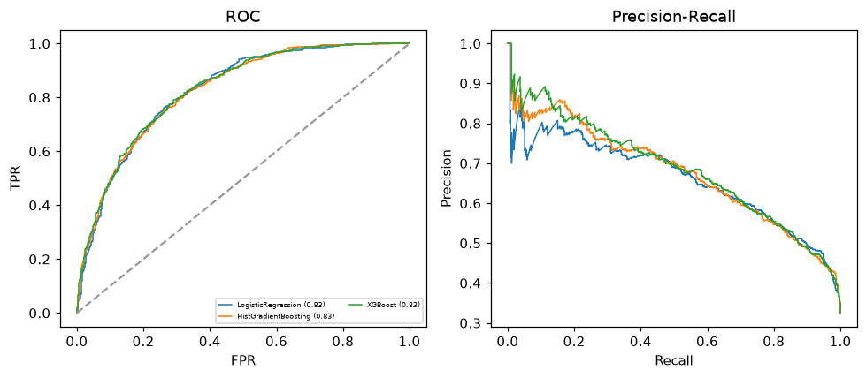

Selected final model — LogisticRegression (CV combined=0.7329; held-out auROC=0.8251)
Among 3 candidate models, LogisticRegression achieved the highest cross-validated combined score (0.7329) within the training partition and was selected on that basis. Refitted on the complete training partition and evaluated once on the untouched held-out partition, it reached an area under the receiver operating characteristic curve of 0.8251 and an area under the precision-recall curve of 0.6616.

Threshold analysis (0.1-0.9)
threshold | TP | TN | FP | FN | sensitivity | specificity | PPV | NPV | f1 | accuracy
0.1 | 570.0 | 435.0 | 780.0 | 15.0 | 0.974 | 0.358 | 0.422 | 0.967 | 0.589 | 0.558
0.2 | 517.0 | 720.0 | 495.0 | 68.0 | 0.884 | 0.593 | 0.511 | 0.914 | 0.647 | 0.687
0.3 | 457.0 | 855.0 | 360.0 | 128.0 | 0.781 | 0.704 | 0.559 | 0.87 | 0.652 | 0.729
0.4 | 386.0 | 978.0 | 237.0 | 199.0 | 0.66 | 0.805 | 0.62 | 0.831 | 0.639 | 0.758
0.5 | 306.0 | 1068.0 | 147.0 | 279.0 | 0.523 | 0.879 | 0.675 | 0.793 | 0.59 | 0.763
0.6 | 216.0 | 1128.0 | 87.0 | 369.0 | 0.369 | 0.928 | 0.713 | 0.754 | 0.486 | 0.747
0.7 | 133.0 | 1173.0 | 42.0 | 452.0 | 0.227 | 0.965 | 0.76 | 0.722 | 0.35 | 0.726
0.8 | 64.0 | 1197.0 | 18.0 | 521.0 | 0.109 | 0.985 | 0.78 | 0.697 | 0.192 | 0.701
0.9 | 11.0 | 1211.0 | 4.0 | 574.0 | 0.019 | 0.997 | 0.733 | 0.678 | 0.037 | 0.679

Calibration
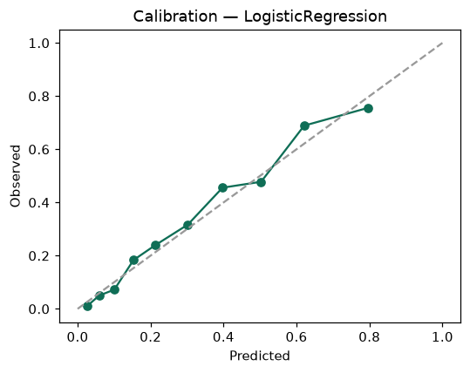

SHAP feature contributions
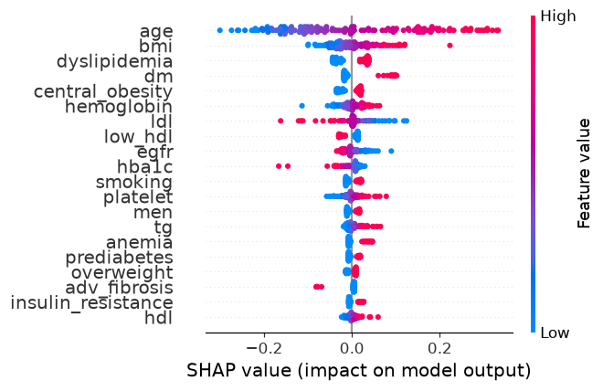

Partial dependence (PDP)
