Machine Learning Prediction Model Report
Outcome: Hypertriglyceridemia (NCEP TG>=150) · KNHANES · 3 models compared · tuning, full metrics, threshold, SHAP, PDP
[ML] outcome = high_tg

Data summary
Item | Value
N | 6000
Outcome prevalence (%) | 27.9
Features | 48
Models compared | 3
Train/test | 4200/1800 (70/30 stratified)
Auto-excluded leakage | None

Hyperparameter search space
Model | Search space
LogisticRegression | {'C': [0.01, 0.1, 1, 10], 'penalty': ['l1', 'l2']}
HistGradientBoosting | {'learning_rate': [0.03, 0.1], 'max_iter': [200, 400], 'max_depth': [3, 6, None]}
XGBoost | {'n_estimators': [300, 500], 'max_depth': [3, 5], 'learning_rate': [0.03, 0.1], 'subsample': [0.8, 1.0]}

Tuning and model selection — training-partition cross-validation
Hyperparameter search and between-model selection both use these training-partition cross-validated scores. The selection criterion is CV_combined, the mean of the cross-validated auROC and auPRC. The held-out partition is not consulted at this stage.
model | CV_auROC | CV_auPRC | CV_combined | best_params
LogisticRegression | 0.8506 | 0.6701 | 0.7603 | {'penalty': 'l1', 'C': 0.1}
HistGradientBoosting | 0.8705 | 0.759 | 0.8147 | {'max_iter': 200, 'max_depth': None, 'learning_rate': 0.03}
XGBoost | 0.8702 | 0.7546 | 0.8124 | {'subsample': 0.8, 'n_estimators': 300, 'max_depth': 5, 'learning_rate': 0.03}

Held-out performance metrics
Reported for every candidate for transparency; only the model selected by CV_combined above is the prespecified final model. Rows are ordered by the CV selection criterion.
model | CV_combined | TP | TN | FP | FN | sensitivity | specificity | PPV | NPV | accuracy | balanced_accuracy | f1 | MCC | kappa | auROC | auPRC | logloss | brier | combined
HistGradientBoosting | 0.8147 | 305 | 1203 | 95 | 197 | 0.6076 | 0.9268 | 0.7625 | 0.8593 | 0.8378 | 0.7672 | 0.6763 | 0.5764 | 0.5699 | 0.8948 | 0.7991 | 0.3519 | 0.112 | 0.8469
XGBoost | 0.8124 | 313 | 1202 | 96 | 189 | 0.6235 | 0.926 | 0.7653 | 0.8641 | 0.8417 | 0.7748 | 0.6872 | 0.5881 | 0.5826 | 0.8959 | 0.8005 | 0.3516 | 0.1114 | 0.8482
LogisticRegression | 0.7603 | 261 | 1192 | 106 | 241 | 0.5199 | 0.9183 | 0.7112 | 0.8318 | 0.8072 | 0.7191 | 0.6007 | 0.4878 | 0.4776 | 0.858 | 0.6903 | 0.4118 | 0.1337 | 0.7742

ROC · Precision-Recall
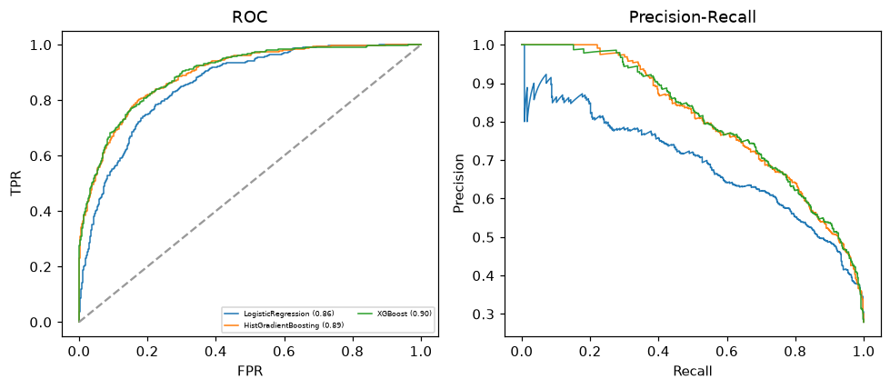

Selected final model — HistGradientBoosting (CV combined=0.8147; held-out auROC=0.8948)
Among 3 candidate models, HistGradientBoosting achieved the highest cross-validated combined score (0.8147) within the training partition and was selected on that basis. Refitted on the complete training partition and evaluated once on the untouched held-out partition, it reached an area under the receiver operating characteristic curve of 0.8948 and an area under the precision-recall curve of 0.7991.

Threshold analysis (0.1-0.9)
threshold | TP | TN | FP | FN | sensitivity | specificity | PPV | NPV | f1 | accuracy
0.1 | 475.0 | 751.0 | 547.0 | 27.0 | 0.946 | 0.579 | 0.465 | 0.965 | 0.623 | 0.681
0.2 | 434.0 | 947.0 | 351.0 | 68.0 | 0.865 | 0.73 | 0.553 | 0.933 | 0.674 | 0.767
0.3 | 403.0 | 1070.0 | 228.0 | 99.0 | 0.803 | 0.824 | 0.639 | 0.915 | 0.711 | 0.818
0.4 | 355.0 | 1145.0 | 153.0 | 147.0 | 0.707 | 0.882 | 0.699 | 0.886 | 0.703 | 0.833
0.5 | 305.0 | 1203.0 | 95.0 | 197.0 | 0.608 | 0.927 | 0.762 | 0.859 | 0.676 | 0.838
0.6 | 254.0 | 1243.0 | 55.0 | 248.0 | 0.506 | 0.958 | 0.822 | 0.834 | 0.626 | 0.832
0.7 | 200.0 | 1270.0 | 28.0 | 302.0 | 0.398 | 0.978 | 0.877 | 0.808 | 0.548 | 0.817
0.8 | 166.0 | 1290.0 | 8.0 | 336.0 | 0.331 | 0.994 | 0.954 | 0.793 | 0.491 | 0.809
0.9 | 106.0 | 1298.0 | 0.0 | 396.0 | 0.211 | 1.0 | 1.0 | 0.766 | 0.349 | 0.78

Calibration
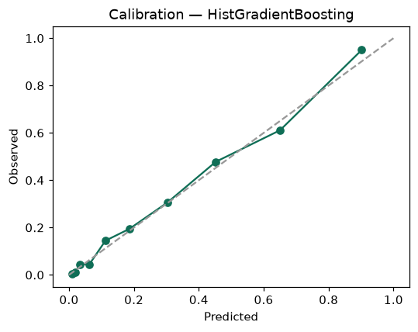

SHAP feature contributions
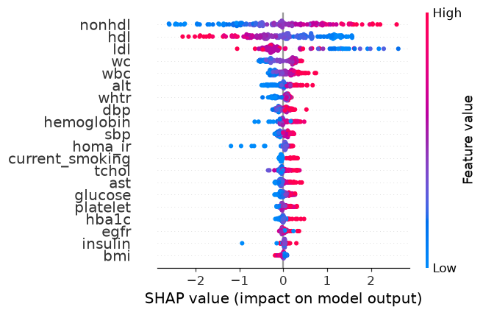

Partial dependence (PDP)
