Machine Learning Prediction Model Report
Outcome: Insulin resistance (HOMA-IR>=2.5) · KNHANES · 3 models compared · tuning, full metrics, threshold, SHAP, PDP
[ML] outcome = insulin_resistance

Data summary
Item | Value
N | 6000
Outcome prevalence (%) | 31.1
Features | 53
Models compared | 3
Train/test | 4200/1800 (70/30 stratified)
Auto-excluded leakage | None

Hyperparameter search space
Model | Search space
LogisticRegression | {'C': [0.01, 0.1, 1, 10], 'penalty': ['l1', 'l2']}
HistGradientBoosting | {'learning_rate': [0.03, 0.1], 'max_iter': [200, 400], 'max_depth': [3, 6, None]}
XGBoost | {'n_estimators': [300, 500], 'max_depth': [3, 5], 'learning_rate': [0.03, 0.1], 'subsample': [0.8, 1.0]}

Tuning and model selection — training-partition cross-validation
Hyperparameter search and between-model selection both use these training-partition cross-validated scores. The selection criterion is CV_combined, the mean of the cross-validated auROC and auPRC. The held-out partition is not consulted at this stage.
model | CV_auROC | CV_auPRC | CV_combined | best_params
LogisticRegression | 0.8143 | 0.7013 | 0.7578 | {'penalty': 'l1', 'C': 0.1}
HistGradientBoosting | 0.8086 | 0.6889 | 0.7488 | {'max_iter': 400, 'max_depth': 3, 'learning_rate': 0.03}
XGBoost | 0.8096 | 0.6931 | 0.7513 | {'subsample': 0.8, 'n_estimators': 500, 'max_depth': 3, 'learning_rate': 0.03}

Held-out performance metrics
Reported for every candidate for transparency; only the model selected by CV_combined above is the prespecified final model. Rows are ordered by the CV selection criterion.
model | CV_combined | TP | TN | FP | FN | sensitivity | specificity | PPV | NPV | accuracy | balanced_accuracy | f1 | MCC | kappa | auROC | auPRC | logloss | brier | combined
LogisticRegression | 0.7578 | 277 | 1125 | 116 | 282 | 0.4955 | 0.9065 | 0.7048 | 0.7996 | 0.7789 | 0.701 | 0.5819 | 0.4503 | 0.4378 | 0.8161 | 0.6791 | 0.4752 | 0.1537 | 0.7476
XGBoost | 0.7513 | 284 | 1122 | 119 | 275 | 0.5081 | 0.9041 | 0.7047 | 0.8031 | 0.7811 | 0.7061 | 0.5904 | 0.4575 | 0.4464 | 0.8173 | 0.6767 | 0.4749 | 0.1537 | 0.747
HistGradientBoosting | 0.7488 | 271 | 1130 | 111 | 288 | 0.4848 | 0.9106 | 0.7094 | 0.7969 | 0.7783 | 0.6977 | 0.576 | 0.4474 | 0.433 | 0.8133 | 0.6742 | 0.4789 | 0.1548 | 0.7438

ROC · Precision-Recall
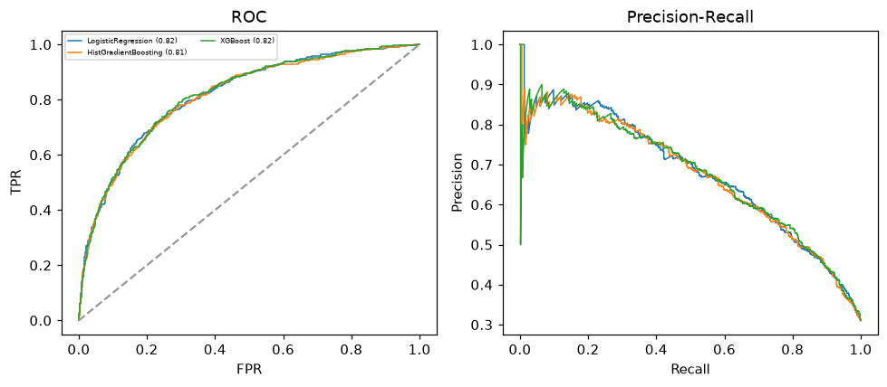

Selected final model — LogisticRegression (CV combined=0.7578; held-out auROC=0.8161)
Among 3 candidate models, LogisticRegression achieved the highest cross-validated combined score (0.7578) within the training partition and was selected on that basis. Refitted on the complete training partition and evaluated once on the untouched held-out partition, it reached an area under the receiver operating characteristic curve of 0.8161 and an area under the precision-recall curve of 0.6791.

Threshold analysis (0.1-0.9)
threshold | TP | TN | FP | FN | sensitivity | specificity | PPV | NPV | f1 | accuracy
0.1 | 539.0 | 357.0 | 884.0 | 20.0 | 0.964 | 0.288 | 0.379 | 0.947 | 0.544 | 0.498
0.2 | 483.0 | 697.0 | 544.0 | 76.0 | 0.864 | 0.562 | 0.47 | 0.902 | 0.609 | 0.656
0.3 | 419.0 | 907.0 | 334.0 | 140.0 | 0.75 | 0.731 | 0.556 | 0.866 | 0.639 | 0.737
0.4 | 354.0 | 1046.0 | 195.0 | 205.0 | 0.633 | 0.843 | 0.645 | 0.836 | 0.639 | 0.778
0.5 | 277.0 | 1125.0 | 116.0 | 282.0 | 0.496 | 0.907 | 0.705 | 0.8 | 0.582 | 0.779
0.6 | 210.0 | 1177.0 | 64.0 | 349.0 | 0.376 | 0.948 | 0.766 | 0.771 | 0.504 | 0.771
0.7 | 158.0 | 1208.0 | 33.0 | 401.0 | 0.283 | 0.973 | 0.827 | 0.751 | 0.421 | 0.759
0.8 | 103.0 | 1223.0 | 18.0 | 456.0 | 0.184 | 0.985 | 0.851 | 0.728 | 0.303 | 0.737
0.9 | 45.0 | 1234.0 | 7.0 | 514.0 | 0.081 | 0.994 | 0.865 | 0.706 | 0.147 | 0.711

Calibration
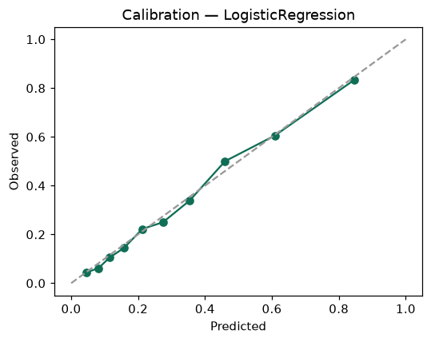

SHAP feature contributions
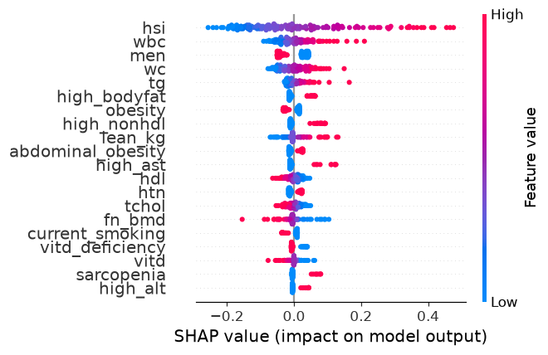

Partial dependence (PDP)
