Machine Learning Prediction Model Report
Outcome: Obesity (KSSO >=25 / WHO >=30, country-specific) · KNHANES · 3 models compared · tuning, full metrics, threshold, SHAP, PDP
[ML] outcome = obesity

Data summary
Item | Value
N | 6000
Outcome prevalence (%) | 34.1
Features | 43
Models compared | 3
Train/test | 4200/1800 (70/30 stratified)
Auto-excluded leakage | None

Hyperparameter search space
Model | Search space
LogisticRegression | {'C': [0.01, 0.1, 1, 10], 'penalty': ['l1', 'l2']}
HistGradientBoosting | {'learning_rate': [0.03, 0.1], 'max_iter': [200, 400], 'max_depth': [3, 6, None]}
XGBoost | {'n_estimators': [300, 500], 'max_depth': [3, 5], 'learning_rate': [0.03, 0.1], 'subsample': [0.8, 1.0]}

Tuning and model selection — training-partition cross-validation
Hyperparameter search and between-model selection both use these training-partition cross-validated scores. The selection criterion is CV_combined, the mean of the cross-validated auROC and auPRC. The held-out partition is not consulted at this stage.
model | CV_auROC | CV_auPRC | CV_combined | best_params
LogisticRegression | 0.784 | 0.6523 | 0.7181 | {'penalty': 'l2', 'C': 0.01}
HistGradientBoosting | 0.7919 | 0.6694 | 0.7307 | {'max_iter': 400, 'max_depth': 3, 'learning_rate': 0.03}
XGBoost | 0.7956 | 0.6772 | 0.7364 | {'subsample': 0.8, 'n_estimators': 500, 'max_depth': 3, 'learning_rate': 0.03}

Held-out performance metrics
Reported for every candidate for transparency; only the model selected by CV_combined above is the prespecified final model. Rows are ordered by the CV selection criterion.
model | CV_combined | TP | TN | FP | FN | sensitivity | specificity | PPV | NPV | accuracy | balanced_accuracy | f1 | MCC | kappa | auROC | auPRC | logloss | brier | combined
XGBoost | 0.7364 | 336 | 1035 | 152 | 277 | 0.5481 | 0.8719 | 0.6885 | 0.7889 | 0.7617 | 0.71 | 0.6104 | 0.4478 | 0.4419 | 0.8095 | 0.6877 | 0.4977 | 0.1637 | 0.7486
HistGradientBoosting | 0.7307 | 336 | 1029 | 158 | 277 | 0.5481 | 0.8669 | 0.6802 | 0.7879 | 0.7583 | 0.7075 | 0.607 | 0.4407 | 0.4355 | 0.8099 | 0.6901 | 0.4972 | 0.1637 | 0.75
LogisticRegression | 0.7181 | 333 | 1024 | 163 | 280 | 0.5432 | 0.8627 | 0.6714 | 0.7853 | 0.7539 | 0.703 | 0.6005 | 0.4305 | 0.4255 | 0.8013 | 0.6802 | 0.5148 | 0.1678 | 0.7408

ROC · Precision-Recall
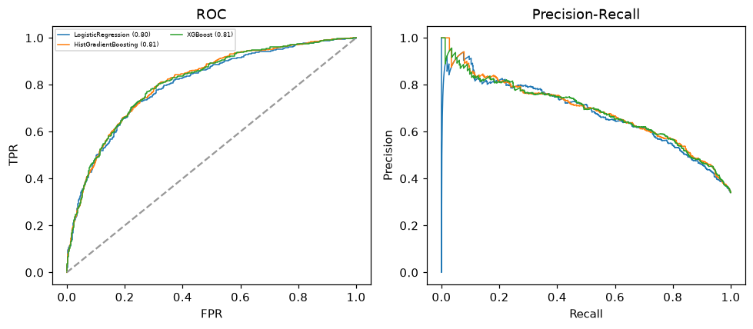

Selected final model — XGBoost (CV combined=0.7364; held-out auROC=0.8095)
Among 3 candidate models, XGBoost achieved the highest cross-validated combined score (0.7364) within the training partition and was selected on that basis. Refitted on the complete training partition and evaluated once on the untouched held-out partition, it reached an area under the receiver operating characteristic curve of 0.8095 and an area under the precision-recall curve of 0.6877.

Threshold analysis (0.1-0.9)
threshold | TP | TN | FP | FN | sensitivity | specificity | PPV | NPV | f1 | accuracy
0.1 | 596.0 | 263.0 | 924.0 | 17.0 | 0.972 | 0.222 | 0.392 | 0.939 | 0.559 | 0.477
0.2 | 547.0 | 600.0 | 587.0 | 66.0 | 0.892 | 0.505 | 0.482 | 0.901 | 0.626 | 0.637
0.3 | 475.0 | 845.0 | 342.0 | 138.0 | 0.775 | 0.712 | 0.581 | 0.86 | 0.664 | 0.733
0.4 | 397.0 | 960.0 | 227.0 | 216.0 | 0.648 | 0.809 | 0.636 | 0.816 | 0.642 | 0.754
0.5 | 336.0 | 1035.0 | 152.0 | 277.0 | 0.548 | 0.872 | 0.689 | 0.789 | 0.61 | 0.762
0.6 | 266.0 | 1097.0 | 90.0 | 347.0 | 0.434 | 0.924 | 0.747 | 0.76 | 0.549 | 0.757
0.7 | 170.0 | 1138.0 | 49.0 | 443.0 | 0.277 | 0.959 | 0.776 | 0.72 | 0.409 | 0.727
0.8 | 89.0 | 1168.0 | 19.0 | 524.0 | 0.145 | 0.984 | 0.824 | 0.69 | 0.247 | 0.698
0.9 | 28.0 | 1185.0 | 2.0 | 585.0 | 0.046 | 0.998 | 0.933 | 0.669 | 0.087 | 0.674

Calibration
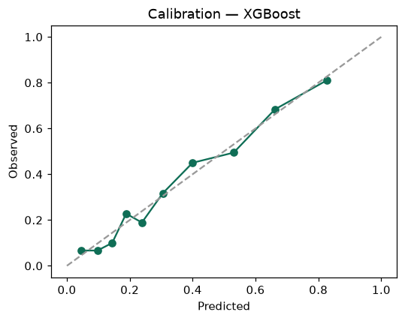

SHAP feature contributions
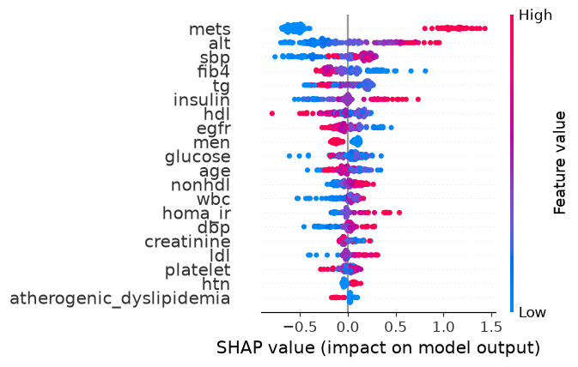

Partial dependence (PDP)
