Machine Learning Prediction Model Report
Outcome: Overweight (KSSO >=23 / WHO >=25, country-specific) · KNHANES · 3 models compared · tuning, full metrics, threshold, SHAP, PDP
[ML] outcome = overweight

Data summary
Item | Value
N | 6000
Outcome prevalence (%) | 57.7
Features | 43
Models compared | 3
Train/test | 4200/1800 (70/30 stratified)
Auto-excluded leakage | None

Hyperparameter search space
Model | Search space
LogisticRegression | {'C': [0.01, 0.1, 1, 10], 'penalty': ['l1', 'l2']}
HistGradientBoosting | {'learning_rate': [0.03, 0.1], 'max_iter': [200, 400], 'max_depth': [3, 6, None]}
XGBoost | {'n_estimators': [300, 500], 'max_depth': [3, 5], 'learning_rate': [0.03, 0.1], 'subsample': [0.8, 1.0]}

Tuning and model selection — training-partition cross-validation
Hyperparameter search and between-model selection both use these training-partition cross-validated scores. The selection criterion is CV_combined, the mean of the cross-validated auROC and auPRC. The held-out partition is not consulted at this stage.
model | CV_auROC | CV_auPRC | CV_combined | best_params
LogisticRegression | 0.7782 | 0.8256 | 0.8019 | {'penalty': 'l1', 'C': 0.1}
HistGradientBoosting | 0.7874 | 0.8354 | 0.8114 | {'max_iter': 400, 'max_depth': 3, 'learning_rate': 0.03}
XGBoost | 0.7887 | 0.838 | 0.8133 | {'subsample': 0.8, 'n_estimators': 500, 'max_depth': 3, 'learning_rate': 0.03}

Held-out performance metrics
Reported for every candidate for transparency; only the model selected by CV_combined above is the prespecified final model. Rows are ordered by the CV selection criterion.
model | CV_combined | TP | TN | FP | FN | sensitivity | specificity | PPV | NPV | accuracy | balanced_accuracy | f1 | MCC | kappa | auROC | auPRC | logloss | brier | combined
XGBoost | 0.8133 | 796 | 503 | 259 | 242 | 0.7669 | 0.6601 | 0.7545 | 0.6752 | 0.7217 | 0.7135 | 0.7606 | 0.4283 | 0.4282 | 0.7987 | 0.8488 | 0.5326 | 0.1802 | 0.8237
HistGradientBoosting | 0.8114 | 801 | 489 | 273 | 237 | 0.7717 | 0.6417 | 0.7458 | 0.6736 | 0.7167 | 0.7067 | 0.7585 | 0.4164 | 0.416 | 0.7978 | 0.846 | 0.5351 | 0.1805 | 0.8219
LogisticRegression | 0.8019 | 760 | 538 | 224 | 278 | 0.7322 | 0.706 | 0.7724 | 0.6593 | 0.7211 | 0.7191 | 0.7517 | 0.4349 | 0.4341 | 0.7902 | 0.8337 | 0.5473 | 0.1843 | 0.812

ROC · Precision-Recall
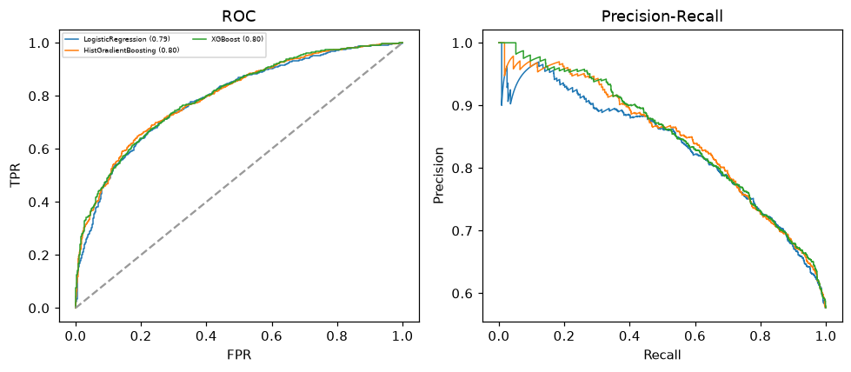

Selected final model — XGBoost (CV combined=0.8133; held-out auROC=0.7987)
Among 3 candidate models, XGBoost achieved the highest cross-validated combined score (0.8133) within the training partition and was selected on that basis. Refitted on the complete training partition and evaluated once on the untouched held-out partition, it reached an area under the receiver operating characteristic curve of 0.7987 and an area under the precision-recall curve of 0.8488.

Threshold analysis (0.1-0.9)
threshold | TP | TN | FP | FN | sensitivity | specificity | PPV | NPV | f1 | accuracy
0.1 | 1035.0 | 44.0 | 718.0 | 3.0 | 0.997 | 0.058 | 0.59 | 0.936 | 0.742 | 0.599
0.2 | 1011.0 | 150.0 | 612.0 | 27.0 | 0.974 | 0.197 | 0.623 | 0.847 | 0.76 | 0.645
0.3 | 977.0 | 263.0 | 499.0 | 61.0 | 0.941 | 0.345 | 0.662 | 0.812 | 0.777 | 0.689
0.4 | 891.0 | 383.0 | 379.0 | 147.0 | 0.858 | 0.503 | 0.702 | 0.723 | 0.772 | 0.708
0.5 | 796.0 | 503.0 | 259.0 | 242.0 | 0.767 | 0.66 | 0.755 | 0.675 | 0.761 | 0.722
0.6 | 684.0 | 595.0 | 167.0 | 354.0 | 0.659 | 0.781 | 0.804 | 0.627 | 0.724 | 0.711
0.7 | 572.0 | 658.0 | 104.0 | 466.0 | 0.551 | 0.864 | 0.846 | 0.585 | 0.667 | 0.683
0.8 | 435.0 | 713.0 | 49.0 | 603.0 | 0.419 | 0.936 | 0.899 | 0.542 | 0.572 | 0.638
0.9 | 249.0 | 750.0 | 12.0 | 789.0 | 0.24 | 0.984 | 0.954 | 0.487 | 0.383 | 0.555

Calibration
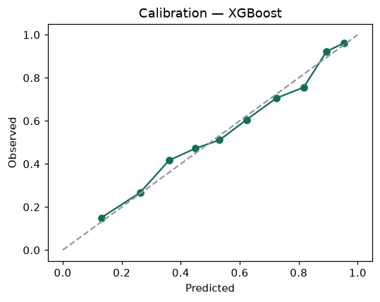

SHAP feature contributions
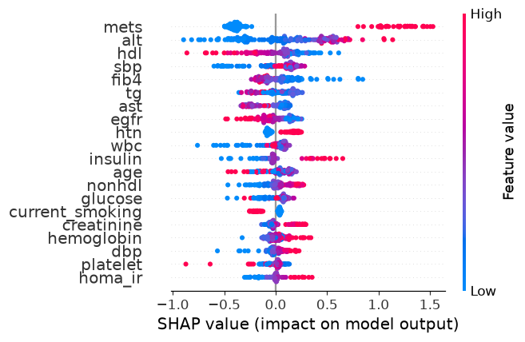

Partial dependence (PDP)
