Machine Learning Prediction Model Report
Outcome: Prediabetes · KNHANES · 3 models compared · tuning, full metrics, threshold, SHAP, PDP
[ML] outcome = prediabetes

Data summary
Item | Value
N | 6000
Outcome prevalence (%) | 32.9
Features | 45
Models compared | 3
Train/test | 4200/1800 (70/30 stratified)
Auto-excluded leakage | None

Hyperparameter search space
Model | Search space
LogisticRegression | {'C': [0.01, 0.1, 1, 10], 'penalty': ['l1', 'l2']}
HistGradientBoosting | {'learning_rate': [0.03, 0.1], 'max_iter': [200, 400], 'max_depth': [3, 6, None]}
XGBoost | {'n_estimators': [300, 500], 'max_depth': [3, 5], 'learning_rate': [0.03, 0.1], 'subsample': [0.8, 1.0]}

Tuning and model selection — training-partition cross-validation
Hyperparameter search and between-model selection both use these training-partition cross-validated scores. The selection criterion is CV_combined, the mean of the cross-validated auROC and auPRC. The held-out partition is not consulted at this stage.
model | CV_auROC | CV_auPRC | CV_combined | best_params
LogisticRegression | 0.7003 | 0.4941 | 0.5972 | {'penalty': 'l1', 'C': 10}
HistGradientBoosting | 0.6883 | 0.4863 | 0.5873 | {'max_iter': 200, 'max_depth': 3, 'learning_rate': 0.1}
XGBoost | 0.6974 | 0.5017 | 0.5996 | {'subsample': 0.8, 'n_estimators': 500, 'max_depth': 3, 'learning_rate': 0.03}

Held-out performance metrics
Reported for every candidate for transparency; only the model selected by CV_combined above is the prespecified final model. Rows are ordered by the CV selection criterion.
model | CV_combined | TP | TN | FP | FN | sensitivity | specificity | PPV | NPV | accuracy | balanced_accuracy | f1 | MCC | kappa | auROC | auPRC | logloss | brier | combined
XGBoost | 0.5996 | 168 | 1069 | 140 | 423 | 0.2843 | 0.8842 | 0.5455 | 0.7165 | 0.6872 | 0.5842 | 0.3737 | 0.2101 | 0.192 | 0.6942 | 0.498 | 0.5797 | 0.1989 | 0.5961
LogisticRegression | 0.5972 | 181 | 1086 | 123 | 410 | 0.3063 | 0.8983 | 0.5954 | 0.7259 | 0.7039 | 0.6023 | 0.4045 | 0.2564 | 0.2335 | 0.7036 | 0.5254 | 0.5746 | 0.1959 | 0.6145
HistGradientBoosting | 0.5873 | 183 | 1055 | 154 | 408 | 0.3096 | 0.8726 | 0.543 | 0.7211 | 0.6878 | 0.5911 | 0.3944 | 0.2194 | 0.2048 | 0.689 | 0.4896 | 0.5862 | 0.2012 | 0.5893

ROC · Precision-Recall
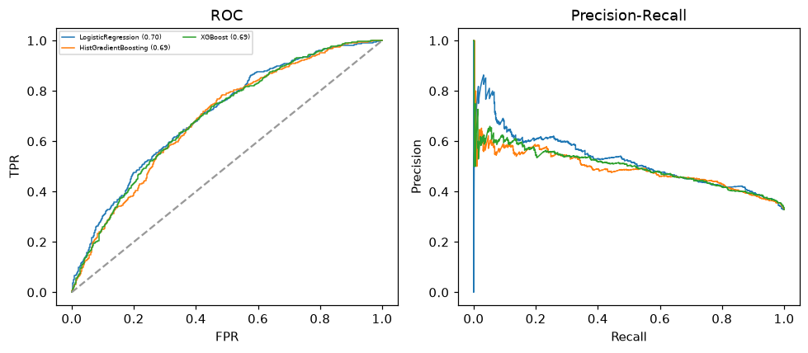

Selected final model — XGBoost (CV combined=0.5996; held-out auROC=0.6942)
Among 3 candidate models, XGBoost achieved the highest cross-validated combined score (0.5996) within the training partition and was selected on that basis. Refitted on the complete training partition and evaluated once on the untouched held-out partition, it reached an area under the receiver operating characteristic curve of 0.6942 and an area under the precision-recall curve of 0.498.

Threshold analysis (0.1-0.9)
threshold | TP | TN | FP | FN | sensitivity | specificity | PPV | NPV | f1 | accuracy
0.1 | 574.0 | 204.0 | 1005.0 | 17.0 | 0.971 | 0.169 | 0.364 | 0.923 | 0.529 | 0.432
0.2 | 522.0 | 407.0 | 802.0 | 69.0 | 0.883 | 0.337 | 0.394 | 0.855 | 0.545 | 0.516
0.3 | 441.0 | 651.0 | 558.0 | 150.0 | 0.746 | 0.538 | 0.441 | 0.813 | 0.555 | 0.607
0.4 | 310.0 | 893.0 | 316.0 | 281.0 | 0.525 | 0.739 | 0.495 | 0.761 | 0.509 | 0.668
0.5 | 168.0 | 1069.0 | 140.0 | 423.0 | 0.284 | 0.884 | 0.545 | 0.716 | 0.374 | 0.687
0.6 | 64.0 | 1167.0 | 42.0 | 527.0 | 0.108 | 0.965 | 0.604 | 0.689 | 0.184 | 0.684
0.7 | 9.0 | 1202.0 | 7.0 | 582.0 | 0.015 | 0.994 | 0.562 | 0.674 | 0.03 | 0.673
0.8 | 0.0 | 1209.0 | 0.0 | 591.0 | 0.0 | 1.0 | nan | 0.672 | 0.0 | 0.672
0.9 | 0.0 | 1209.0 | 0.0 | 591.0 | 0.0 | 1.0 | nan | 0.672 | 0.0 | 0.672

Calibration
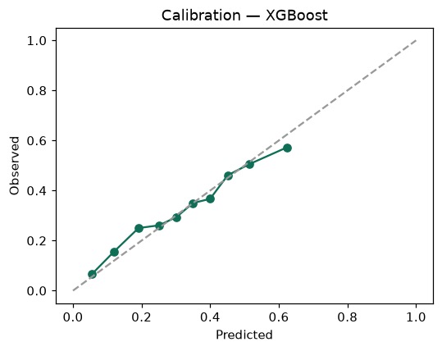

SHAP feature contributions
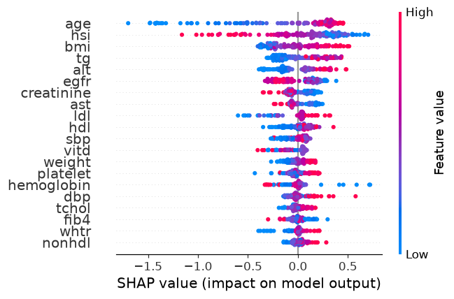

Partial dependence (PDP)
