Machine Learning Prediction Model Report
Outcome: Vitamin D deficiency (<20 ng/mL) · KNHANES · 3 models compared · tuning, full metrics, threshold, SHAP, PDP
[ML] outcome = vitd_deficiency

Data summary
Item | Value
N | 6000
Outcome prevalence (%) | 67.4
Features | 61
Models compared | 3
Train/test | 4200/1800 (70/30 stratified)
Auto-excluded leakage | None

Hyperparameter search space
Model | Search space
LogisticRegression | {'C': [0.01, 0.1, 1, 10], 'penalty': ['l1', 'l2']}
HistGradientBoosting | {'learning_rate': [0.03, 0.1], 'max_iter': [200, 400], 'max_depth': [3, 6, None]}
XGBoost | {'n_estimators': [300, 500], 'max_depth': [3, 5], 'learning_rate': [0.03, 0.1], 'subsample': [0.8, 1.0]}

Tuning and model selection — training-partition cross-validation
Hyperparameter search and between-model selection both use these training-partition cross-validated scores. The selection criterion is CV_combined, the mean of the cross-validated auROC and auPRC. The held-out partition is not consulted at this stage.
model | CV_auROC | CV_auPRC | CV_combined | best_params
LogisticRegression | 0.6502 | 0.7854 | 0.7178 | {'penalty': 'l1', 'C': 0.1}
HistGradientBoosting | 0.661 | 0.7933 | 0.7271 | {'max_iter': 400, 'max_depth': 3, 'learning_rate': 0.03}
XGBoost | 0.6648 | 0.7943 | 0.7295 | {'subsample': 1.0, 'n_estimators': 300, 'max_depth': 3, 'learning_rate': 0.03}

Held-out performance metrics
Reported for every candidate for transparency; only the model selected by CV_combined above is the prespecified final model. Rows are ordered by the CV selection criterion.
model | CV_combined | TP | TN | FP | FN | sensitivity | specificity | PPV | NPV | accuracy | balanced_accuracy | f1 | MCC | kappa | auROC | auPRC | logloss | brier | combined
XGBoost | 0.7295 | 1134 | 127 | 460 | 79 | 0.9349 | 0.2164 | 0.7114 | 0.6165 | 0.7006 | 0.5756 | 0.808 | 0.2227 | 0.1816 | 0.6693 | 0.7836 | 0.5924 | 0.202 | 0.7264
HistGradientBoosting | 0.7271 | 1116 | 135 | 452 | 97 | 0.92 | 0.23 | 0.7117 | 0.5819 | 0.695 | 0.575 | 0.8026 | 0.2099 | 0.1778 | 0.6746 | 0.7881 | 0.5914 | 0.2013 | 0.7313
LogisticRegression | 0.7178 | 1137 | 102 | 485 | 76 | 0.9373 | 0.1738 | 0.701 | 0.573 | 0.6883 | 0.5556 | 0.8021 | 0.1745 | 0.1355 | 0.6489 | 0.7712 | 0.6007 | 0.206 | 0.7101

ROC · Precision-Recall
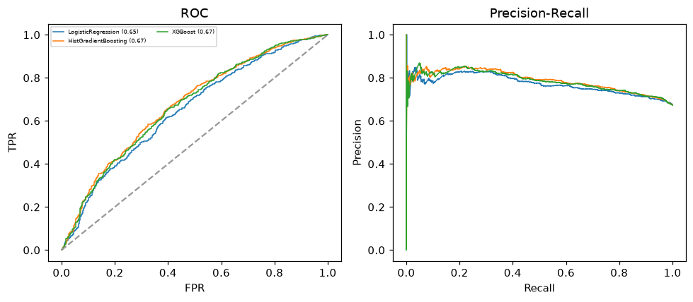

Selected final model — XGBoost (CV combined=0.7295; held-out auROC=0.6693)
Among 3 candidate models, XGBoost achieved the highest cross-validated combined score (0.7295) within the training partition and was selected on that basis. Refitted on the complete training partition and evaluated once on the untouched held-out partition, it reached an area under the receiver operating characteristic curve of 0.6693 and an area under the precision-recall curve of 0.7836.

Threshold analysis (0.1-0.9)
threshold | TP | TN | FP | FN | sensitivity | specificity | PPV | NPV | f1 | accuracy
0.1 | 1213.0 | 0.0 | 587.0 | 0.0 | 1.0 | 0.0 | 0.674 | nan | 0.805 | 0.674
0.2 | 1213.0 | 0.0 | 587.0 | 0.0 | 1.0 | 0.0 | 0.674 | nan | 0.805 | 0.674
0.3 | 1209.0 | 7.0 | 580.0 | 4.0 | 0.997 | 0.012 | 0.676 | 0.636 | 0.805 | 0.676
0.4 | 1187.0 | 52.0 | 535.0 | 26.0 | 0.979 | 0.089 | 0.689 | 0.667 | 0.809 | 0.688
0.5 | 1134.0 | 127.0 | 460.0 | 79.0 | 0.935 | 0.216 | 0.711 | 0.617 | 0.808 | 0.701
0.6 | 940.0 | 264.0 | 323.0 | 273.0 | 0.775 | 0.45 | 0.744 | 0.492 | 0.759 | 0.669
0.7 | 605.0 | 423.0 | 164.0 | 608.0 | 0.499 | 0.721 | 0.787 | 0.41 | 0.61 | 0.571
0.8 | 313.0 | 525.0 | 62.0 | 900.0 | 0.258 | 0.894 | 0.835 | 0.368 | 0.394 | 0.466
0.9 | 50.0 | 578.0 | 9.0 | 1163.0 | 0.041 | 0.985 | 0.847 | 0.332 | 0.079 | 0.349

Calibration
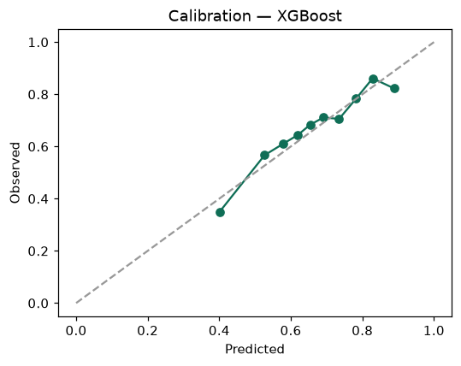

SHAP feature contributions
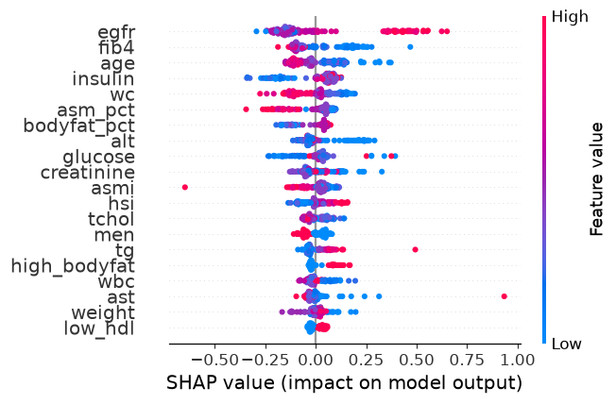

Partial dependence (PDP)
