Machine Learning Prediction Model Report
Outcome: Chronic kidney disease (KDIGO: eGFR<60 or ACR>=30) · NHANES · 3 models compared · tuning, full metrics, threshold, SHAP, PDP
[ML] outcome = ckd

Data summary
Item | Value
N | 6000
Outcome prevalence (%) | 16.8
Features | 57
Models compared | 3
Train/test | 4200/1800 (70/30 stratified)
Auto-excluded leakage | None

Hyperparameter search space
Model | Search space
LogisticRegression | {'C': [0.01, 0.1, 1, 10], 'penalty': ['l1', 'l2']}
HistGradientBoosting | {'learning_rate': [0.03, 0.1], 'max_iter': [200, 400], 'max_depth': [3, 6, None]}
XGBoost | {'n_estimators': [300, 500], 'max_depth': [3, 5], 'learning_rate': [0.03, 0.1], 'subsample': [0.8, 1.0]}

Tuning and model selection — training-partition cross-validation
Hyperparameter search and between-model selection both use these training-partition cross-validated scores. The selection criterion is CV_combined, the mean of the cross-validated auROC and auPRC. The held-out partition is not consulted at this stage.
model | CV_auROC | CV_auPRC | CV_combined | best_params
LogisticRegression | 0.7874 | 0.4792 | 0.6333 | {'penalty': 'l1', 'C': 0.1}
HistGradientBoosting | 0.7823 | 0.4735 | 0.6279 | {'max_iter': 400, 'max_depth': 3, 'learning_rate': 0.03}
XGBoost | 0.7899 | 0.4798 | 0.6349 | {'subsample': 1.0, 'n_estimators': 300, 'max_depth': 3, 'learning_rate': 0.03}

Held-out performance metrics
Reported for every candidate for transparency; only the model selected by CV_combined above is the prespecified final model. Rows are ordered by the CV selection criterion.
model | CV_combined | TP | TN | FP | FN | sensitivity | specificity | PPV | NPV | accuracy | balanced_accuracy | f1 | MCC | kappa | auROC | auPRC | logloss | brier | combined
XGBoost | 0.6349 | 80 | 1471 | 28 | 221 | 0.2658 | 0.9813 | 0.7407 | 0.8694 | 0.8617 | 0.6236 | 0.3912 | 0.3883 | 0.3322 | 0.8074 | 0.5422 | 0.3518 | 0.1065 | 0.6748
LogisticRegression | 0.6333 | 85 | 1465 | 34 | 216 | 0.2824 | 0.9773 | 0.7143 | 0.8715 | 0.8611 | 0.6299 | 0.4048 | 0.39 | 0.3425 | 0.8079 | 0.543 | 0.3523 | 0.1066 | 0.6754
HistGradientBoosting | 0.6279 | 85 | 1469 | 30 | 216 | 0.2824 | 0.98 | 0.7391 | 0.8718 | 0.8633 | 0.6312 | 0.4087 | 0.4004 | 0.3484 | 0.8025 | 0.546 | 0.3537 | 0.1067 | 0.6742

ROC · Precision-Recall
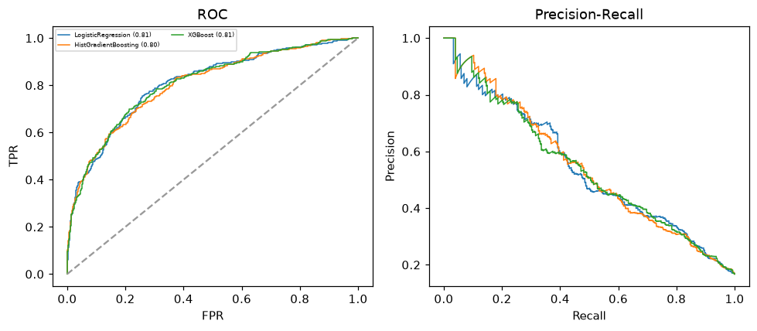

Selected final model — XGBoost (CV combined=0.6349; held-out auROC=0.8074)
Among 3 candidate models, XGBoost achieved the highest cross-validated combined score (0.6349) within the training partition and was selected on that basis. Refitted on the complete training partition and evaluated once on the untouched held-out partition, it reached an area under the receiver operating characteristic curve of 0.8074 and an area under the precision-recall curve of 0.5422.

Threshold analysis (0.1-0.9)
threshold | TP | TN | FP | FN | sensitivity | specificity | PPV | NPV | f1 | accuracy
0.1 | 252.0 | 891.0 | 608.0 | 49.0 | 0.837 | 0.594 | 0.293 | 0.948 | 0.434 | 0.635
0.2 | 208.0 | 1183.0 | 316.0 | 93.0 | 0.691 | 0.789 | 0.397 | 0.927 | 0.504 | 0.773
0.3 | 159.0 | 1325.0 | 174.0 | 142.0 | 0.528 | 0.884 | 0.477 | 0.903 | 0.502 | 0.824
0.4 | 119.0 | 1417.0 | 82.0 | 182.0 | 0.395 | 0.945 | 0.592 | 0.886 | 0.474 | 0.853
0.5 | 80.0 | 1471.0 | 28.0 | 221.0 | 0.266 | 0.981 | 0.741 | 0.869 | 0.391 | 0.862
0.6 | 45.0 | 1490.0 | 9.0 | 256.0 | 0.15 | 0.994 | 0.833 | 0.853 | 0.254 | 0.853
0.7 | 30.0 | 1495.0 | 4.0 | 271.0 | 0.1 | 0.997 | 0.882 | 0.847 | 0.179 | 0.847
0.8 | 18.0 | 1497.0 | 2.0 | 283.0 | 0.06 | 0.999 | 0.9 | 0.841 | 0.112 | 0.842
0.9 | 7.0 | 1499.0 | 0.0 | 294.0 | 0.023 | 1.0 | 1.0 | 0.836 | 0.045 | 0.837

Calibration
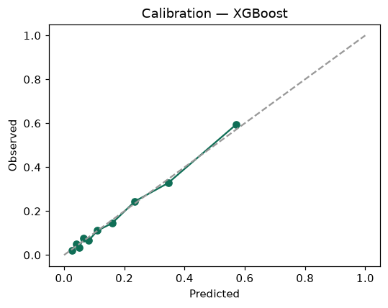

SHAP feature contributions
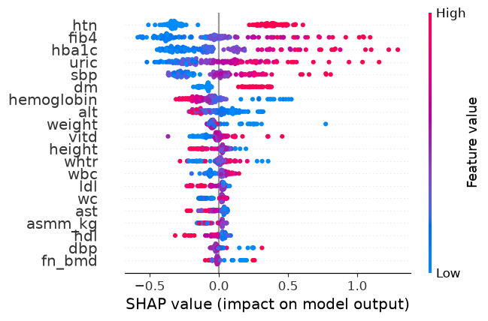

Partial dependence (PDP)
