Machine Learning Prediction Model Report
Outcome: Diabetes mellitus · NHANES · 3 models compared · tuning, full metrics, threshold, SHAP, PDP
[ML] outcome = dm

Data summary
Item | Value
N | 6000
Outcome prevalence (%) | 17.8
Features | 56
Models compared | 3
Train/test | 4200/1800 (70/30 stratified)
Auto-excluded leakage | None

Hyperparameter search space
Model | Search space
LogisticRegression | {'C': [0.01, 0.1, 1, 10], 'penalty': ['l1', 'l2']}
HistGradientBoosting | {'learning_rate': [0.03, 0.1], 'max_iter': [200, 400], 'max_depth': [3, 6, None]}
XGBoost | {'n_estimators': [300, 500], 'max_depth': [3, 5], 'learning_rate': [0.03, 0.1], 'subsample': [0.8, 1.0]}

Tuning and model selection — training-partition cross-validation
Hyperparameter search and between-model selection both use these training-partition cross-validated scores. The selection criterion is CV_combined, the mean of the cross-validated auROC and auPRC. The held-out partition is not consulted at this stage.
model | CV_auROC | CV_auPRC | CV_combined | best_params
LogisticRegression | 0.8368 | 0.5341 | 0.6855 | {'penalty': 'l1', 'C': 10}
HistGradientBoosting | 0.8524 | 0.6031 | 0.7277 | {'max_iter': 400, 'max_depth': 3, 'learning_rate': 0.03}
XGBoost | 0.8583 | 0.6166 | 0.7375 | {'subsample': 0.8, 'n_estimators': 500, 'max_depth': 3, 'learning_rate': 0.03}

Held-out performance metrics
Reported for every candidate for transparency; only the model selected by CV_combined above is the prespecified final model. Rows are ordered by the CV selection criterion.
model | CV_combined | TP | TN | FP | FN | sensitivity | specificity | PPV | NPV | accuracy | balanced_accuracy | f1 | MCC | kappa | auROC | auPRC | logloss | brier | combined
XGBoost | 0.7375 | 120 | 1410 | 69 | 201 | 0.3738 | 0.9533 | 0.6349 | 0.8752 | 0.85 | 0.6636 | 0.4706 | 0.4085 | 0.39 | 0.8468 | 0.585 | 0.3413 | 0.107 | 0.7159
HistGradientBoosting | 0.7277 | 108 | 1409 | 70 | 213 | 0.3364 | 0.9527 | 0.6067 | 0.8687 | 0.8428 | 0.6446 | 0.4329 | 0.3707 | 0.3502 | 0.8434 | 0.5693 | 0.3449 | 0.1084 | 0.7064
LogisticRegression | 0.6855 | 108 | 1410 | 69 | 213 | 0.3364 | 0.9533 | 0.6102 | 0.8688 | 0.8433 | 0.6449 | 0.4337 | 0.3725 | 0.3515 | 0.8287 | 0.5278 | 0.3592 | 0.1127 | 0.6783

ROC · Precision-Recall
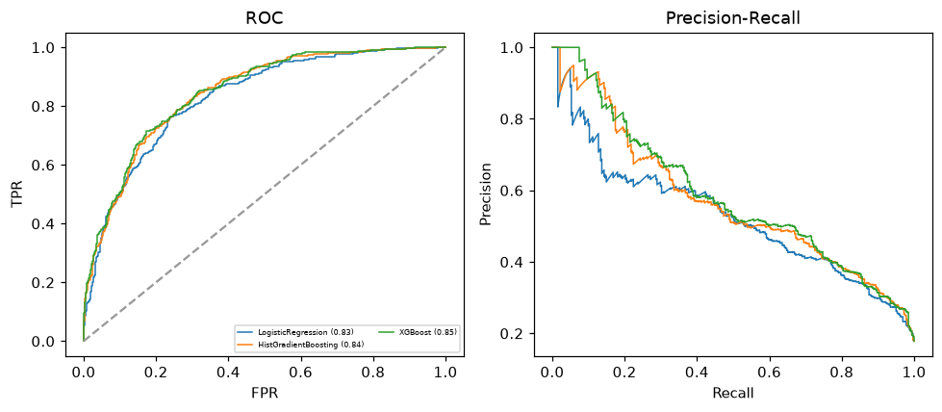

Selected final model — XGBoost (CV combined=0.7375; held-out auROC=0.8468)
Among 3 candidate models, XGBoost achieved the highest cross-validated combined score (0.7375) within the training partition and was selected on that basis. Refitted on the complete training partition and evaluated once on the untouched held-out partition, it reached an area under the receiver operating characteristic curve of 0.8468 and an area under the precision-recall curve of 0.585.

Threshold analysis (0.1-0.9)
threshold | TP | TN | FP | FN | sensitivity | specificity | PPV | NPV | f1 | accuracy
0.1 | 276.0 | 942.0 | 537.0 | 45.0 | 0.86 | 0.637 | 0.339 | 0.954 | 0.487 | 0.677
0.2 | 234.0 | 1181.0 | 298.0 | 87.0 | 0.729 | 0.799 | 0.44 | 0.931 | 0.549 | 0.786
0.3 | 190.0 | 1296.0 | 183.0 | 131.0 | 0.592 | 0.876 | 0.509 | 0.908 | 0.548 | 0.826
0.4 | 148.0 | 1364.0 | 115.0 | 173.0 | 0.461 | 0.922 | 0.563 | 0.887 | 0.507 | 0.84
0.5 | 120.0 | 1410.0 | 69.0 | 201.0 | 0.374 | 0.953 | 0.635 | 0.875 | 0.471 | 0.85
0.6 | 85.0 | 1447.0 | 32.0 | 236.0 | 0.265 | 0.978 | 0.726 | 0.86 | 0.388 | 0.851
0.7 | 59.0 | 1465.0 | 14.0 | 262.0 | 0.184 | 0.991 | 0.808 | 0.848 | 0.299 | 0.847
0.8 | 39.0 | 1476.0 | 3.0 | 282.0 | 0.121 | 0.998 | 0.929 | 0.84 | 0.215 | 0.842
0.9 | 3.0 | 1479.0 | 0.0 | 318.0 | 0.009 | 1.0 | 1.0 | 0.823 | 0.019 | 0.823

Calibration
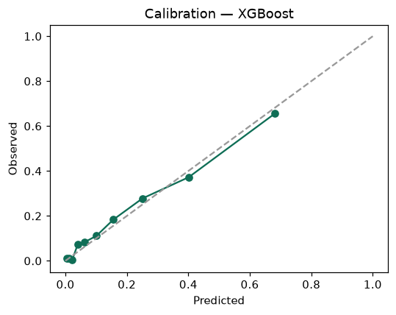

SHAP feature contributions
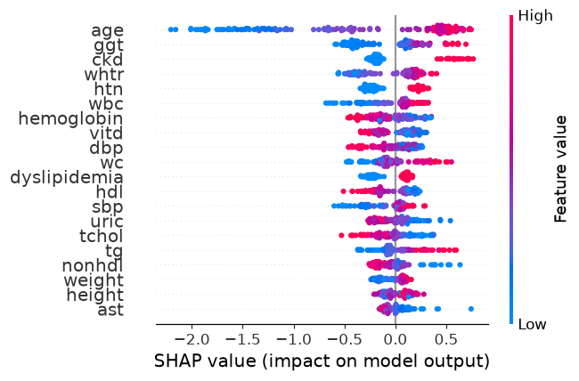

Partial dependence (PDP)
