Machine Learning Prediction Model Report
Outcome: Dyslipidemia (KSoLA composite) · NHANES · 3 models compared · tuning, full metrics, threshold, SHAP, PDP
[ML] outcome = dyslipidemia

Data summary
Item | Value
N | 6000
Outcome prevalence (%) | 55.6
Features | 52
Models compared | 3
Train/test | 4200/1800 (70/30 stratified)
Auto-excluded leakage | None

Hyperparameter search space
Model | Search space
LogisticRegression | {'C': [0.01, 0.1, 1, 10], 'penalty': ['l1', 'l2']}
HistGradientBoosting | {'learning_rate': [0.03, 0.1], 'max_iter': [200, 400], 'max_depth': [3, 6, None]}
XGBoost | {'n_estimators': [300, 500], 'max_depth': [3, 5], 'learning_rate': [0.03, 0.1], 'subsample': [0.8, 1.0]}

Tuning and model selection — training-partition cross-validation
Hyperparameter search and between-model selection both use these training-partition cross-validated scores. The selection criterion is CV_combined, the mean of the cross-validated auROC and auPRC. The held-out partition is not consulted at this stage.
model | CV_auROC | CV_auPRC | CV_combined | best_params
LogisticRegression | 0.7048 | 0.7172 | 0.711 | {'penalty': 'l2', 'C': 0.01}
HistGradientBoosting | 0.7075 | 0.7367 | 0.7221 | {'max_iter': 400, 'max_depth': 3, 'learning_rate': 0.03}
XGBoost | 0.7137 | 0.7477 | 0.7307 | {'subsample': 0.8, 'n_estimators': 300, 'max_depth': 5, 'learning_rate': 0.03}

Held-out performance metrics
Reported for every candidate for transparency; only the model selected by CV_combined above is the prespecified final model. Rows are ordered by the CV selection criterion.
model | CV_combined | TP | TN | FP | FN | sensitivity | specificity | PPV | NPV | accuracy | balanced_accuracy | f1 | MCC | kappa | auROC | auPRC | logloss | brier | combined
XGBoost | 0.7307 | 801 | 429 | 370 | 200 | 0.8002 | 0.5369 | 0.684 | 0.682 | 0.6833 | 0.6686 | 0.7376 | 0.3513 | 0.3445 | 0.7415 | 0.7707 | 0.5959 | 0.2042 | 0.7561
HistGradientBoosting | 0.7221 | 812 | 409 | 390 | 189 | 0.8112 | 0.5119 | 0.6755 | 0.6839 | 0.6783 | 0.6615 | 0.7372 | 0.3408 | 0.3315 | 0.7402 | 0.7741 | 0.5944 | 0.2042 | 0.7571
LogisticRegression | 0.711 | 793 | 430 | 369 | 208 | 0.7922 | 0.5382 | 0.6824 | 0.674 | 0.6794 | 0.6652 | 0.7332 | 0.3432 | 0.3372 | 0.7308 | 0.7482 | 0.601 | 0.2068 | 0.7395

ROC · Precision-Recall
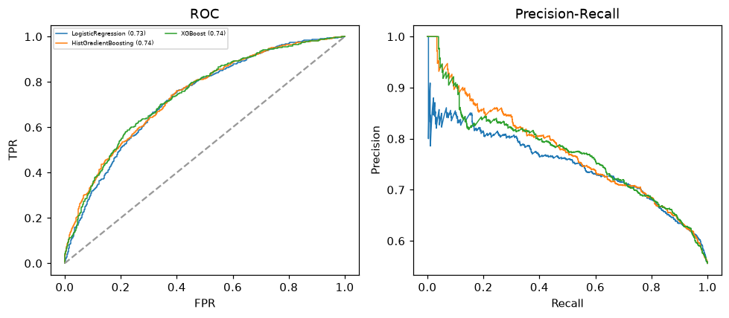

Selected final model — XGBoost (CV combined=0.7307; held-out auROC=0.7415)
Among 3 candidate models, XGBoost achieved the highest cross-validated combined score (0.7307) within the training partition and was selected on that basis. Refitted on the complete training partition and evaluated once on the untouched held-out partition, it reached an area under the receiver operating characteristic curve of 0.7415 and an area under the precision-recall curve of 0.7707.

Threshold analysis (0.1-0.9)
threshold | TP | TN | FP | FN | sensitivity | specificity | PPV | NPV | f1 | accuracy
0.1 | 992.0 | 45.0 | 754.0 | 9.0 | 0.991 | 0.056 | 0.568 | 0.833 | 0.722 | 0.576
0.2 | 965.0 | 143.0 | 656.0 | 36.0 | 0.964 | 0.179 | 0.595 | 0.799 | 0.736 | 0.616
0.3 | 936.0 | 240.0 | 559.0 | 65.0 | 0.935 | 0.3 | 0.626 | 0.787 | 0.75 | 0.653
0.4 | 894.0 | 310.0 | 489.0 | 107.0 | 0.893 | 0.388 | 0.646 | 0.743 | 0.75 | 0.669
0.5 | 801.0 | 429.0 | 370.0 | 200.0 | 0.8 | 0.537 | 0.684 | 0.682 | 0.738 | 0.683
0.6 | 633.0 | 581.0 | 218.0 | 368.0 | 0.632 | 0.727 | 0.744 | 0.612 | 0.684 | 0.674
0.7 | 414.0 | 692.0 | 107.0 | 587.0 | 0.414 | 0.866 | 0.795 | 0.541 | 0.544 | 0.614
0.8 | 191.0 | 763.0 | 36.0 | 810.0 | 0.191 | 0.955 | 0.841 | 0.485 | 0.311 | 0.53
0.9 | 67.0 | 794.0 | 5.0 | 934.0 | 0.067 | 0.994 | 0.931 | 0.459 | 0.125 | 0.478

Calibration
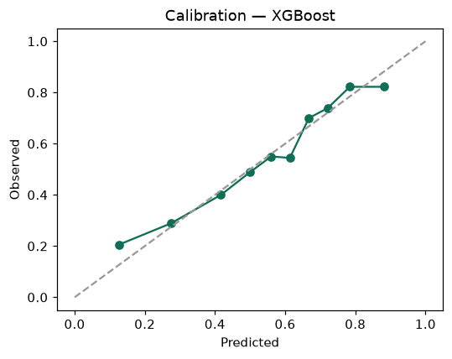

SHAP feature contributions
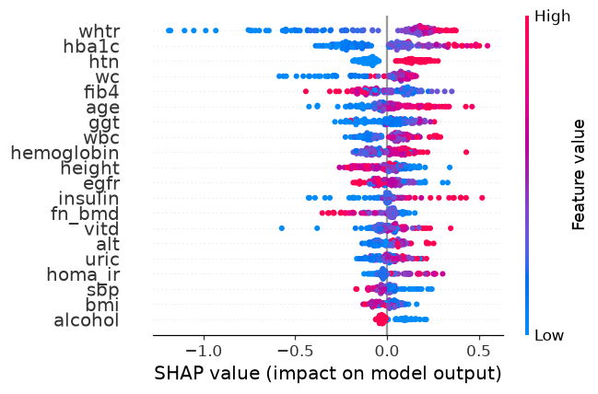

Partial dependence (PDP)
