Machine Learning Prediction Model Report
Outcome: Elevated AST (>40 IU/L) · NHANES · 3 models compared · tuning, full metrics, threshold, SHAP, PDP
[ML] outcome = high_ast

Data summary
Item | Value
N | 6000
Outcome prevalence (%) | 5.9
Features | 57
Models compared | 3
Train/test | 4200/1800 (70/30 stratified)
Auto-excluded leakage | None

Hyperparameter search space
Model | Search space
LogisticRegression | {'C': [0.01, 0.1, 1, 10], 'penalty': ['l1', 'l2']}
HistGradientBoosting | {'learning_rate': [0.03, 0.1], 'max_iter': [200, 400], 'max_depth': [3, 6, None]}
XGBoost | {'n_estimators': [300, 500], 'max_depth': [3, 5], 'learning_rate': [0.03, 0.1], 'subsample': [0.8, 1.0]}

Tuning and model selection — training-partition cross-validation
Hyperparameter search and between-model selection both use these training-partition cross-validated scores. The selection criterion is CV_combined, the mean of the cross-validated auROC and auPRC. The held-out partition is not consulted at this stage.
model | CV_auROC | CV_auPRC | CV_combined | best_params
LogisticRegression | 0.8254 | 0.3532 | 0.5893 | {'penalty': 'l1', 'C': 0.01}
HistGradientBoosting | 0.8293 | 0.3255 | 0.5774 | {'max_iter': 400, 'max_depth': 3, 'learning_rate': 0.03}
XGBoost | 0.8336 | 0.3515 | 0.5925 | {'subsample': 1.0, 'n_estimators': 300, 'max_depth': 3, 'learning_rate': 0.03}

Held-out performance metrics
Reported for every candidate for transparency; only the model selected by CV_combined above is the prespecified final model. Rows are ordered by the CV selection criterion.
model | CV_combined | TP | TN | FP | FN | sensitivity | specificity | PPV | NPV | accuracy | balanced_accuracy | f1 | MCC | kappa | auROC | auPRC | logloss | brier | combined
XGBoost | 0.5925 | 7 | 1682 | 12 | 99 | 0.066 | 0.9929 | 0.3684 | 0.9444 | 0.9383 | 0.5295 | 0.112 | 0.1358 | 0.0958 | 0.8647 | 0.3088 | 0.17 | 0.0473 | 0.5868
LogisticRegression | 0.5893 | 14 | 1692 | 2 | 92 | 0.1321 | 0.9988 | 0.875 | 0.9484 | 0.9478 | 0.5654 | 0.2295 | 0.3283 | 0.2174 | 0.8792 | 0.4112 | 0.1926 | 0.0471 | 0.6452
HistGradientBoosting | 0.5774 | 8 | 1682 | 12 | 98 | 0.0755 | 0.9929 | 0.4 | 0.9449 | 0.9389 | 0.5342 | 0.127 | 0.1536 | 0.1104 | 0.8567 | 0.2998 | 0.1738 | 0.0484 | 0.5782

ROC · Precision-Recall
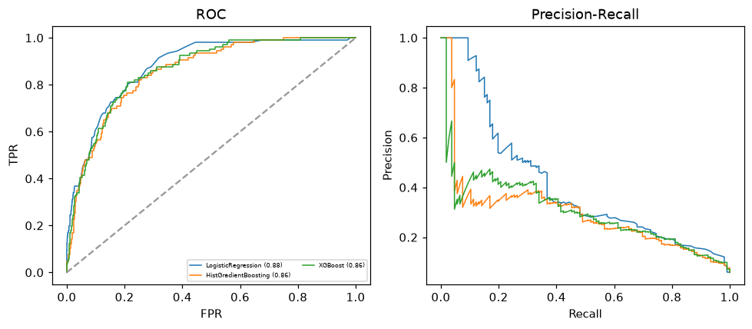

Selected final model — XGBoost (CV combined=0.5925; held-out auROC=0.8647)
Among 3 candidate models, XGBoost achieved the highest cross-validated combined score (0.5925) within the training partition and was selected on that basis. Refitted on the complete training partition and evaluated once on the untouched held-out partition, it reached an area under the receiver operating characteristic curve of 0.8647 and an area under the precision-recall curve of 0.3088.

Threshold analysis (0.1-0.9)
threshold | TP | TN | FP | FN | sensitivity | specificity | PPV | NPV | f1 | accuracy
0.1 | 69.0 | 1465.0 | 229.0 | 37.0 | 0.651 | 0.865 | 0.232 | 0.975 | 0.342 | 0.852
0.2 | 46.0 | 1587.0 | 107.0 | 60.0 | 0.434 | 0.937 | 0.301 | 0.964 | 0.355 | 0.907
0.3 | 32.0 | 1649.0 | 45.0 | 74.0 | 0.302 | 0.973 | 0.416 | 0.957 | 0.35 | 0.934
0.4 | 19.0 | 1670.0 | 24.0 | 87.0 | 0.179 | 0.986 | 0.442 | 0.95 | 0.255 | 0.938
0.5 | 7.0 | 1682.0 | 12.0 | 99.0 | 0.066 | 0.993 | 0.368 | 0.944 | 0.112 | 0.938
0.6 | 5.0 | 1689.0 | 5.0 | 101.0 | 0.047 | 0.997 | 0.5 | 0.944 | 0.086 | 0.941
0.7 | 3.0 | 1692.0 | 2.0 | 103.0 | 0.028 | 0.999 | 0.6 | 0.943 | 0.054 | 0.942
0.8 | 1.0 | 1694.0 | 0.0 | 105.0 | 0.009 | 1.0 | 1.0 | 0.942 | 0.019 | 0.942
0.9 | 1.0 | 1694.0 | 0.0 | 105.0 | 0.009 | 1.0 | 1.0 | 0.942 | 0.019 | 0.942

Calibration
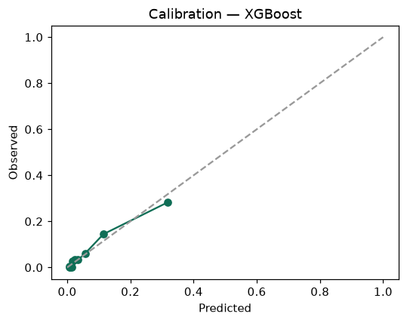

SHAP feature contributions
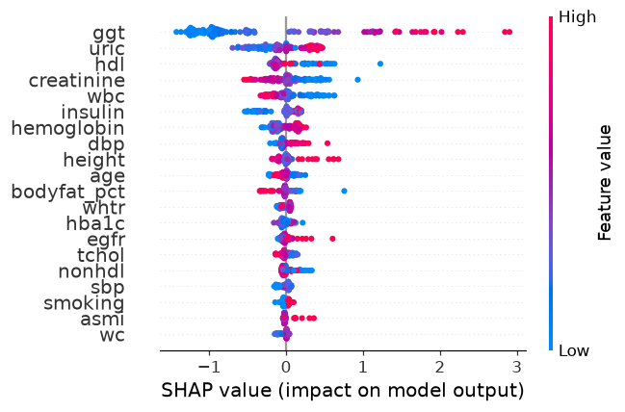

Partial dependence (PDP)
