Machine Learning Prediction Model Report
Outcome: Hepatic steatosis · NHANES · 3 models compared · tuning, full metrics, threshold, SHAP, PDP
[ML] outcome = steatosis

Data summary
Item | Value
N | 4869
Outcome prevalence (%) | 59.6
Features | 31
Models compared | 3
Train/test | 3408/1461 (70/30 stratified)
Auto-excluded leakage | None

Hyperparameter search space
Model | Search space
LogisticRegression | {'C': [0.01, 0.1, 1, 10], 'penalty': ['l1', 'l2']}
HistGradientBoosting | {'learning_rate': [0.03, 0.1], 'max_iter': [200, 400], 'max_depth': [3, 6, None]}
XGBoost | {'n_estimators': [300, 500], 'max_depth': [3, 5], 'learning_rate': [0.03, 0.1], 'subsample': [0.8, 1.0]}

Tuning and model selection — training-partition cross-validation
Hyperparameter search and between-model selection both use these training-partition cross-validated scores. The selection criterion is CV_combined, the mean of the cross-validated auROC and auPRC. The held-out partition is not consulted at this stage.
model | CV_auROC | CV_auPRC | CV_combined | best_params
LogisticRegression | 0.8199 | 0.8579 | 0.8389 | {'penalty': 'l2', 'C': 1}
HistGradientBoosting | 0.8107 | 0.8512 | 0.831 | {'max_iter': 400, 'max_depth': 3, 'learning_rate': 0.03}
XGBoost | 0.8146 | 0.855 | 0.8348 | {'subsample': 0.8, 'n_estimators': 500, 'max_depth': 3, 'learning_rate': 0.03}

Held-out performance metrics
Reported for every candidate for transparency; only the model selected by CV_combined above is the prespecified final model. Rows are ordered by the CV selection criterion.
model | CV_combined | TP | TN | FP | FN | sensitivity | specificity | PPV | NPV | accuracy | balanced_accuracy | f1 | MCC | kappa | auROC | auPRC | logloss | brier | combined
LogisticRegression | 0.8389 | 753 | 366 | 224 | 118 | 0.8645 | 0.6203 | 0.7707 | 0.7562 | 0.7659 | 0.7424 | 0.8149 | 0.5055 | 0.4993 | 0.8318 | 0.8685 | 0.4896 | 0.161 | 0.8501
XGBoost | 0.8348 | 753 | 372 | 218 | 118 | 0.8645 | 0.6305 | 0.7755 | 0.7592 | 0.77 | 0.7475 | 0.8176 | 0.5145 | 0.5089 | 0.8415 | 0.8767 | 0.4761 | 0.1562 | 0.8591
HistGradientBoosting | 0.831 | 751 | 377 | 213 | 120 | 0.8622 | 0.639 | 0.779 | 0.7586 | 0.7721 | 0.7506 | 0.8185 | 0.5191 | 0.5143 | 0.8384 | 0.8722 | 0.4817 | 0.1579 | 0.8553

ROC · Precision-Recall
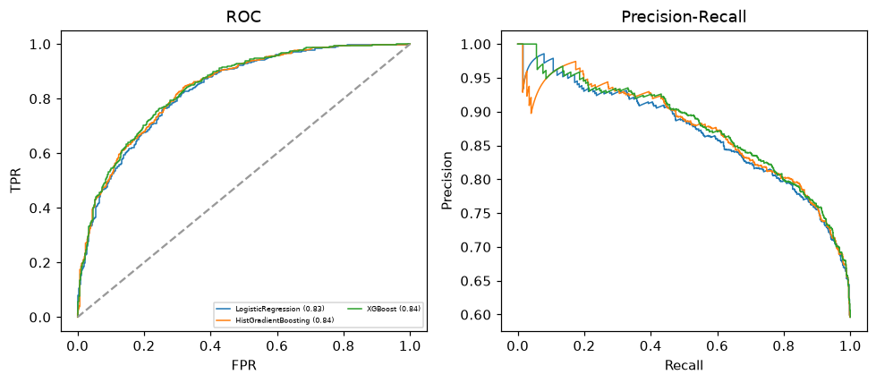

Selected final model — LogisticRegression (CV combined=0.8389; held-out auROC=0.8318)
Among 3 candidate models, LogisticRegression achieved the highest cross-validated combined score (0.8389) within the training partition and was selected on that basis. Refitted on the complete training partition and evaluated once on the untouched held-out partition, it reached an area under the receiver operating characteristic curve of 0.8318 and an area under the precision-recall curve of 0.8685.

Threshold analysis (0.1-0.9)
threshold | TP | TN | FP | FN | sensitivity | specificity | PPV | NPV | f1 | accuracy
0.1 | 868.0 | 75.0 | 515.0 | 3.0 | 0.997 | 0.127 | 0.628 | 0.962 | 0.77 | 0.645
0.2 | 858.0 | 163.0 | 427.0 | 13.0 | 0.985 | 0.276 | 0.668 | 0.926 | 0.796 | 0.699
0.3 | 837.0 | 231.0 | 359.0 | 34.0 | 0.961 | 0.392 | 0.7 | 0.872 | 0.81 | 0.731
0.4 | 807.0 | 295.0 | 295.0 | 64.0 | 0.927 | 0.5 | 0.732 | 0.822 | 0.818 | 0.754
0.5 | 753.0 | 366.0 | 224.0 | 118.0 | 0.865 | 0.62 | 0.771 | 0.756 | 0.815 | 0.766
0.6 | 678.0 | 424.0 | 166.0 | 193.0 | 0.778 | 0.719 | 0.803 | 0.687 | 0.791 | 0.754
0.7 | 548.0 | 489.0 | 101.0 | 323.0 | 0.629 | 0.829 | 0.844 | 0.602 | 0.721 | 0.71
0.8 | 408.0 | 543.0 | 47.0 | 463.0 | 0.468 | 0.92 | 0.897 | 0.54 | 0.615 | 0.651
0.9 | 213.0 | 573.0 | 17.0 | 658.0 | 0.245 | 0.971 | 0.926 | 0.465 | 0.387 | 0.538

Calibration
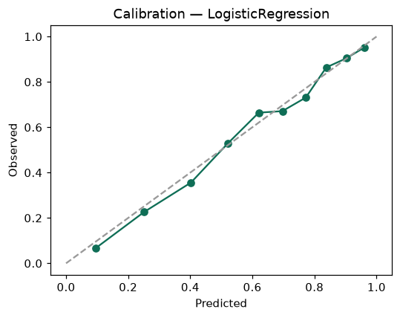

SHAP feature contributions
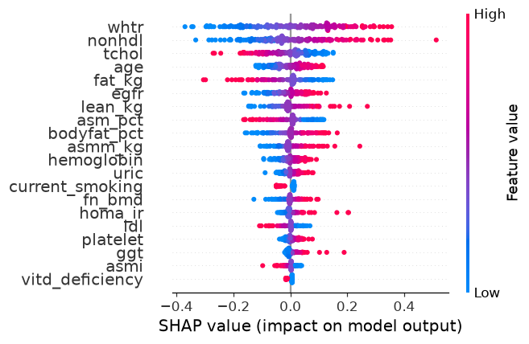

Partial dependence (PDP)
