Machine Learning Prediction Model Report
Outcome: High LDL cholesterol (>=160) · NHANES · 3 models compared · tuning, full metrics, threshold, SHAP, PDP
[ML] outcome = high_ldl

Data summary
Item | Value
N | 6000
Outcome prevalence (%) | 9.5
Features | 56
Models compared | 3
Train/test | 4200/1800 (70/30 stratified)
Auto-excluded leakage | None

Hyperparameter search space
Model | Search space
LogisticRegression | {'C': [0.01, 0.1, 1, 10], 'penalty': ['l1', 'l2']}
HistGradientBoosting | {'learning_rate': [0.03, 0.1], 'max_iter': [200, 400], 'max_depth': [3, 6, None]}
XGBoost | {'n_estimators': [300, 500], 'max_depth': [3, 5], 'learning_rate': [0.03, 0.1], 'subsample': [0.8, 1.0]}

Tuning and model selection — training-partition cross-validation
Hyperparameter search and between-model selection both use these training-partition cross-validated scores. The selection criterion is CV_combined, the mean of the cross-validated auROC and auPRC. The held-out partition is not consulted at this stage.
model | CV_auROC | CV_auPRC | CV_combined | best_params
LogisticRegression | 0.7057 | 0.2002 | 0.4529 | {'penalty': 'l2', 'C': 0.01}
HistGradientBoosting | 0.7141 | 0.1968 | 0.4555 | {'max_iter': 200, 'max_depth': 6, 'learning_rate': 0.03}
XGBoost | 0.7239 | 0.2004 | 0.4621 | {'subsample': 1.0, 'n_estimators': 300, 'max_depth': 3, 'learning_rate': 0.03}

Held-out performance metrics
Reported for every candidate for transparency; only the model selected by CV_combined above is the prespecified final model. Rows are ordered by the CV selection criterion.
model | CV_combined | TP | TN | FP | FN | sensitivity | specificity | PPV | NPV | accuracy | balanced_accuracy | f1 | MCC | kappa | auROC | auPRC | logloss | brier | combined
XGBoost | 0.4621 | 0 | 1628 | 0 | 172 | 0.0 | 1.0 | nan | 0.9044 | 0.9044 | 0.5 | 0.0 | 0.0 | 0.0 | 0.7198 | 0.188 | 0.2895 | 0.0825 | 0.4539
HistGradientBoosting | 0.4555 | 0 | 1627 | 1 | 172 | 0.0 | 0.9994 | 0.0 | 0.9044 | 0.9039 | 0.4997 | 0.0 | -0.0077 | -0.0011 | 0.7102 | 0.1921 | 0.2949 | 0.0832 | 0.4511
LogisticRegression | 0.4529 | 0 | 1628 | 0 | 172 | 0.0 | 1.0 | nan | 0.9044 | 0.9044 | 0.5 | 0.0 | 0.0 | 0.0 | 0.6783 | 0.1655 | 0.3091 | 0.0857 | 0.4219

ROC · Precision-Recall
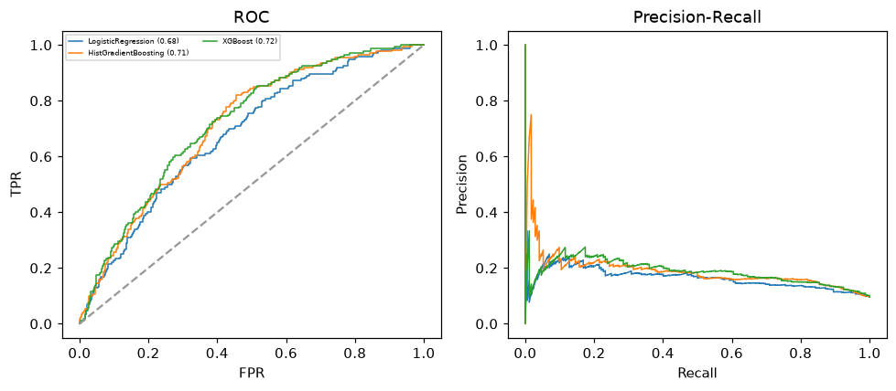

Selected final model — XGBoost (CV combined=0.4621; held-out auROC=0.7198)
Among 3 candidate models, XGBoost achieved the highest cross-validated combined score (0.4621) within the training partition and was selected on that basis. Refitted on the complete training partition and evaluated once on the untouched held-out partition, it reached an area under the receiver operating characteristic curve of 0.7198 and an area under the precision-recall curve of 0.188.

Threshold analysis (0.1-0.9)
threshold | TP | TN | FP | FN | sensitivity | specificity | PPV | NPV | f1 | accuracy
0.1 | 112.0 | 1079.0 | 549.0 | 60.0 | 0.651 | 0.663 | 0.169 | 0.947 | 0.269 | 0.662
0.2 | 39.0 | 1508.0 | 120.0 | 133.0 | 0.227 | 0.926 | 0.245 | 0.919 | 0.236 | 0.859
0.3 | 5.0 | 1600.0 | 28.0 | 167.0 | 0.029 | 0.983 | 0.152 | 0.905 | 0.049 | 0.892
0.4 | 2.0 | 1623.0 | 5.0 | 170.0 | 0.012 | 0.997 | 0.286 | 0.905 | 0.022 | 0.903
0.5 | 0.0 | 1628.0 | 0.0 | 172.0 | 0.0 | 1.0 | nan | 0.904 | 0.0 | 0.904
0.6 | 0.0 | 1628.0 | 0.0 | 172.0 | 0.0 | 1.0 | nan | 0.904 | 0.0 | 0.904
0.7 | 0.0 | 1628.0 | 0.0 | 172.0 | 0.0 | 1.0 | nan | 0.904 | 0.0 | 0.904
0.8 | 0.0 | 1628.0 | 0.0 | 172.0 | 0.0 | 1.0 | nan | 0.904 | 0.0 | 0.904
0.9 | 0.0 | 1628.0 | 0.0 | 172.0 | 0.0 | 1.0 | nan | 0.904 | 0.0 | 0.904

Calibration
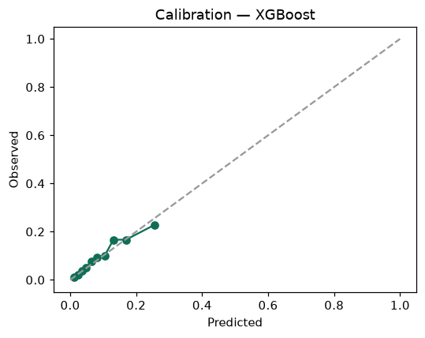

SHAP feature contributions
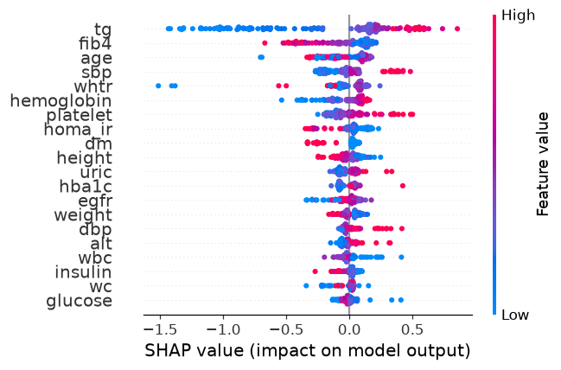

Partial dependence (PDP)
