Machine Learning Prediction Model Report
Outcome: Hypertriglyceridemia (NCEP TG>=150) · NHANES · 3 models compared · tuning, full metrics, threshold, SHAP, PDP
[ML] outcome = high_tg

Data summary
Item | Value
N | 6000
Outcome prevalence (%) | 25.0
Features | 59
Models compared | 3
Train/test | 4200/1800 (70/30 stratified)
Auto-excluded leakage | None

Hyperparameter search space
Model | Search space
LogisticRegression | {'C': [0.01, 0.1, 1, 10], 'penalty': ['l1', 'l2']}
HistGradientBoosting | {'learning_rate': [0.03, 0.1], 'max_iter': [200, 400], 'max_depth': [3, 6, None]}
XGBoost | {'n_estimators': [300, 500], 'max_depth': [3, 5], 'learning_rate': [0.03, 0.1], 'subsample': [0.8, 1.0]}

Tuning and model selection — training-partition cross-validation
Hyperparameter search and between-model selection both use these training-partition cross-validated scores. The selection criterion is CV_combined, the mean of the cross-validated auROC and auPRC. The held-out partition is not consulted at this stage.
model | CV_auROC | CV_auPRC | CV_combined | best_params
LogisticRegression | 0.9965 | 0.9954 | 0.9959 | {'penalty': 'l1', 'C': 1}
HistGradientBoosting | 0.9948 | 0.985 | 0.9899 | {'max_iter': 400, 'max_depth': None, 'learning_rate': 0.1}
XGBoost | 0.9908 | 0.9764 | 0.9836 | {'subsample': 1.0, 'n_estimators': 300, 'max_depth': 3, 'learning_rate': 0.1}

Held-out performance metrics
Reported for every candidate for transparency; only the model selected by CV_combined above is the prespecified final model. Rows are ordered by the CV selection criterion.
model | CV_combined | TP | TN | FP | FN | sensitivity | specificity | PPV | NPV | accuracy | balanced_accuracy | f1 | MCC | kappa | auROC | auPRC | logloss | brier | combined
LogisticRegression | 0.9959 | 434 | 1344 | 7 | 15 | 0.9666 | 0.9948 | 0.9841 | 0.989 | 0.9878 | 0.9807 | 0.9753 | 0.9672 | 0.9672 | 0.9972 | 0.9965 | 0.0524 | 0.0125 | 0.9969
HistGradientBoosting | 0.9899 | 420 | 1329 | 22 | 29 | 0.9354 | 0.9837 | 0.9502 | 0.9786 | 0.9717 | 0.9596 | 0.9428 | 0.924 | 0.9239 | 0.9966 | 0.9901 | 0.0963 | 0.0226 | 0.9934
XGBoost | 0.9836 | 394 | 1337 | 14 | 55 | 0.8775 | 0.9896 | 0.9657 | 0.9605 | 0.9617 | 0.9336 | 0.9195 | 0.8962 | 0.8944 | 0.9932 | 0.9813 | 0.108 | 0.0299 | 0.9873

ROC · Precision-Recall
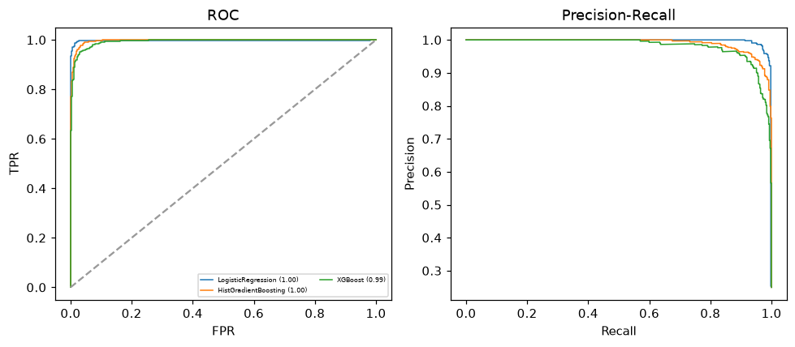

Selected final model — LogisticRegression (CV combined=0.9959; held-out auROC=0.9972)
Among 3 candidate models, LogisticRegression achieved the highest cross-validated combined score (0.9959) within the training partition and was selected on that basis. Refitted on the complete training partition and evaluated once on the untouched held-out partition, it reached an area under the receiver operating characteristic curve of 0.9972 and an area under the precision-recall curve of 0.9965.

Threshold analysis (0.1-0.9)
threshold | TP | TN | FP | FN | sensitivity | specificity | PPV | NPV | f1 | accuracy
0.1 | 448.0 | 1251.0 | 100.0 | 1.0 | 0.998 | 0.926 | 0.818 | 0.999 | 0.899 | 0.944
0.2 | 448.0 | 1284.0 | 67.0 | 1.0 | 0.998 | 0.95 | 0.87 | 0.999 | 0.929 | 0.962
0.3 | 448.0 | 1309.0 | 42.0 | 1.0 | 0.998 | 0.969 | 0.914 | 0.999 | 0.954 | 0.976
0.4 | 442.0 | 1332.0 | 19.0 | 7.0 | 0.984 | 0.986 | 0.959 | 0.995 | 0.971 | 0.986
0.5 | 434.0 | 1344.0 | 7.0 | 15.0 | 0.967 | 0.995 | 0.984 | 0.989 | 0.975 | 0.988
0.6 | 420.0 | 1350.0 | 1.0 | 29.0 | 0.935 | 0.999 | 0.998 | 0.979 | 0.966 | 0.983
0.7 | 407.0 | 1351.0 | 0.0 | 42.0 | 0.906 | 1.0 | 1.0 | 0.97 | 0.951 | 0.977
0.8 | 389.0 | 1351.0 | 0.0 | 60.0 | 0.866 | 1.0 | 1.0 | 0.957 | 0.928 | 0.967
0.9 | 362.0 | 1351.0 | 0.0 | 87.0 | 0.806 | 1.0 | 1.0 | 0.939 | 0.893 | 0.952

Calibration
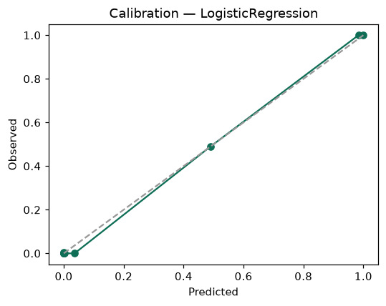

SHAP feature contributions
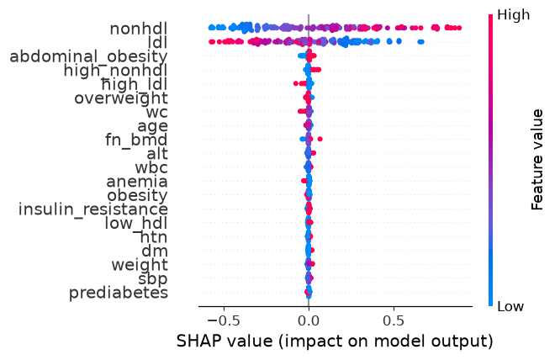

Partial dependence (PDP)
