Machine Learning Prediction Model Report
Outcome: Leukocytosis (WBC>11) · NHANES · 3 models compared · tuning, full metrics, threshold, SHAP, PDP
[ML] outcome = leukocytosis

Data summary
Item | Value
N | 6000
Outcome prevalence (%) | 5.2
Features | 62
Models compared | 3
Train/test | 4200/1800 (70/30 stratified)
Auto-excluded leakage | None

Hyperparameter search space
Model | Search space
LogisticRegression | {'C': [0.01, 0.1, 1, 10], 'penalty': ['l1', 'l2']}
HistGradientBoosting | {'learning_rate': [0.03, 0.1], 'max_iter': [200, 400], 'max_depth': [3, 6, None]}
XGBoost | {'n_estimators': [300, 500], 'max_depth': [3, 5], 'learning_rate': [0.03, 0.1], 'subsample': [0.8, 1.0]}

Tuning and model selection — training-partition cross-validation
Hyperparameter search and between-model selection both use these training-partition cross-validated scores. The selection criterion is CV_combined, the mean of the cross-validated auROC and auPRC. The held-out partition is not consulted at this stage.
model | CV_auROC | CV_auPRC | CV_combined | best_params
LogisticRegression | 0.7575 | 0.1574 | 0.4574 | {'penalty': 'l1', 'C': 0.1}
HistGradientBoosting | 0.7282 | 0.1529 | 0.4405 | {'max_iter': 400, 'max_depth': 3, 'learning_rate': 0.03}
XGBoost | 0.7485 | 0.1595 | 0.454 | {'subsample': 0.8, 'n_estimators': 300, 'max_depth': 5, 'learning_rate': 0.03}

Held-out performance metrics
Reported for every candidate for transparency; only the model selected by CV_combined above is the prespecified final model. Rows are ordered by the CV selection criterion.
model | CV_combined | TP | TN | FP | FN | sensitivity | specificity | PPV | NPV | accuracy | balanced_accuracy | f1 | MCC | kappa | auROC | auPRC | logloss | brier | combined
LogisticRegression | 0.4574 | 0 | 1706 | 0 | 94 | 0.0 | 1.0 | nan | 0.9478 | 0.9478 | 0.5 | 0.0 | 0.0 | 0.0 | 0.8075 | 0.2706 | 0.1711 | 0.0443 | 0.539
XGBoost | 0.454 | 6 | 1704 | 2 | 88 | 0.0638 | 0.9988 | 0.75 | 0.9509 | 0.95 | 0.5313 | 0.1176 | 0.2096 | 0.1104 | 0.8068 | 0.2128 | 0.1774 | 0.046 | 0.5098
HistGradientBoosting | 0.4405 | 1 | 1703 | 3 | 93 | 0.0106 | 0.9982 | 0.25 | 0.9482 | 0.9467 | 0.5044 | 0.0204 | 0.042 | 0.0162 | 0.8021 | 0.1931 | 0.1747 | 0.0461 | 0.4976

ROC · Precision-Recall
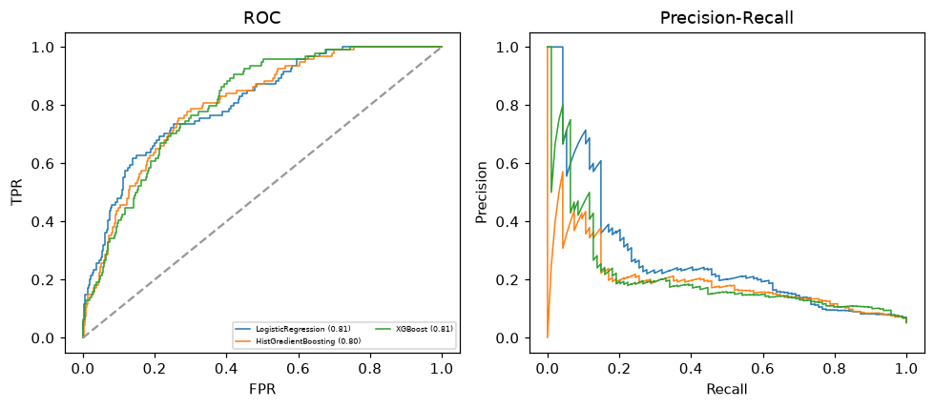

Selected final model — LogisticRegression (CV combined=0.4574; held-out auROC=0.8075)
Among 3 candidate models, LogisticRegression achieved the highest cross-validated combined score (0.4574) within the training partition and was selected on that basis. Refitted on the complete training partition and evaluated once on the untouched held-out partition, it reached an area under the receiver operating characteristic curve of 0.8075 and an area under the precision-recall curve of 0.2706.

Threshold analysis (0.1-0.9)
threshold | TP | TN | FP | FN | sensitivity | specificity | PPV | NPV | f1 | accuracy
0.1 | 53.0 | 1504.0 | 202.0 | 41.0 | 0.564 | 0.882 | 0.208 | 0.973 | 0.304 | 0.865
0.2 | 19.0 | 1674.0 | 32.0 | 75.0 | 0.202 | 0.981 | 0.373 | 0.957 | 0.262 | 0.941
0.3 | 11.0 | 1700.0 | 6.0 | 83.0 | 0.117 | 0.996 | 0.647 | 0.953 | 0.198 | 0.951
0.4 | 4.0 | 1704.0 | 2.0 | 90.0 | 0.043 | 0.999 | 0.667 | 0.95 | 0.08 | 0.949
0.5 | 0.0 | 1706.0 | 0.0 | 94.0 | 0.0 | 1.0 | nan | 0.948 | 0.0 | 0.948
0.6 | 0.0 | 1706.0 | 0.0 | 94.0 | 0.0 | 1.0 | nan | 0.948 | 0.0 | 0.948
0.7 | 0.0 | 1706.0 | 0.0 | 94.0 | 0.0 | 1.0 | nan | 0.948 | 0.0 | 0.948
0.8 | 0.0 | 1706.0 | 0.0 | 94.0 | 0.0 | 1.0 | nan | 0.948 | 0.0 | 0.948
0.9 | 0.0 | 1706.0 | 0.0 | 94.0 | 0.0 | 1.0 | nan | 0.948 | 0.0 | 0.948

Calibration
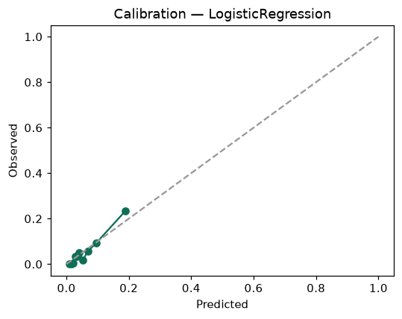

SHAP feature contributions
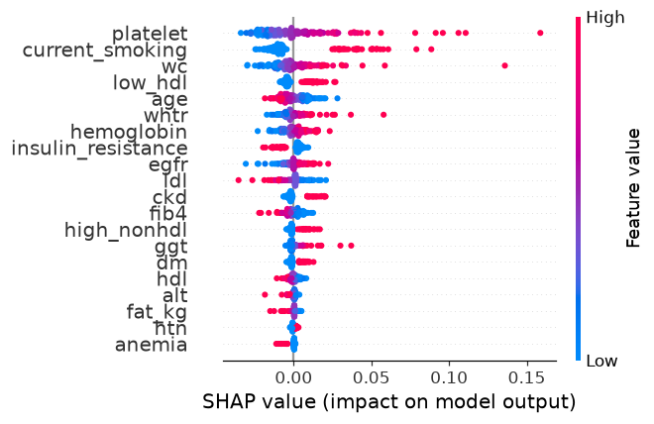

Partial dependence (PDP)
