Machine Learning Prediction Model Report
Outcome: Osteoporosis (T-score<=-2.5, age>=50) · NHANES · 3 models compared · tuning, full metrics, threshold, SHAP, PDP
[ML] outcome = osteoporosis

Data summary
Item | Value
N | 6000
Outcome prevalence (%) | 9.0
Features | 54
Models compared | 3
Train/test | 4200/1800 (70/30 stratified)
Auto-excluded leakage | None

Hyperparameter search space
Model | Search space
LogisticRegression | {'C': [0.01, 0.1, 1, 10], 'penalty': ['l1', 'l2']}
HistGradientBoosting | {'learning_rate': [0.03, 0.1], 'max_iter': [200, 400], 'max_depth': [3, 6, None]}
XGBoost | {'n_estimators': [300, 500], 'max_depth': [3, 5], 'learning_rate': [0.03, 0.1], 'subsample': [0.8, 1.0]}

Tuning and model selection — training-partition cross-validation
Hyperparameter search and between-model selection both use these training-partition cross-validated scores. The selection criterion is CV_combined, the mean of the cross-validated auROC and auPRC. The held-out partition is not consulted at this stage.
model | CV_auROC | CV_auPRC | CV_combined | best_params
LogisticRegression | 0.8281 | 0.3705 | 0.5993 | {'penalty': 'l1', 'C': 0.1}
HistGradientBoosting | 0.8023 | 0.3269 | 0.5646 | {'max_iter': 200, 'max_depth': 6, 'learning_rate': 0.03}
XGBoost | 0.811 | 0.3434 | 0.5772 | {'subsample': 1.0, 'n_estimators': 300, 'max_depth': 3, 'learning_rate': 0.03}

Held-out performance metrics
Reported for every candidate for transparency; only the model selected by CV_combined above is the prespecified final model. Rows are ordered by the CV selection criterion.
model | CV_combined | TP | TN | FP | FN | sensitivity | specificity | PPV | NPV | accuracy | balanced_accuracy | f1 | MCC | kappa | auROC | auPRC | logloss | brier | combined
LogisticRegression | 0.5993 | 9 | 1626 | 12 | 153 | 0.0556 | 0.9927 | 0.4286 | 0.914 | 0.9083 | 0.5241 | 0.0984 | 0.1285 | 0.0793 | 0.824 | 0.3346 | 0.2425 | 0.0696 | 0.5793
XGBoost | 0.5772 | 18 | 1621 | 17 | 144 | 0.1111 | 0.9896 | 0.5143 | 0.9184 | 0.9106 | 0.5504 | 0.1827 | 0.2088 | 0.1557 | 0.8101 | 0.3491 | 0.246 | 0.07 | 0.5796
HistGradientBoosting | 0.5646 | 20 | 1617 | 21 | 142 | 0.1235 | 0.9872 | 0.4878 | 0.9193 | 0.9094 | 0.5553 | 0.197 | 0.2122 | 0.1668 | 0.8116 | 0.3317 | 0.2498 | 0.071 | 0.5716

ROC · Precision-Recall
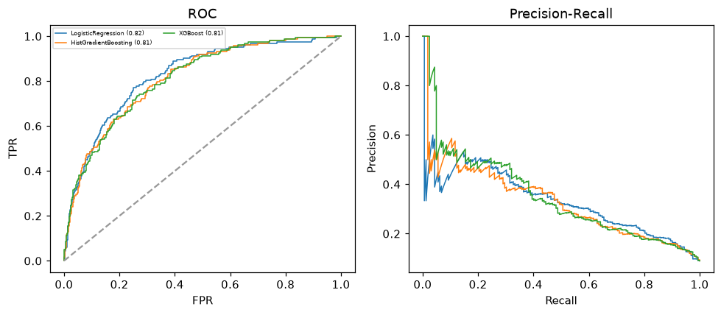

Selected final model — LogisticRegression (CV combined=0.5993; held-out auROC=0.824)
Among 3 candidate models, LogisticRegression achieved the highest cross-validated combined score (0.5993) within the training partition and was selected on that basis. Refitted on the complete training partition and evaluated once on the untouched held-out partition, it reached an area under the receiver operating characteristic curve of 0.824 and an area under the precision-recall curve of 0.3346.

Threshold analysis (0.1-0.9)
threshold | TP | TN | FP | FN | sensitivity | specificity | PPV | NPV | f1 | accuracy
0.1 | 125.0 | 1213.0 | 425.0 | 37.0 | 0.772 | 0.741 | 0.227 | 0.97 | 0.351 | 0.743
0.2 | 79.0 | 1484.0 | 154.0 | 83.0 | 0.488 | 0.906 | 0.339 | 0.947 | 0.4 | 0.868
0.3 | 46.0 | 1581.0 | 57.0 | 116.0 | 0.284 | 0.965 | 0.447 | 0.932 | 0.347 | 0.904
0.4 | 26.0 | 1611.0 | 27.0 | 136.0 | 0.16 | 0.984 | 0.491 | 0.922 | 0.242 | 0.909
0.5 | 9.0 | 1626.0 | 12.0 | 153.0 | 0.056 | 0.993 | 0.429 | 0.914 | 0.098 | 0.908
0.6 | 5.0 | 1634.0 | 4.0 | 157.0 | 0.031 | 0.998 | 0.556 | 0.912 | 0.058 | 0.911
0.7 | 1.0 | 1637.0 | 1.0 | 161.0 | 0.006 | 0.999 | 0.5 | 0.91 | 0.012 | 0.91
0.8 | 1.0 | 1638.0 | 0.0 | 161.0 | 0.006 | 1.0 | 1.0 | 0.911 | 0.012 | 0.911
0.9 | 0.0 | 1638.0 | 0.0 | 162.0 | 0.0 | 1.0 | nan | 0.91 | 0.0 | 0.91

Calibration
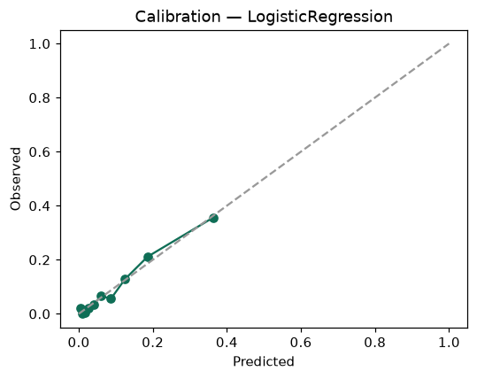

SHAP feature contributions
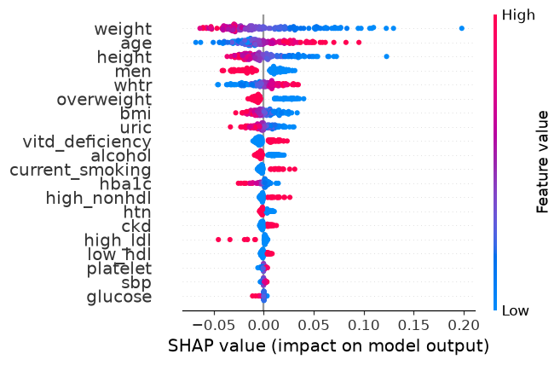

Partial dependence (PDP)
