Machine Learning Prediction Model Report
Outcome: Prediabetes · NHANES · 3 models compared · tuning, full metrics, threshold, SHAP, PDP
[ML] outcome = prediabetes

Data summary
Item | Value
N | 6000
Outcome prevalence (%) | 33.9
Features | 56
Models compared | 3
Train/test | 4200/1800 (70/30 stratified)
Auto-excluded leakage | None

Hyperparameter search space
Model | Search space
LogisticRegression | {'C': [0.01, 0.1, 1, 10], 'penalty': ['l1', 'l2']}
HistGradientBoosting | {'learning_rate': [0.03, 0.1], 'max_iter': [200, 400], 'max_depth': [3, 6, None]}
XGBoost | {'n_estimators': [300, 500], 'max_depth': [3, 5], 'learning_rate': [0.03, 0.1], 'subsample': [0.8, 1.0]}

Tuning and model selection — training-partition cross-validation
Hyperparameter search and between-model selection both use these training-partition cross-validated scores. The selection criterion is CV_combined, the mean of the cross-validated auROC and auPRC. The held-out partition is not consulted at this stage.
model | CV_auROC | CV_auPRC | CV_combined | best_params
LogisticRegression | 0.6533 | 0.4619 | 0.5576 | {'penalty': 'l1', 'C': 10}
HistGradientBoosting | 0.6886 | 0.5088 | 0.5987 | {'max_iter': 400, 'max_depth': 3, 'learning_rate': 0.03}
XGBoost | 0.6935 | 0.5143 | 0.6039 | {'subsample': 1.0, 'n_estimators': 300, 'max_depth': 3, 'learning_rate': 0.03}

Held-out performance metrics
Reported for every candidate for transparency; only the model selected by CV_combined above is the prespecified final model. Rows are ordered by the CV selection criterion.
model | CV_combined | TP | TN | FP | FN | sensitivity | specificity | PPV | NPV | accuracy | balanced_accuracy | f1 | MCC | kappa | auROC | auPRC | logloss | brier | combined
XGBoost | 0.6039 | 192 | 1035 | 154 | 419 | 0.3142 | 0.8705 | 0.5549 | 0.7118 | 0.6817 | 0.5924 | 0.4013 | 0.222 | 0.2065 | 0.7248 | 0.5411 | 0.5694 | 0.1945 | 0.633
HistGradientBoosting | 0.5987 | 206 | 1036 | 153 | 405 | 0.3372 | 0.8713 | 0.5738 | 0.7189 | 0.69 | 0.6042 | 0.4247 | 0.247 | 0.2317 | 0.7214 | 0.5351 | 0.5704 | 0.195 | 0.6282
LogisticRegression | 0.5576 | 152 | 1071 | 118 | 459 | 0.2488 | 0.9008 | 0.563 | 0.7 | 0.6794 | 0.5748 | 0.3451 | 0.1983 | 0.173 | 0.6905 | 0.4971 | 0.5939 | 0.2033 | 0.5938

ROC · Precision-Recall
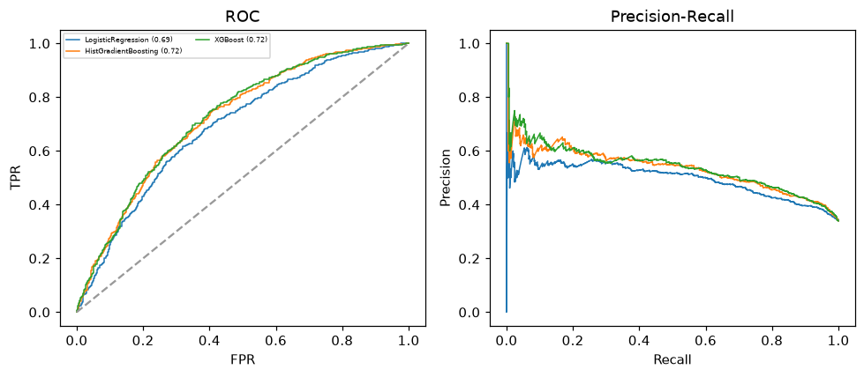

Selected final model — XGBoost (CV combined=0.6039; held-out auROC=0.7248)
Among 3 candidate models, XGBoost achieved the highest cross-validated combined score (0.6039) within the training partition and was selected on that basis. Refitted on the complete training partition and evaluated once on the untouched held-out partition, it reached an area under the receiver operating characteristic curve of 0.7248 and an area under the precision-recall curve of 0.5411.

Threshold analysis (0.1-0.9)
threshold | TP | TN | FP | FN | sensitivity | specificity | PPV | NPV | f1 | accuracy
0.1 | 606.0 | 110.0 | 1079.0 | 5.0 | 0.992 | 0.093 | 0.36 | 0.957 | 0.528 | 0.398
0.2 | 580.0 | 315.0 | 874.0 | 31.0 | 0.949 | 0.265 | 0.399 | 0.91 | 0.562 | 0.497
0.3 | 493.0 | 618.0 | 571.0 | 118.0 | 0.807 | 0.52 | 0.463 | 0.84 | 0.589 | 0.617
0.4 | 355.0 | 882.0 | 307.0 | 256.0 | 0.581 | 0.742 | 0.536 | 0.775 | 0.558 | 0.687
0.5 | 192.0 | 1035.0 | 154.0 | 419.0 | 0.314 | 0.87 | 0.555 | 0.712 | 0.401 | 0.682
0.6 | 73.0 | 1147.0 | 42.0 | 538.0 | 0.119 | 0.965 | 0.635 | 0.681 | 0.201 | 0.678
0.7 | 8.0 | 1184.0 | 5.0 | 603.0 | 0.013 | 0.996 | 0.615 | 0.663 | 0.026 | 0.662
0.8 | 0.0 | 1189.0 | 0.0 | 611.0 | 0.0 | 1.0 | nan | 0.661 | 0.0 | 0.661
0.9 | 0.0 | 1189.0 | 0.0 | 611.0 | 0.0 | 1.0 | nan | 0.661 | 0.0 | 0.661

Calibration
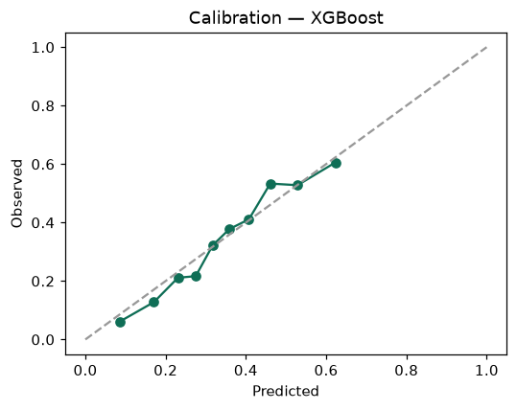

SHAP feature contributions
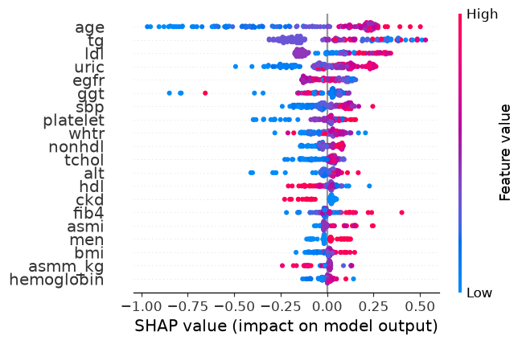

Partial dependence (PDP)
