Machine Learning Prediction Model Report
Outcome: Abdominal obesity · KNHANES · 3 models compared · tuning, full metrics, threshold, SHAP, PDP
[ML] outcome = abdominal_obesity

Data summary
Item | Value
N | 6000
Outcome prevalence (%) | 32.2
Features | 43
Models compared | 3
Train/test | 4200/1800 (70/30 stratified)
Auto-excluded leakage | None

Hyperparameter search space
Model | Search space
LogisticRegression | {'C': [0.01, 0.1, 1, 10], 'penalty': ['l1', 'l2']}
HistGradientBoosting | {'learning_rate': [0.03, 0.1], 'max_iter': [200, 400], 'max_depth': [3, 6, None]}
XGBoost | {'n_estimators': [300, 500], 'max_depth': [3, 5], 'learning_rate': [0.03, 0.1], 'subsample': [0.8, 1.0]}

Tuning results — best parameters and CV auROC
model | CV_auROC | best_params
LogisticRegression | 0.9005 | {'penalty': 'l1', 'C': 10}
HistGradientBoosting | 0.9097 | {'max_iter': 200, 'max_depth': 3, 'learning_rate': 0.1}
XGBoost | 0.9135 | {'subsample': 0.8, 'n_estimators': 500, 'max_depth': 3, 'learning_rate': 0.03}

Full performance metrics (test set)
model | TP | TN | FP | FN | sensitivity | specificity | PPV | NPV | accuracy | balanced_accuracy | f1 | MCC | kappa | auROC | auPRC | logloss | brier | combined
HistGradientBoosting | 408 | 1103 | 118 | 171 | 0.7047 | 0.9034 | 0.7757 | 0.8658 | 0.8394 | 0.804 | 0.7385 | 0.6245 | 0.623 | 0.9196 | 0.8492 | 0.3301 | 0.1061 | 0.8844
XGBoost | 418 | 1098 | 123 | 161 | 0.7219 | 0.8993 | 0.7726 | 0.8721 | 0.8422 | 0.8106 | 0.7464 | 0.6329 | 0.6321 | 0.9191 | 0.849 | 0.3328 | 0.1069 | 0.8841
LogisticRegression | 387 | 1108 | 113 | 192 | 0.6684 | 0.9075 | 0.774 | 0.8523 | 0.8306 | 0.7879 | 0.7173 | 0.6005 | 0.5973 | 0.9098 | 0.8392 | 0.353 | 0.112 | 0.8745

ROC · Precision-Recall
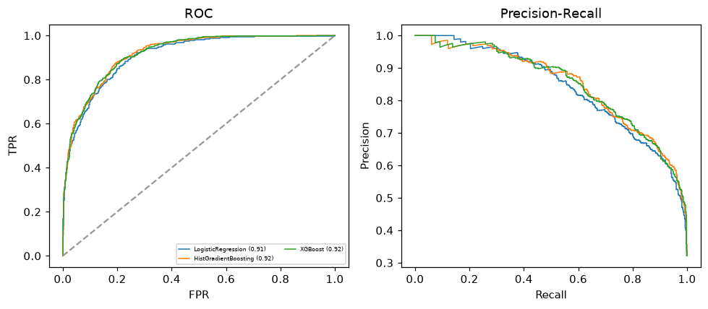

Selected final model — HistGradientBoosting (combined=0.8844)
Among 3 candidate models, HistGradientBoosting achieved the highest combined score, with an area under the receiver operating characteristic curve of 0.9196 and area under the precision-recall curve of 0.8492.

Threshold analysis (0.1-0.9)
threshold | TP | TN | FP | FN | sensitivity | specificity | PPV | NPV | f1 | accuracy
0.1 | 563.0 | 721.0 | 500.0 | 16.0 | 0.972 | 0.59 | 0.53 | 0.978 | 0.686 | 0.713
0.2 | 542.0 | 869.0 | 352.0 | 37.0 | 0.936 | 0.712 | 0.606 | 0.959 | 0.736 | 0.784
0.3 | 515.0 | 953.0 | 268.0 | 64.0 | 0.889 | 0.781 | 0.658 | 0.937 | 0.756 | 0.816
0.4 | 466.0 | 1027.0 | 194.0 | 113.0 | 0.805 | 0.841 | 0.706 | 0.901 | 0.752 | 0.829
0.5 | 408.0 | 1103.0 | 118.0 | 171.0 | 0.705 | 0.903 | 0.776 | 0.866 | 0.738 | 0.839
0.6 | 355.0 | 1162.0 | 59.0 | 224.0 | 0.613 | 0.952 | 0.857 | 0.838 | 0.715 | 0.843
0.7 | 290.0 | 1183.0 | 38.0 | 289.0 | 0.501 | 0.969 | 0.884 | 0.804 | 0.639 | 0.818
0.8 | 224.0 | 1204.0 | 17.0 | 355.0 | 0.387 | 0.986 | 0.929 | 0.772 | 0.546 | 0.793
0.9 | 136.0 | 1217.0 | 4.0 | 443.0 | 0.235 | 0.997 | 0.971 | 0.733 | 0.378 | 0.752

Calibration
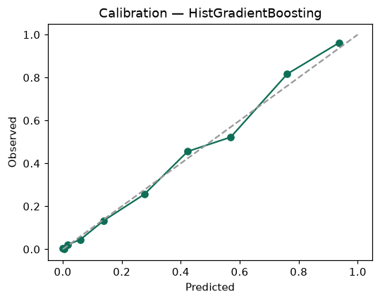

SHAP feature contributions
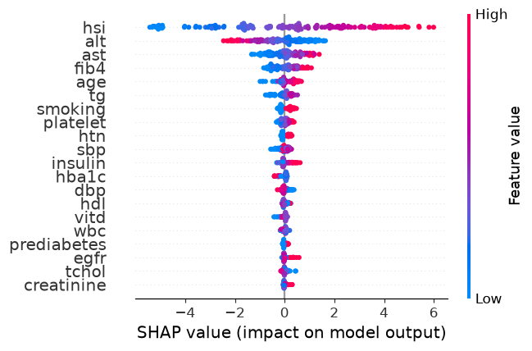

Partial dependence (PDP)
