Machine Learning Prediction Model Report
Outcome: Anemia (WHO) · KNHANES · 3 models compared · tuning, full metrics, threshold, SHAP, PDP
[ML] outcome = anemia

Data summary
Item | Value
N | 6000
Outcome prevalence (%) | 9.9
Features | 49
Models compared | 3
Train/test | 4200/1800 (70/30 stratified)
Auto-excluded leakage | None

Hyperparameter search space
Model | Search space
LogisticRegression | {'C': [0.01, 0.1, 1, 10], 'penalty': ['l1', 'l2']}
HistGradientBoosting | {'learning_rate': [0.03, 0.1], 'max_iter': [200, 400], 'max_depth': [3, 6, None]}
XGBoost | {'n_estimators': [300, 500], 'max_depth': [3, 5], 'learning_rate': [0.03, 0.1], 'subsample': [0.8, 1.0]}

Tuning results — best parameters and CV auROC
model | CV_auROC | best_params
LogisticRegression | 0.7457 | {'penalty': 'l1', 'C': 1}
HistGradientBoosting | 0.7698 | {'max_iter': 400, 'max_depth': 3, 'learning_rate': 0.03}
XGBoost | 0.7762 | {'subsample': 1.0, 'n_estimators': 300, 'max_depth': 3, 'learning_rate': 0.03}

Full performance metrics (test set)
model | TP | TN | FP | FN | sensitivity | specificity | PPV | NPV | accuracy | balanced_accuracy | f1 | MCC | kappa | auROC | auPRC | logloss | brier | combined
XGBoost | 15 | 1610 | 12 | 163 | 0.0843 | 0.9926 | 0.5556 | 0.9081 | 0.9028 | 0.5384 | 0.1463 | 0.1888 | 0.1235 | 0.7978 | 0.3067 | 0.2697 | 0.079 | 0.5523
HistGradientBoosting | 15 | 1603 | 19 | 163 | 0.0843 | 0.9883 | 0.4412 | 0.9077 | 0.8989 | 0.5363 | 0.1415 | 0.1591 | 0.1134 | 0.795 | 0.2946 | 0.2718 | 0.08 | 0.5448
LogisticRegression | 9 | 1609 | 13 | 169 | 0.0506 | 0.992 | 0.4091 | 0.9049 | 0.8989 | 0.5213 | 0.09 | 0.1156 | 0.0698 | 0.7674 | 0.252 | 0.281 | 0.082 | 0.5097

ROC · Precision-Recall
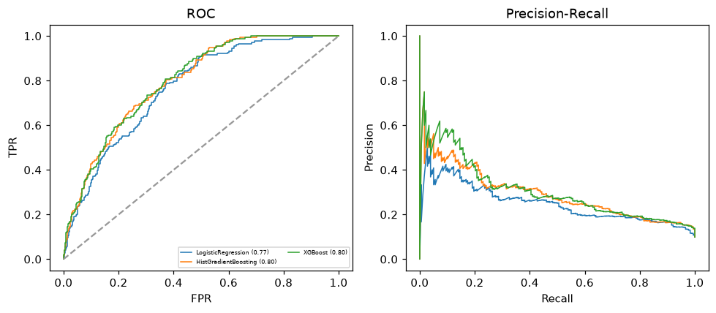

Selected final model — XGBoost (combined=0.5523)
Among 3 candidate models, XGBoost achieved the highest combined score, with an area under the receiver operating characteristic curve of 0.7978 and area under the precision-recall curve of 0.3067.

Threshold analysis (0.1-0.9)
threshold | TP | TN | FP | FN | sensitivity | specificity | PPV | NPV | f1 | accuracy
0.1 | 123.0 | 1170.0 | 452.0 | 55.0 | 0.691 | 0.721 | 0.214 | 0.955 | 0.327 | 0.718
0.2 | 64.0 | 1488.0 | 134.0 | 114.0 | 0.36 | 0.917 | 0.323 | 0.929 | 0.34 | 0.862
0.3 | 37.0 | 1563.0 | 59.0 | 141.0 | 0.208 | 0.964 | 0.385 | 0.917 | 0.27 | 0.889
0.4 | 26.0 | 1599.0 | 23.0 | 152.0 | 0.146 | 0.986 | 0.531 | 0.913 | 0.229 | 0.903
0.5 | 15.0 | 1610.0 | 12.0 | 163.0 | 0.084 | 0.993 | 0.556 | 0.908 | 0.146 | 0.903
0.6 | 7.0 | 1615.0 | 7.0 | 171.0 | 0.039 | 0.996 | 0.5 | 0.904 | 0.073 | 0.901
0.7 | 4.0 | 1618.0 | 4.0 | 174.0 | 0.022 | 0.998 | 0.5 | 0.903 | 0.043 | 0.901
0.8 | 2.0 | 1621.0 | 1.0 | 176.0 | 0.011 | 0.999 | 0.667 | 0.902 | 0.022 | 0.902
0.9 | 0.0 | 1621.0 | 1.0 | 178.0 | 0.0 | 0.999 | 0.0 | 0.901 | 0.0 | 0.901

Calibration
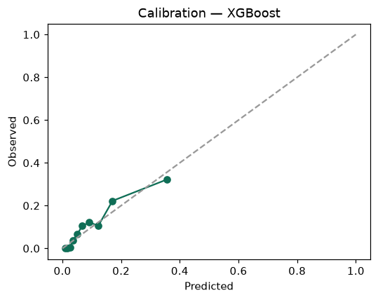

SHAP feature contributions
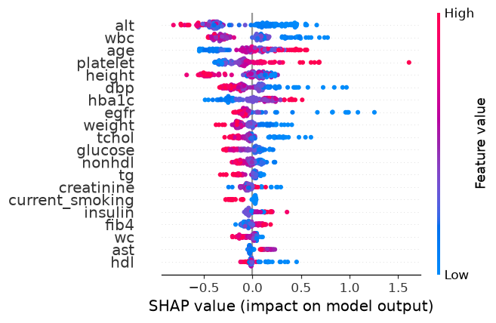

Partial dependence (PDP)
