Machine Learning Prediction Model Report
Outcome: Central obesity (WHtR>=0.5) · KNHANES · 3 models compared · tuning, full metrics, threshold, SHAP, PDP
[ML] outcome = central_obesity

Data summary
Item | Value
N | 6000
Outcome prevalence (%) | 54.0
Features | 43
Models compared | 3
Train/test | 4200/1800 (70/30 stratified)
Auto-excluded leakage | None

Hyperparameter search space
Model | Search space
LogisticRegression | {'C': [0.01, 0.1, 1, 10], 'penalty': ['l1', 'l2']}
HistGradientBoosting | {'learning_rate': [0.03, 0.1], 'max_iter': [200, 400], 'max_depth': [3, 6, None]}
XGBoost | {'n_estimators': [300, 500], 'max_depth': [3, 5], 'learning_rate': [0.03, 0.1], 'subsample': [0.8, 1.0]}

Tuning results — best parameters and CV auROC
model | CV_auROC | best_params
LogisticRegression | 0.9272 | {'penalty': 'l1', 'C': 1}
HistGradientBoosting | 0.9261 | {'max_iter': 200, 'max_depth': 3, 'learning_rate': 0.1}
XGBoost | 0.9264 | {'subsample': 0.8, 'n_estimators': 500, 'max_depth': 3, 'learning_rate': 0.03}

Full performance metrics (test set)
model | TP | TN | FP | FN | sensitivity | specificity | PPV | NPV | accuracy | balanced_accuracy | f1 | MCC | kappa | auROC | auPRC | logloss | brier | combined
HistGradientBoosting | 842 | 675 | 153 | 130 | 0.8663 | 0.8152 | 0.8462 | 0.8385 | 0.8428 | 0.8407 | 0.8561 | 0.6831 | 0.6829 | 0.9272 | 0.9372 | 0.3394 | 0.1088 | 0.9322
XGBoost | 847 | 674 | 154 | 125 | 0.8714 | 0.814 | 0.8462 | 0.8436 | 0.845 | 0.8427 | 0.8586 | 0.6876 | 0.6872 | 0.9268 | 0.9367 | 0.3415 | 0.1094 | 0.9317
LogisticRegression | 826 | 681 | 147 | 146 | 0.8498 | 0.8225 | 0.8489 | 0.8235 | 0.8372 | 0.8361 | 0.8494 | 0.6723 | 0.6723 | 0.9248 | 0.9326 | 0.3492 | 0.1108 | 0.9287

ROC · Precision-Recall
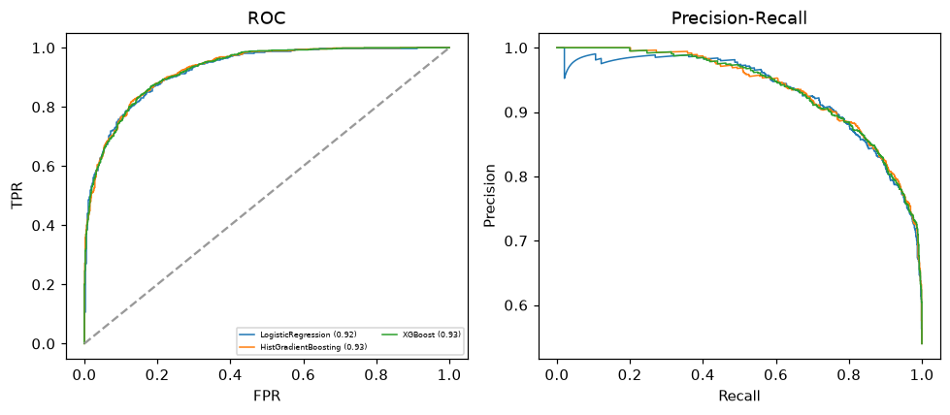

Selected final model — HistGradientBoosting (combined=0.9322)
Among 3 candidate models, HistGradientBoosting achieved the highest combined score, with an area under the receiver operating characteristic curve of 0.9272 and area under the precision-recall curve of 0.9372.

Threshold analysis (0.1-0.9)
threshold | TP | TN | FP | FN | sensitivity | specificity | PPV | NPV | f1 | accuracy
0.1 | 961.0 | 428.0 | 400.0 | 11.0 | 0.989 | 0.517 | 0.706 | 0.975 | 0.824 | 0.772
0.2 | 940.0 | 521.0 | 307.0 | 32.0 | 0.967 | 0.629 | 0.754 | 0.942 | 0.847 | 0.812
0.3 | 912.0 | 583.0 | 245.0 | 60.0 | 0.938 | 0.704 | 0.788 | 0.907 | 0.857 | 0.831
0.4 | 880.0 | 627.0 | 201.0 | 92.0 | 0.905 | 0.757 | 0.814 | 0.872 | 0.857 | 0.837
0.5 | 842.0 | 675.0 | 153.0 | 130.0 | 0.866 | 0.815 | 0.846 | 0.839 | 0.856 | 0.843
0.6 | 806.0 | 710.0 | 118.0 | 166.0 | 0.829 | 0.857 | 0.872 | 0.811 | 0.85 | 0.842
0.7 | 745.0 | 743.0 | 85.0 | 227.0 | 0.766 | 0.897 | 0.898 | 0.766 | 0.827 | 0.827
0.8 | 665.0 | 777.0 | 51.0 | 307.0 | 0.684 | 0.938 | 0.929 | 0.717 | 0.788 | 0.801
0.9 | 489.0 | 812.0 | 16.0 | 483.0 | 0.503 | 0.981 | 0.968 | 0.627 | 0.662 | 0.723

Calibration
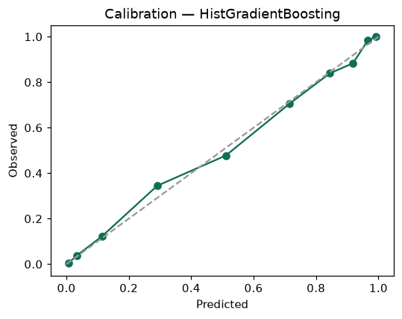

SHAP feature contributions
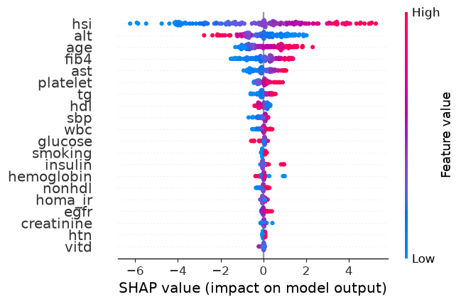

Partial dependence (PDP)
