Machine Learning Prediction Model Report
Outcome: Chronic kidney disease (KDIGO: eGFR<60 or ACR>=30) · KNHANES · 3 models compared · tuning, full metrics, threshold, SHAP, PDP
[ML] outcome = ckd

Data summary
Item | Value
N | 6000
Outcome prevalence (%) | 9.6
Features | 44
Models compared | 3
Train/test | 4200/1800 (70/30 stratified)
Auto-excluded leakage | None

Hyperparameter search space
Model | Search space
LogisticRegression | {'C': [0.01, 0.1, 1, 10], 'penalty': ['l1', 'l2']}
HistGradientBoosting | {'learning_rate': [0.03, 0.1], 'max_iter': [200, 400], 'max_depth': [3, 6, None]}
XGBoost | {'n_estimators': [300, 500], 'max_depth': [3, 5], 'learning_rate': [0.03, 0.1], 'subsample': [0.8, 1.0]}

Tuning results — best parameters and CV auROC
model | CV_auROC | best_params
LogisticRegression | 0.7861 | {'penalty': 'l2', 'C': 0.01}
HistGradientBoosting | 0.7687 | {'max_iter': 400, 'max_depth': 3, 'learning_rate': 0.03}
XGBoost | 0.7777 | {'subsample': 1.0, 'n_estimators': 300, 'max_depth': 3, 'learning_rate': 0.03}

Full performance metrics (test set)
model | TP | TN | FP | FN | sensitivity | specificity | PPV | NPV | accuracy | balanced_accuracy | f1 | MCC | kappa | auROC | auPRC | logloss | brier | combined
LogisticRegression | 12 | 1622 | 6 | 160 | 0.0698 | 0.9963 | 0.6667 | 0.9102 | 0.9078 | 0.533 | 0.1263 | 0.1952 | 0.1102 | 0.8128 | 0.3523 | 0.274 | 0.0758 | 0.5826
XGBoost | 18 | 1613 | 15 | 154 | 0.1047 | 0.9908 | 0.5455 | 0.9128 | 0.9061 | 0.5477 | 0.1756 | 0.2091 | 0.1494 | 0.8007 | 0.3337 | 0.2605 | 0.075 | 0.5672
HistGradientBoosting | 19 | 1611 | 17 | 153 | 0.1105 | 0.9896 | 0.5278 | 0.9133 | 0.9056 | 0.55 | 0.1827 | 0.21 | 0.1547 | 0.7955 | 0.3254 | 0.263 | 0.0754 | 0.5604

ROC · Precision-Recall
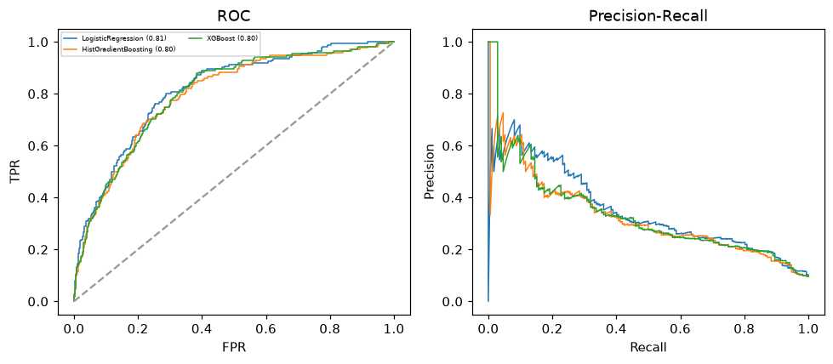

Selected final model — LogisticRegression (combined=0.5826)
Among 3 candidate models, LogisticRegression achieved the highest combined score, with an area under the receiver operating characteristic curve of 0.8128 and area under the precision-recall curve of 0.3523.

Threshold analysis (0.1-0.9)
threshold | TP | TN | FP | FN | sensitivity | specificity | PPV | NPV | f1 | accuracy
0.1 | 157.0 | 810.0 | 818.0 | 15.0 | 0.913 | 0.498 | 0.161 | 0.982 | 0.274 | 0.537
0.2 | 101.0 | 1352.0 | 276.0 | 71.0 | 0.587 | 0.83 | 0.268 | 0.95 | 0.368 | 0.807
0.3 | 55.0 | 1545.0 | 83.0 | 117.0 | 0.32 | 0.949 | 0.399 | 0.93 | 0.355 | 0.889
0.4 | 32.0 | 1601.0 | 27.0 | 140.0 | 0.186 | 0.983 | 0.542 | 0.92 | 0.277 | 0.907
0.5 | 12.0 | 1622.0 | 6.0 | 160.0 | 0.07 | 0.996 | 0.667 | 0.91 | 0.126 | 0.908
0.6 | 2.0 | 1627.0 | 1.0 | 170.0 | 0.012 | 0.999 | 0.667 | 0.905 | 0.023 | 0.905
0.7 | 0.0 | 1627.0 | 1.0 | 172.0 | 0.0 | 0.999 | 0.0 | 0.904 | 0.0 | 0.904
0.8 | 0.0 | 1628.0 | 0.0 | 172.0 | 0.0 | 1.0 | nan | 0.904 | 0.0 | 0.904
0.9 | 0.0 | 1628.0 | 0.0 | 172.0 | 0.0 | 1.0 | nan | 0.904 | 0.0 | 0.904

Calibration
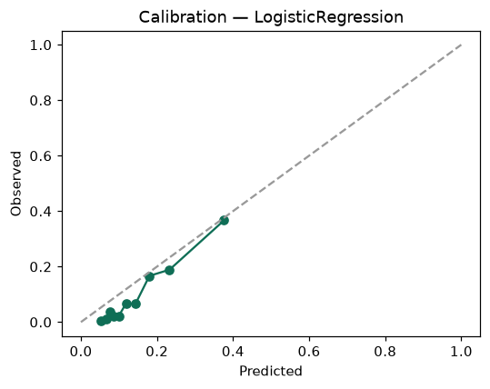

SHAP feature contributions
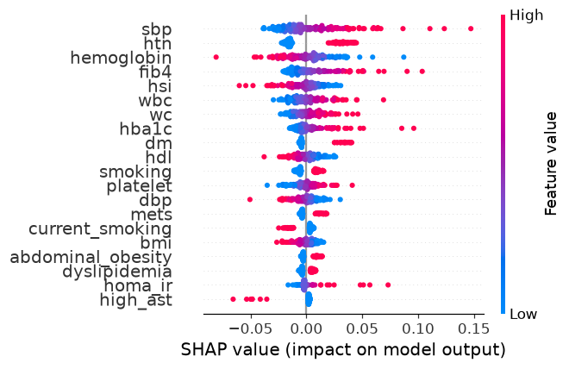

Partial dependence (PDP)
