Machine Learning Prediction Model Report
Outcome: Diabetes mellitus · KNHANES · 3 models compared · tuning, full metrics, threshold, SHAP, PDP
[ML] outcome = dm

Data summary
Item | Value
N | 6000
Outcome prevalence (%) | 14.4
Features | 44
Models compared | 3
Train/test | 4200/1800 (70/30 stratified)
Auto-excluded leakage | None

Hyperparameter search space
Model | Search space
LogisticRegression | {'C': [0.01, 0.1, 1, 10], 'penalty': ['l1', 'l2']}
HistGradientBoosting | {'learning_rate': [0.03, 0.1], 'max_iter': [200, 400], 'max_depth': [3, 6, None]}
XGBoost | {'n_estimators': [300, 500], 'max_depth': [3, 5], 'learning_rate': [0.03, 0.1], 'subsample': [0.8, 1.0]}

Tuning results — best parameters and CV auROC
model | CV_auROC | best_params
LogisticRegression | 0.8304 | {'penalty': 'l2', 'C': 0.01}
HistGradientBoosting | 0.839 | {'max_iter': 400, 'max_depth': 3, 'learning_rate': 0.03}
XGBoost | 0.8418 | {'subsample': 0.8, 'n_estimators': 500, 'max_depth': 3, 'learning_rate': 0.03}

Full performance metrics (test set)
model | TP | TN | FP | FN | sensitivity | specificity | PPV | NPV | accuracy | balanced_accuracy | f1 | MCC | kappa | auROC | auPRC | logloss | brier | combined
XGBoost | 63 | 1499 | 41 | 197 | 0.2423 | 0.9734 | 0.6058 | 0.8838 | 0.8678 | 0.6078 | 0.3462 | 0.325 | 0.2873 | 0.8421 | 0.4799 | 0.3114 | 0.0967 | 0.661
HistGradientBoosting | 57 | 1498 | 42 | 203 | 0.2192 | 0.9727 | 0.5758 | 0.8807 | 0.8639 | 0.596 | 0.3175 | 0.296 | 0.2585 | 0.8369 | 0.4652 | 0.3148 | 0.098 | 0.651
LogisticRegression | 57 | 1501 | 39 | 203 | 0.2192 | 0.9747 | 0.5938 | 0.8809 | 0.8656 | 0.597 | 0.3202 | 0.3034 | 0.2628 | 0.8371 | 0.4645 | 0.3285 | 0.0995 | 0.6508

ROC · Precision-Recall
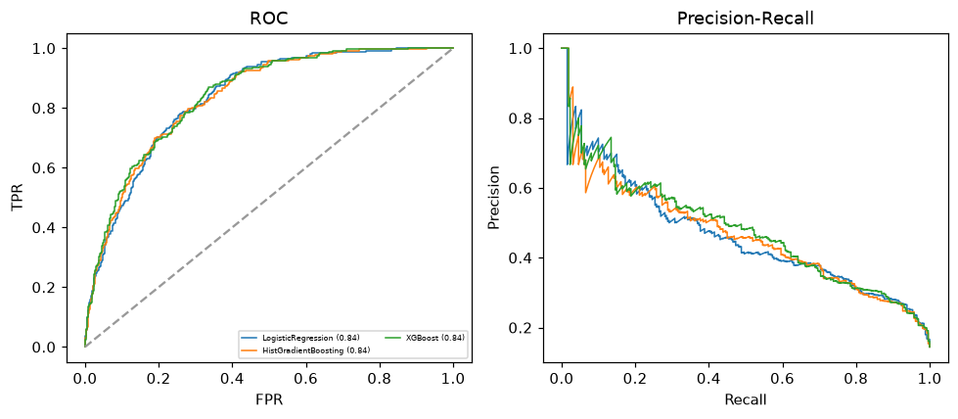

Selected final model — XGBoost (combined=0.661)
Among 3 candidate models, XGBoost achieved the highest combined score, with an area under the receiver operating characteristic curve of 0.8421 and area under the precision-recall curve of 0.4799.

Threshold analysis (0.1-0.9)
threshold | TP | TN | FP | FN | sensitivity | specificity | PPV | NPV | f1 | accuracy
0.1 | 217.0 | 1052.0 | 488.0 | 43.0 | 0.835 | 0.683 | 0.308 | 0.961 | 0.45 | 0.705
0.2 | 167.0 | 1284.0 | 256.0 | 93.0 | 0.642 | 0.834 | 0.395 | 0.932 | 0.489 | 0.806
0.3 | 128.0 | 1402.0 | 138.0 | 132.0 | 0.492 | 0.91 | 0.481 | 0.914 | 0.487 | 0.85
0.4 | 96.0 | 1458.0 | 82.0 | 164.0 | 0.369 | 0.947 | 0.539 | 0.899 | 0.438 | 0.863
0.5 | 63.0 | 1499.0 | 41.0 | 197.0 | 0.242 | 0.973 | 0.606 | 0.884 | 0.346 | 0.868
0.6 | 38.0 | 1514.0 | 26.0 | 222.0 | 0.146 | 0.983 | 0.594 | 0.872 | 0.235 | 0.862
0.7 | 24.0 | 1530.0 | 10.0 | 236.0 | 0.092 | 0.994 | 0.706 | 0.866 | 0.163 | 0.863
0.8 | 9.0 | 1537.0 | 3.0 | 251.0 | 0.035 | 0.998 | 0.75 | 0.86 | 0.066 | 0.859
0.9 | 2.0 | 1540.0 | 0.0 | 258.0 | 0.008 | 1.0 | 1.0 | 0.857 | 0.015 | 0.857

Calibration
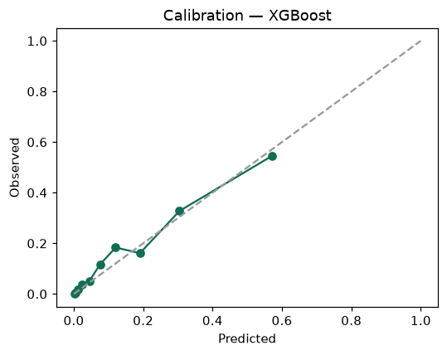

SHAP feature contributions
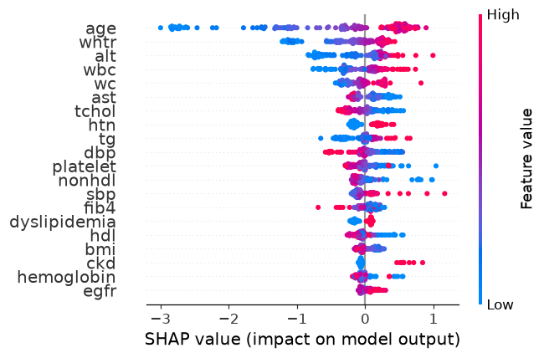

Partial dependence (PDP)
