Machine Learning Prediction Model Report
Outcome: Dyslipidemia (KSoLA composite) · KNHANES · 3 models compared · tuning, full metrics, threshold, SHAP, PDP
[ML] outcome = dyslipidemia

Data summary
Item | Value
N | 6000
Outcome prevalence (%) | 51.6
Features | 41
Models compared | 3
Train/test | 4200/1800 (70/30 stratified)
Auto-excluded leakage | None

Hyperparameter search space
Model | Search space
LogisticRegression | {'C': [0.01, 0.1, 1, 10], 'penalty': ['l1', 'l2']}
HistGradientBoosting | {'learning_rate': [0.03, 0.1], 'max_iter': [200, 400], 'max_depth': [3, 6, None]}
XGBoost | {'n_estimators': [300, 500], 'max_depth': [3, 5], 'learning_rate': [0.03, 0.1], 'subsample': [0.8, 1.0]}

Tuning results — best parameters and CV auROC
model | CV_auROC | best_params
LogisticRegression | 0.7404 | {'penalty': 'l1', 'C': 0.1}
HistGradientBoosting | 0.7325 | {'max_iter': 400, 'max_depth': 3, 'learning_rate': 0.03}
XGBoost | 0.7366 | {'subsample': 1.0, 'n_estimators': 300, 'max_depth': 3, 'learning_rate': 0.03}

Full performance metrics (test set)
model | TP | TN | FP | FN | sensitivity | specificity | PPV | NPV | accuracy | balanced_accuracy | f1 | MCC | kappa | auROC | auPRC | logloss | brier | combined
HistGradientBoosting | 682 | 552 | 319 | 247 | 0.7341 | 0.6338 | 0.6813 | 0.6909 | 0.6856 | 0.6839 | 0.7067 | 0.37 | 0.3688 | 0.7421 | 0.7295 | 0.5982 | 0.2057 | 0.7358
XGBoost | 673 | 547 | 324 | 256 | 0.7244 | 0.628 | 0.675 | 0.6812 | 0.6778 | 0.6762 | 0.6989 | 0.3543 | 0.3533 | 0.7415 | 0.7278 | 0.5987 | 0.206 | 0.7346
LogisticRegression | 652 | 585 | 286 | 277 | 0.7018 | 0.6716 | 0.6951 | 0.6787 | 0.6872 | 0.6867 | 0.6984 | 0.3736 | 0.3736 | 0.7378 | 0.7241 | 0.6043 | 0.2079 | 0.7309

ROC · Precision-Recall
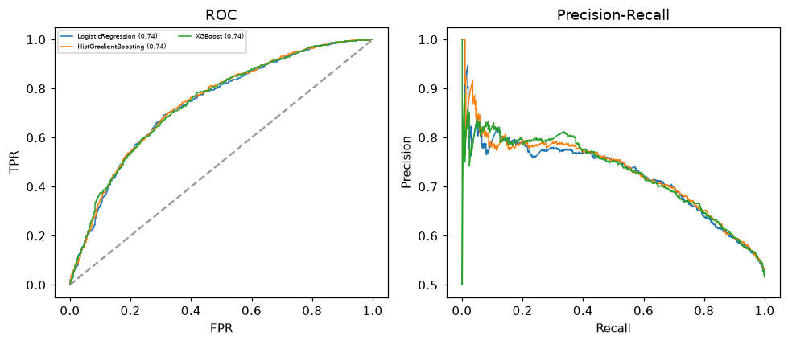

Selected final model — HistGradientBoosting (combined=0.7358)
Among 3 candidate models, HistGradientBoosting achieved the highest combined score, with an area under the receiver operating characteristic curve of 0.7421 and area under the precision-recall curve of 0.7295.

Threshold analysis (0.1-0.9)
threshold | TP | TN | FP | FN | sensitivity | specificity | PPV | NPV | f1 | accuracy
0.1 | 928.0 | 39.0 | 832.0 | 1.0 | 0.999 | 0.045 | 0.527 | 0.975 | 0.69 | 0.537
0.2 | 899.0 | 169.0 | 702.0 | 30.0 | 0.968 | 0.194 | 0.562 | 0.849 | 0.711 | 0.593
0.3 | 838.0 | 298.0 | 573.0 | 91.0 | 0.902 | 0.342 | 0.594 | 0.766 | 0.716 | 0.631
0.4 | 766.0 | 438.0 | 433.0 | 163.0 | 0.825 | 0.503 | 0.639 | 0.729 | 0.72 | 0.669
0.5 | 682.0 | 552.0 | 319.0 | 247.0 | 0.734 | 0.634 | 0.681 | 0.691 | 0.707 | 0.686
0.6 | 540.0 | 670.0 | 201.0 | 389.0 | 0.581 | 0.769 | 0.729 | 0.633 | 0.647 | 0.672
0.7 | 354.0 | 770.0 | 101.0 | 575.0 | 0.381 | 0.884 | 0.778 | 0.572 | 0.512 | 0.624
0.8 | 134.0 | 838.0 | 33.0 | 795.0 | 0.144 | 0.962 | 0.802 | 0.513 | 0.245 | 0.54
0.9 | 12.0 | 868.0 | 3.0 | 917.0 | 0.013 | 0.997 | 0.8 | 0.486 | 0.025 | 0.489

Calibration
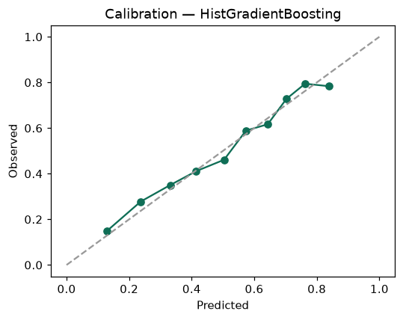

SHAP feature contributions
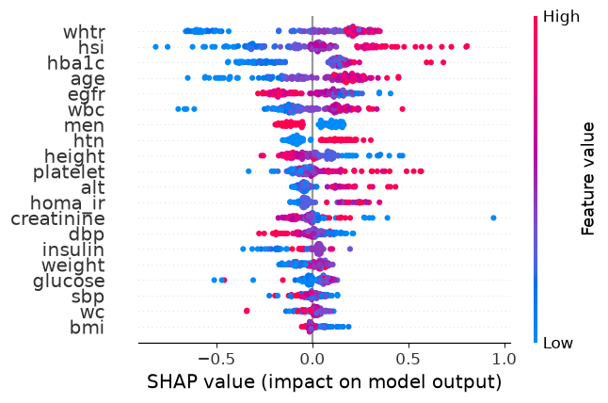

Partial dependence (PDP)
