Machine Learning Prediction Model Report
Outcome: Elevated ALT (>40 IU/L) · KNHANES · 3 models compared · tuning, full metrics, threshold, SHAP, PDP
[ML] outcome = high_alt

Data summary
Item | Value
N | 6000
Outcome prevalence (%) | 8.4
Features | 45
Models compared | 3
Train/test | 4200/1800 (70/30 stratified)
Auto-excluded leakage | None

Hyperparameter search space
Model | Search space
LogisticRegression | {'C': [0.01, 0.1, 1, 10], 'penalty': ['l1', 'l2']}
HistGradientBoosting | {'learning_rate': [0.03, 0.1], 'max_iter': [200, 400], 'max_depth': [3, 6, None]}
XGBoost | {'n_estimators': [300, 500], 'max_depth': [3, 5], 'learning_rate': [0.03, 0.1], 'subsample': [0.8, 1.0]}

Tuning results — best parameters and CV auROC
model | CV_auROC | best_params
LogisticRegression | 0.7841 | {'penalty': 'l1', 'C': 0.1}
HistGradientBoosting | 0.7712 | {'max_iter': 400, 'max_depth': 3, 'learning_rate': 0.03}
XGBoost | 0.7785 | {'subsample': 1.0, 'n_estimators': 300, 'max_depth': 3, 'learning_rate': 0.03}

Full performance metrics (test set)
model | TP | TN | FP | FN | sensitivity | specificity | PPV | NPV | accuracy | balanced_accuracy | f1 | MCC | kappa | auROC | auPRC | logloss | brier | combined
XGBoost | 21 | 1625 | 23 | 131 | 0.1382 | 0.986 | 0.4773 | 0.9254 | 0.9144 | 0.5621 | 0.2143 | 0.2236 | 0.1833 | 0.8023 | 0.3314 | 0.2383 | 0.0669 | 0.5669
LogisticRegression | 11 | 1636 | 12 | 141 | 0.0724 | 0.9927 | 0.4783 | 0.9207 | 0.915 | 0.5325 | 0.1257 | 0.1611 | 0.1059 | 0.8162 | 0.3173 | 0.2359 | 0.0668 | 0.5667
HistGradientBoosting | 21 | 1627 | 21 | 131 | 0.1382 | 0.9873 | 0.5 | 0.9255 | 0.9156 | 0.5627 | 0.2165 | 0.231 | 0.1868 | 0.8007 | 0.3166 | 0.2405 | 0.0676 | 0.5587

ROC · Precision-Recall
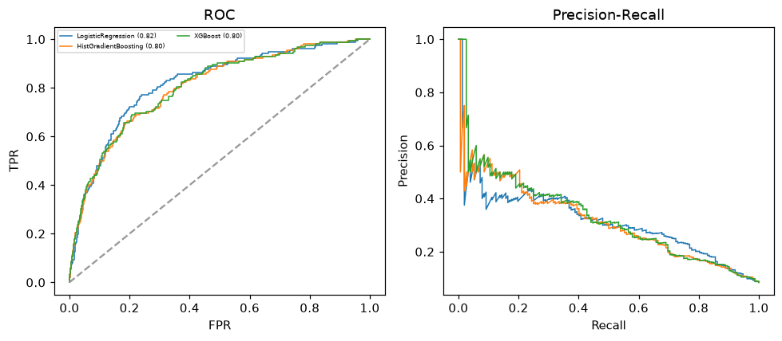

Selected final model — XGBoost (combined=0.5669)
Among 3 candidate models, XGBoost achieved the highest combined score, with an area under the receiver operating characteristic curve of 0.8023 and area under the precision-recall curve of 0.3314.

Threshold analysis (0.1-0.9)
threshold | TP | TN | FP | FN | sensitivity | specificity | PPV | NPV | f1 | accuracy
0.1 | 100.0 | 1343.0 | 305.0 | 52.0 | 0.658 | 0.815 | 0.247 | 0.963 | 0.359 | 0.802
0.2 | 65.0 | 1529.0 | 119.0 | 87.0 | 0.428 | 0.928 | 0.353 | 0.946 | 0.387 | 0.886
0.3 | 45.0 | 1584.0 | 64.0 | 107.0 | 0.296 | 0.961 | 0.413 | 0.937 | 0.345 | 0.905
0.4 | 31.0 | 1611.0 | 37.0 | 121.0 | 0.204 | 0.978 | 0.456 | 0.93 | 0.282 | 0.912
0.5 | 21.0 | 1625.0 | 23.0 | 131.0 | 0.138 | 0.986 | 0.477 | 0.925 | 0.214 | 0.914
0.6 | 11.0 | 1638.0 | 10.0 | 141.0 | 0.072 | 0.994 | 0.524 | 0.921 | 0.127 | 0.916
0.7 | 5.0 | 1643.0 | 5.0 | 147.0 | 0.033 | 0.997 | 0.5 | 0.918 | 0.062 | 0.916
0.8 | 0.0 | 1648.0 | 0.0 | 152.0 | 0.0 | 1.0 | nan | 0.916 | 0.0 | 0.916
0.9 | 0.0 | 1648.0 | 0.0 | 152.0 | 0.0 | 1.0 | nan | 0.916 | 0.0 | 0.916

Calibration
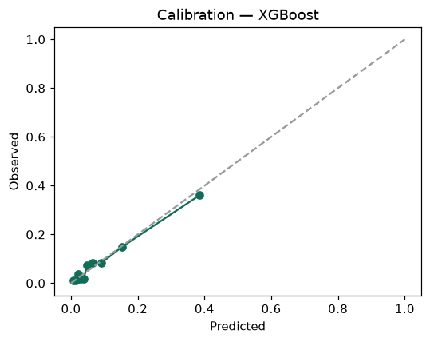

SHAP feature contributions
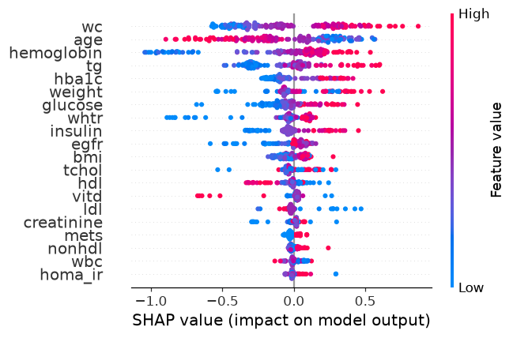

Partial dependence (PDP)
