Machine Learning Prediction Model Report
Outcome: Elevated AST (>40 IU/L) · KNHANES · 3 models compared · tuning, full metrics, threshold, SHAP, PDP
[ML] outcome = high_ast

Data summary
Item | Value
N | 6000
Outcome prevalence (%) | 4.7
Features | 45
Models compared | 3
Train/test | 4200/1800 (70/30 stratified)
Auto-excluded leakage | None

Hyperparameter search space
Model | Search space
LogisticRegression | {'C': [0.01, 0.1, 1, 10], 'penalty': ['l1', 'l2']}
HistGradientBoosting | {'learning_rate': [0.03, 0.1], 'max_iter': [200, 400], 'max_depth': [3, 6, None]}
XGBoost | {'n_estimators': [300, 500], 'max_depth': [3, 5], 'learning_rate': [0.03, 0.1], 'subsample': [0.8, 1.0]}

Tuning results — best parameters and CV auROC
model | CV_auROC | best_params
LogisticRegression | 0.723 | {'penalty': 'l1', 'C': 0.1}
HistGradientBoosting | 0.7015 | {'max_iter': 400, 'max_depth': 3, 'learning_rate': 0.03}
XGBoost | 0.725 | {'subsample': 1.0, 'n_estimators': 300, 'max_depth': 3, 'learning_rate': 0.03}

Full performance metrics (test set)
model | TP | TN | FP | FN | sensitivity | specificity | PPV | NPV | accuracy | balanced_accuracy | f1 | MCC | kappa | auROC | auPRC | logloss | brier | combined
XGBoost | 2 | 1715 | 0 | 83 | 0.0235 | 1.0 | 1.0 | 0.9538 | 0.9539 | 0.5118 | 0.046 | 0.1498 | 0.0439 | 0.797 | 0.2031 | 0.1622 | 0.0414 | 0.5001
HistGradientBoosting | 2 | 1714 | 1 | 83 | 0.0235 | 0.9994 | 0.6667 | 0.9538 | 0.9533 | 0.5115 | 0.0455 | 0.1193 | 0.0424 | 0.7983 | 0.1962 | 0.1627 | 0.0416 | 0.4973
LogisticRegression | 1 | 1715 | 0 | 84 | 0.0118 | 1.0 | 1.0 | 0.9533 | 0.9533 | 0.5059 | 0.0233 | 0.1059 | 0.0222 | 0.7917 | 0.1941 | 0.1657 | 0.0418 | 0.4929

ROC · Precision-Recall
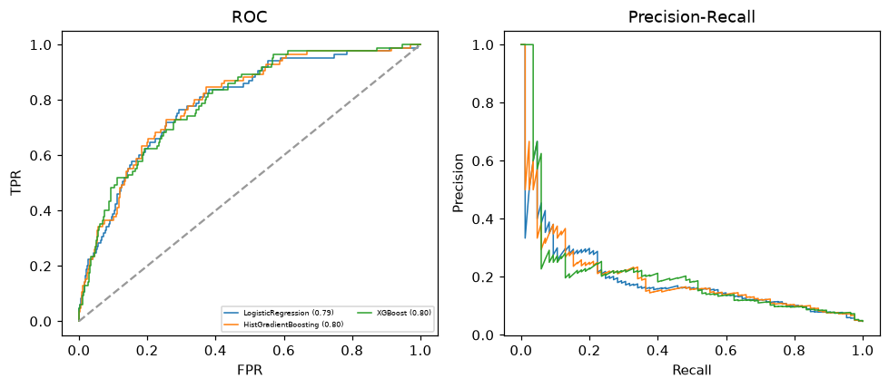

Selected final model — XGBoost (combined=0.5001)
Among 3 candidate models, XGBoost achieved the highest combined score, with an area under the receiver operating characteristic curve of 0.797 and area under the precision-recall curve of 0.2031.

Threshold analysis (0.1-0.9)
threshold | TP | TN | FP | FN | sensitivity | specificity | PPV | NPV | f1 | accuracy
0.1 | 38.0 | 1556.0 | 159.0 | 47.0 | 0.447 | 0.907 | 0.193 | 0.971 | 0.27 | 0.886
0.2 | 11.0 | 1677.0 | 38.0 | 74.0 | 0.129 | 0.978 | 0.224 | 0.958 | 0.164 | 0.938
0.3 | 5.0 | 1709.0 | 6.0 | 80.0 | 0.059 | 0.997 | 0.455 | 0.955 | 0.104 | 0.952
0.4 | 3.0 | 1714.0 | 1.0 | 82.0 | 0.035 | 0.999 | 0.75 | 0.954 | 0.067 | 0.954
0.5 | 2.0 | 1715.0 | 0.0 | 83.0 | 0.024 | 1.0 | 1.0 | 0.954 | 0.046 | 0.954
0.6 | 1.0 | 1715.0 | 0.0 | 84.0 | 0.012 | 1.0 | 1.0 | 0.953 | 0.023 | 0.953
0.7 | 0.0 | 1715.0 | 0.0 | 85.0 | 0.0 | 1.0 | nan | 0.953 | 0.0 | 0.953
0.8 | 0.0 | 1715.0 | 0.0 | 85.0 | 0.0 | 1.0 | nan | 0.953 | 0.0 | 0.953
0.9 | 0.0 | 1715.0 | 0.0 | 85.0 | 0.0 | 1.0 | nan | 0.953 | 0.0 | 0.953

Calibration
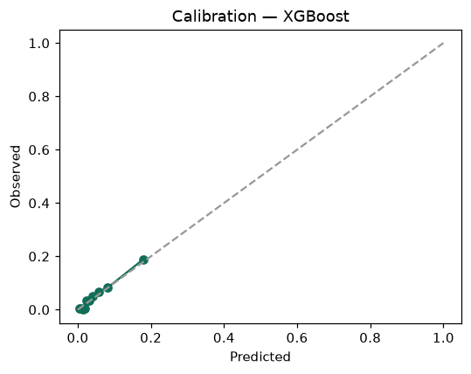

SHAP feature contributions
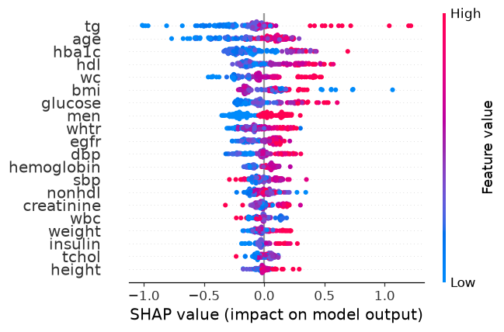

Partial dependence (PDP)
