Machine Learning Prediction Model Report
Outcome: Hepatic steatosis · KNHANES · 3 models compared · tuning, full metrics, threshold, SHAP, PDP
[ML] outcome = steatosis

Data summary
Item | Value
N | 6000
Outcome prevalence (%) | 23.2
Features | 19
Models compared | 3
Train/test | 4200/1800 (70/30 stratified)
Auto-excluded leakage | None

Hyperparameter search space
Model | Search space
LogisticRegression | {'C': [0.01, 0.1, 1, 10], 'penalty': ['l1', 'l2']}
HistGradientBoosting | {'learning_rate': [0.03, 0.1], 'max_iter': [200, 400], 'max_depth': [3, 6, None]}
XGBoost | {'n_estimators': [300, 500], 'max_depth': [3, 5], 'learning_rate': [0.03, 0.1], 'subsample': [0.8, 1.0]}

Tuning results — best parameters and CV auROC
model | CV_auROC | best_params
LogisticRegression | 0.9071 | {'penalty': 'l2', 'C': 1}
HistGradientBoosting | 0.9053 | {'max_iter': 200, 'max_depth': None, 'learning_rate': 0.03}
XGBoost | 0.9075 | {'subsample': 0.8, 'n_estimators': 500, 'max_depth': 3, 'learning_rate': 0.03}

Full performance metrics (test set)
model | TP | TN | FP | FN | sensitivity | specificity | PPV | NPV | accuracy | balanced_accuracy | f1 | MCC | kappa | auROC | auPRC | logloss | brier | combined
HistGradientBoosting | 242 | 1291 | 92 | 175 | 0.5803 | 0.9335 | 0.7246 | 0.8806 | 0.8517 | 0.7569 | 0.6445 | 0.5576 | 0.5522 | 0.9007 | 0.7535 | 0.3269 | 0.1036 | 0.8271
LogisticRegression | 248 | 1299 | 84 | 169 | 0.5947 | 0.9393 | 0.747 | 0.8849 | 0.8594 | 0.767 | 0.6622 | 0.5809 | 0.5749 | 0.9005 | 0.7519 | 0.3258 | 0.1013 | 0.8262
XGBoost | 244 | 1295 | 88 | 173 | 0.5851 | 0.9364 | 0.7349 | 0.8822 | 0.855 | 0.7608 | 0.6515 | 0.5673 | 0.5615 | 0.9031 | 0.7445 | 0.3243 | 0.1022 | 0.8238

ROC · Precision-Recall
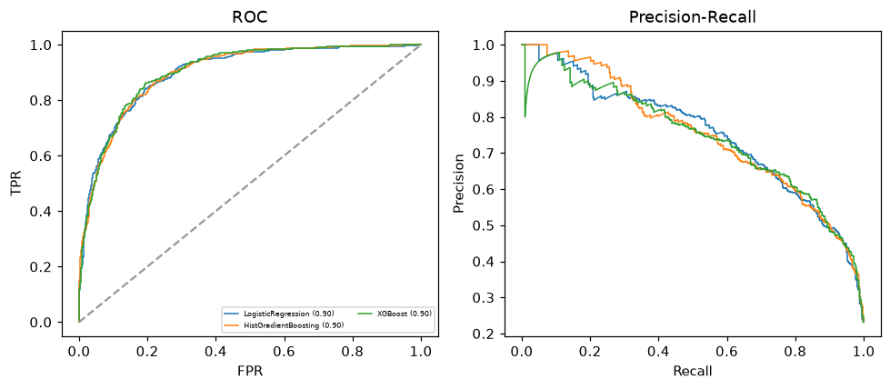

Selected final model — HistGradientBoosting (combined=0.8271)
Among 3 candidate models, HistGradientBoosting achieved the highest combined score, with an area under the receiver operating characteristic curve of 0.9007 and area under the precision-recall curve of 0.7535.

Threshold analysis (0.1-0.9)
threshold | TP | TN | FP | FN | sensitivity | specificity | PPV | NPV | f1 | accuracy
0.1 | 382.0 | 965.0 | 418.0 | 35.0 | 0.916 | 0.698 | 0.478 | 0.965 | 0.628 | 0.748
0.2 | 341.0 | 1134.0 | 249.0 | 76.0 | 0.818 | 0.82 | 0.578 | 0.937 | 0.677 | 0.819
0.3 | 305.0 | 1217.0 | 166.0 | 112.0 | 0.731 | 0.88 | 0.648 | 0.916 | 0.687 | 0.846
0.4 | 269.0 | 1253.0 | 130.0 | 148.0 | 0.645 | 0.906 | 0.674 | 0.894 | 0.659 | 0.846
0.5 | 242.0 | 1291.0 | 92.0 | 175.0 | 0.58 | 0.933 | 0.725 | 0.881 | 0.644 | 0.852
0.6 | 208.0 | 1320.0 | 63.0 | 209.0 | 0.499 | 0.954 | 0.768 | 0.863 | 0.605 | 0.849
0.7 | 177.0 | 1342.0 | 41.0 | 240.0 | 0.424 | 0.97 | 0.812 | 0.848 | 0.557 | 0.844
0.8 | 135.0 | 1360.0 | 23.0 | 282.0 | 0.324 | 0.983 | 0.854 | 0.828 | 0.47 | 0.831
0.9 | 78.0 | 1380.0 | 3.0 | 339.0 | 0.187 | 0.998 | 0.963 | 0.803 | 0.313 | 0.81

Calibration
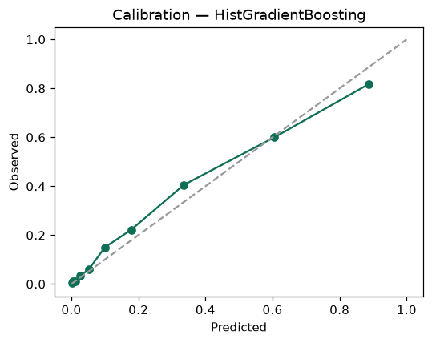

SHAP feature contributions
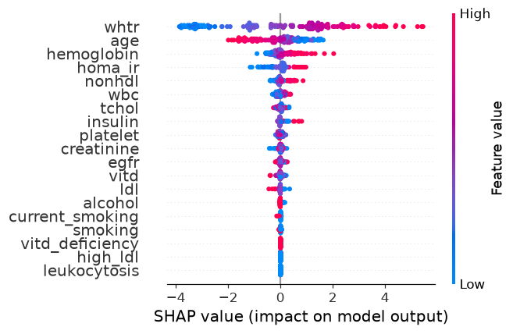

Partial dependence (PDP)
