Machine Learning Prediction Model Report
Outcome: High body fat (M>=25/F>=35%) · KNHANES · 3 models compared · tuning, full metrics, threshold, SHAP, PDP
[ML] outcome = high_bodyfat

Data summary
Item | Value
N | 6000
Outcome prevalence (%) | 34.2
Features | 45
Models compared | 3
Train/test | 4200/1800 (70/30 stratified)
Auto-excluded leakage | None

Hyperparameter search space
Model | Search space
LogisticRegression | {'C': [0.01, 0.1, 1, 10], 'penalty': ['l1', 'l2']}
HistGradientBoosting | {'learning_rate': [0.03, 0.1], 'max_iter': [200, 400], 'max_depth': [3, 6, None]}
XGBoost | {'n_estimators': [300, 500], 'max_depth': [3, 5], 'learning_rate': [0.03, 0.1], 'subsample': [0.8, 1.0]}

Tuning results — best parameters and CV auROC
model | CV_auROC | best_params
LogisticRegression | 0.8004 | {'penalty': 'l1', 'C': 0.1}
HistGradientBoosting | 0.7954 | {'max_iter': 400, 'max_depth': 3, 'learning_rate': 0.03}
XGBoost | 0.8005 | {'subsample': 0.8, 'n_estimators': 500, 'max_depth': 3, 'learning_rate': 0.03}

Full performance metrics (test set)
model | TP | TN | FP | FN | sensitivity | specificity | PPV | NPV | accuracy | balanced_accuracy | f1 | MCC | kappa | auROC | auPRC | logloss | brier | combined
XGBoost | 322 | 1026 | 158 | 294 | 0.5227 | 0.8666 | 0.6708 | 0.7773 | 0.7489 | 0.6946 | 0.5876 | 0.4177 | 0.411 | 0.8123 | 0.6917 | 0.4927 | 0.1638 | 0.752
HistGradientBoosting | 324 | 1036 | 148 | 292 | 0.526 | 0.875 | 0.6864 | 0.7801 | 0.7556 | 0.7005 | 0.5956 | 0.4325 | 0.4248 | 0.809 | 0.6881 | 0.4964 | 0.1652 | 0.7485
LogisticRegression | 311 | 1049 | 135 | 305 | 0.5049 | 0.886 | 0.6973 | 0.7747 | 0.7556 | 0.6954 | 0.5857 | 0.4295 | 0.4186 | 0.8057 | 0.6912 | 0.4979 | 0.166 | 0.7484

ROC · Precision-Recall
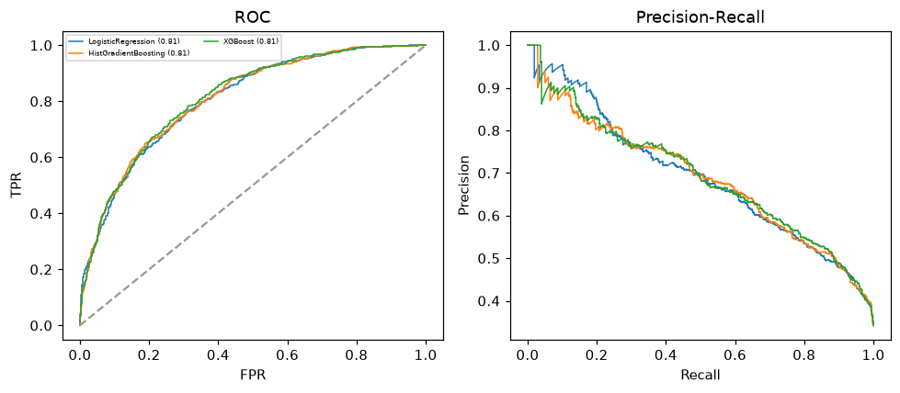

Selected final model — XGBoost (combined=0.752)
Among 3 candidate models, XGBoost achieved the highest combined score, with an area under the receiver operating characteristic curve of 0.8123 and area under the precision-recall curve of 0.6917.

Threshold analysis (0.1-0.9)
threshold | TP | TN | FP | FN | sensitivity | specificity | PPV | NPV | f1 | accuracy
0.1 | 596.0 | 370.0 | 814.0 | 20.0 | 0.968 | 0.312 | 0.423 | 0.949 | 0.588 | 0.537
0.2 | 546.0 | 633.0 | 551.0 | 70.0 | 0.886 | 0.535 | 0.498 | 0.9 | 0.637 | 0.655
0.3 | 486.0 | 798.0 | 386.0 | 130.0 | 0.789 | 0.674 | 0.557 | 0.86 | 0.653 | 0.713
0.4 | 414.0 | 934.0 | 250.0 | 202.0 | 0.672 | 0.789 | 0.623 | 0.822 | 0.647 | 0.749
0.5 | 322.0 | 1026.0 | 158.0 | 294.0 | 0.523 | 0.867 | 0.671 | 0.777 | 0.588 | 0.749
0.6 | 237.0 | 1112.0 | 72.0 | 379.0 | 0.385 | 0.939 | 0.767 | 0.746 | 0.512 | 0.749
0.7 | 156.0 | 1144.0 | 40.0 | 460.0 | 0.253 | 0.966 | 0.796 | 0.713 | 0.384 | 0.722
0.8 | 88.0 | 1170.0 | 14.0 | 528.0 | 0.143 | 0.988 | 0.863 | 0.689 | 0.245 | 0.699
0.9 | 23.0 | 1183.0 | 1.0 | 593.0 | 0.037 | 0.999 | 0.958 | 0.666 | 0.072 | 0.67

Calibration
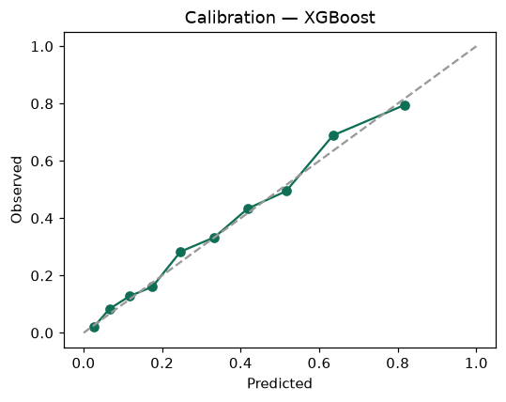

SHAP feature contributions
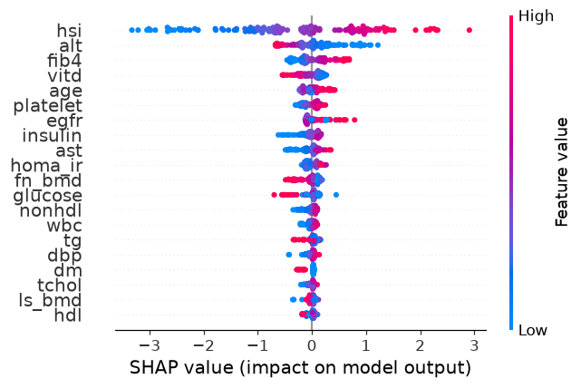

Partial dependence (PDP)
