Machine Learning Prediction Model Report
Outcome: Hypertension · KNHANES · 3 models compared · tuning, full metrics, threshold, SHAP, PDP
[ML] outcome = htn

Data summary
Item | Value
N | 6000
Outcome prevalence (%) | 32.5
Features | 49
Models compared | 3
Train/test | 4200/1800 (70/30 stratified)
Auto-excluded leakage | None

Hyperparameter search space
Model | Search space
LogisticRegression | {'C': [0.01, 0.1, 1, 10], 'penalty': ['l1', 'l2']}
HistGradientBoosting | {'learning_rate': [0.03, 0.1], 'max_iter': [200, 400], 'max_depth': [3, 6, None]}
XGBoost | {'n_estimators': [300, 500], 'max_depth': [3, 5], 'learning_rate': [0.03, 0.1], 'subsample': [0.8, 1.0]}

Tuning results — best parameters and CV auROC
model | CV_auROC | best_params
LogisticRegression | 0.8211 | {'penalty': 'l1', 'C': 0.1}
HistGradientBoosting | 0.8149 | {'max_iter': 400, 'max_depth': 3, 'learning_rate': 0.03}
XGBoost | 0.8181 | {'subsample': 0.8, 'n_estimators': 500, 'max_depth': 3, 'learning_rate': 0.03}

Full performance metrics (test set)
model | TP | TN | FP | FN | sensitivity | specificity | PPV | NPV | accuracy | balanced_accuracy | f1 | MCC | kappa | auROC | auPRC | logloss | brier | combined
XGBoost | 330 | 1063 | 152 | 255 | 0.5641 | 0.8749 | 0.6846 | 0.8065 | 0.7739 | 0.7195 | 0.6186 | 0.4644 | 0.46 | 0.8282 | 0.6857 | 0.4674 | 0.1555 | 0.757
HistGradientBoosting | 332 | 1053 | 162 | 253 | 0.5675 | 0.8667 | 0.6721 | 0.8063 | 0.7694 | 0.7171 | 0.6154 | 0.4557 | 0.4524 | 0.8252 | 0.6773 | 0.4703 | 0.1569 | 0.7512
LogisticRegression | 306 | 1068 | 147 | 279 | 0.5231 | 0.879 | 0.6755 | 0.7929 | 0.7633 | 0.701 | 0.5896 | 0.434 | 0.4271 | 0.8251 | 0.6616 | 0.4749 | 0.1578 | 0.7433

ROC · Precision-Recall
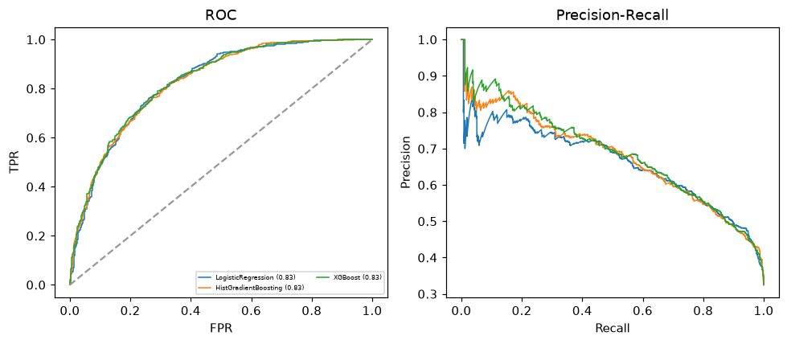

Selected final model — XGBoost (combined=0.757)
Among 3 candidate models, XGBoost achieved the highest combined score, with an area under the receiver operating characteristic curve of 0.8282 and area under the precision-recall curve of 0.6857.

Threshold analysis (0.1-0.9)
threshold | TP | TN | FP | FN | sensitivity | specificity | PPV | NPV | f1 | accuracy
0.1 | 564.0 | 503.0 | 712.0 | 21.0 | 0.964 | 0.414 | 0.442 | 0.96 | 0.606 | 0.593
0.2 | 512.0 | 698.0 | 517.0 | 73.0 | 0.875 | 0.574 | 0.498 | 0.905 | 0.634 | 0.672
0.3 | 471.0 | 835.0 | 380.0 | 114.0 | 0.805 | 0.687 | 0.553 | 0.88 | 0.656 | 0.726
0.4 | 409.0 | 946.0 | 269.0 | 176.0 | 0.699 | 0.779 | 0.603 | 0.843 | 0.648 | 0.753
0.5 | 330.0 | 1063.0 | 152.0 | 255.0 | 0.564 | 0.875 | 0.685 | 0.807 | 0.619 | 0.774
0.6 | 229.0 | 1130.0 | 85.0 | 356.0 | 0.391 | 0.93 | 0.729 | 0.76 | 0.509 | 0.755
0.7 | 154.0 | 1174.0 | 41.0 | 431.0 | 0.263 | 0.966 | 0.79 | 0.731 | 0.395 | 0.738
0.8 | 60.0 | 1207.0 | 8.0 | 525.0 | 0.103 | 0.993 | 0.882 | 0.697 | 0.184 | 0.704
0.9 | 8.0 | 1214.0 | 1.0 | 577.0 | 0.014 | 0.999 | 0.889 | 0.678 | 0.027 | 0.679

Calibration
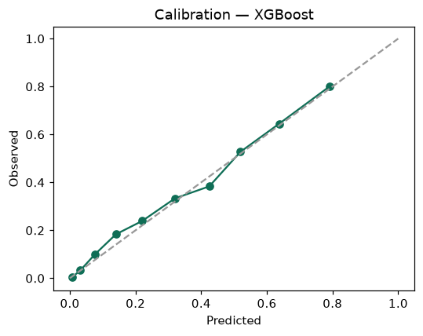

SHAP feature contributions
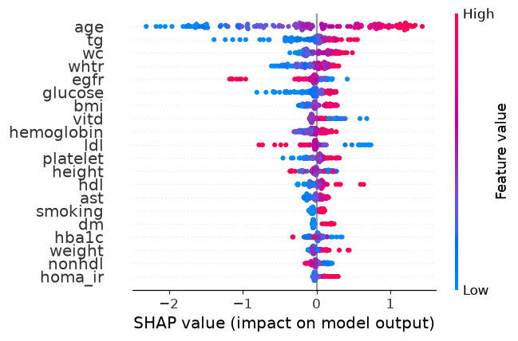

Partial dependence (PDP)
