Machine Learning Prediction Model Report
Outcome: Hypertriglyceridemia (NCEP TG>=150) · KNHANES · 3 models compared · tuning, full metrics, threshold, SHAP, PDP
[ML] outcome = high_tg

Data summary
Item | Value
N | 6000
Outcome prevalence (%) | 27.9
Features | 48
Models compared | 3
Train/test | 4200/1800 (70/30 stratified)
Auto-excluded leakage | None

Hyperparameter search space
Model | Search space
LogisticRegression | {'C': [0.01, 0.1, 1, 10], 'penalty': ['l1', 'l2']}
HistGradientBoosting | {'learning_rate': [0.03, 0.1], 'max_iter': [200, 400], 'max_depth': [3, 6, None]}
XGBoost | {'n_estimators': [300, 500], 'max_depth': [3, 5], 'learning_rate': [0.03, 0.1], 'subsample': [0.8, 1.0]}

Tuning results — best parameters and CV auROC
model | CV_auROC | best_params
LogisticRegression | 0.8506 | {'penalty': 'l1', 'C': 0.1}
HistGradientBoosting | 0.8705 | {'max_iter': 200, 'max_depth': None, 'learning_rate': 0.03}
XGBoost | 0.8702 | {'subsample': 0.8, 'n_estimators': 300, 'max_depth': 5, 'learning_rate': 0.03}

Full performance metrics (test set)
model | TP | TN | FP | FN | sensitivity | specificity | PPV | NPV | accuracy | balanced_accuracy | f1 | MCC | kappa | auROC | auPRC | logloss | brier | combined
XGBoost | 313 | 1202 | 96 | 189 | 0.6235 | 0.926 | 0.7653 | 0.8641 | 0.8417 | 0.7748 | 0.6872 | 0.5881 | 0.5826 | 0.8959 | 0.8005 | 0.3516 | 0.1114 | 0.8482
HistGradientBoosting | 305 | 1203 | 95 | 197 | 0.6076 | 0.9268 | 0.7625 | 0.8593 | 0.8378 | 0.7672 | 0.6763 | 0.5764 | 0.5699 | 0.8948 | 0.7991 | 0.3519 | 0.112 | 0.8469
LogisticRegression | 261 | 1192 | 106 | 241 | 0.5199 | 0.9183 | 0.7112 | 0.8318 | 0.8072 | 0.7191 | 0.6007 | 0.4878 | 0.4776 | 0.8581 | 0.6903 | 0.4118 | 0.1337 | 0.7742

ROC · Precision-Recall
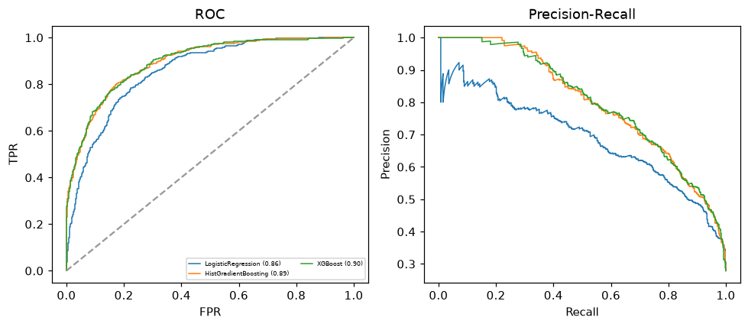

Selected final model — XGBoost (combined=0.8482)
Among 3 candidate models, XGBoost achieved the highest combined score, with an area under the receiver operating characteristic curve of 0.8959 and area under the precision-recall curve of 0.8005.

Threshold analysis (0.1-0.9)
threshold | TP | TN | FP | FN | sensitivity | specificity | PPV | NPV | f1 | accuracy
0.1 | 480.0 | 725.0 | 573.0 | 22.0 | 0.956 | 0.559 | 0.456 | 0.971 | 0.617 | 0.669
0.2 | 442.0 | 936.0 | 362.0 | 60.0 | 0.88 | 0.721 | 0.55 | 0.94 | 0.677 | 0.766
0.3 | 399.0 | 1063.0 | 235.0 | 103.0 | 0.795 | 0.819 | 0.629 | 0.912 | 0.702 | 0.812
0.4 | 360.0 | 1142.0 | 156.0 | 142.0 | 0.717 | 0.88 | 0.698 | 0.889 | 0.707 | 0.834
0.5 | 313.0 | 1202.0 | 96.0 | 189.0 | 0.624 | 0.926 | 0.765 | 0.864 | 0.687 | 0.842
0.6 | 259.0 | 1242.0 | 56.0 | 243.0 | 0.516 | 0.957 | 0.822 | 0.836 | 0.634 | 0.834
0.7 | 204.0 | 1274.0 | 24.0 | 298.0 | 0.406 | 0.982 | 0.895 | 0.81 | 0.559 | 0.821
0.8 | 150.0 | 1290.0 | 8.0 | 352.0 | 0.299 | 0.994 | 0.949 | 0.786 | 0.455 | 0.8
0.9 | 78.0 | 1297.0 | 1.0 | 424.0 | 0.155 | 0.999 | 0.987 | 0.754 | 0.269 | 0.764

Calibration
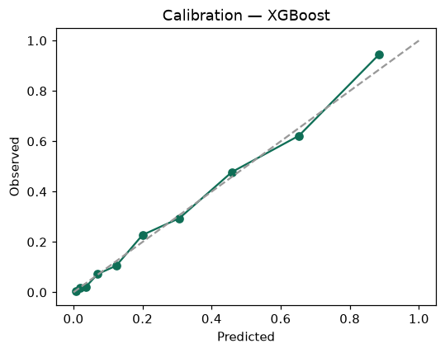

SHAP feature contributions
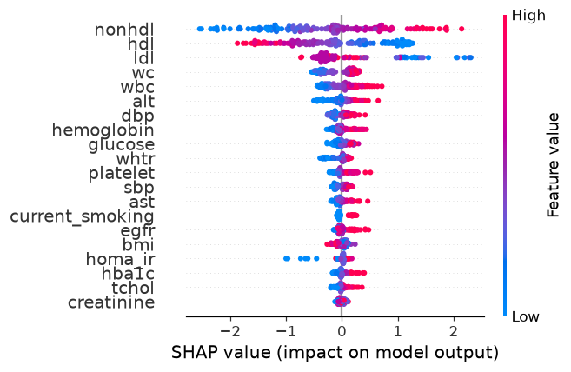

Partial dependence (PDP)
