Machine Learning Prediction Model Report
Outcome: Low HDL cholesterol · KNHANES · 3 models compared · tuning, full metrics, threshold, SHAP, PDP
[ML] outcome = low_hdl

Data summary
Item | Value
N | 6000
Outcome prevalence (%) | 33.9
Features | 43
Models compared | 3
Train/test | 4200/1800 (70/30 stratified)
Auto-excluded leakage | None

Hyperparameter search space
Model | Search space
LogisticRegression | {'C': [0.01, 0.1, 1, 10], 'penalty': ['l1', 'l2']}
HistGradientBoosting | {'learning_rate': [0.03, 0.1], 'max_iter': [200, 400], 'max_depth': [3, 6, None]}
XGBoost | {'n_estimators': [300, 500], 'max_depth': [3, 5], 'learning_rate': [0.03, 0.1], 'subsample': [0.8, 1.0]}

Tuning results — best parameters and CV auROC
model | CV_auROC | best_params
LogisticRegression | 0.7358 | {'penalty': 'l1', 'C': 1}
HistGradientBoosting | 0.7404 | {'max_iter': 400, 'max_depth': 3, 'learning_rate': 0.03}
XGBoost | 0.7434 | {'subsample': 0.8, 'n_estimators': 500, 'max_depth': 3, 'learning_rate': 0.03}

Full performance metrics (test set)
model | TP | TN | FP | FN | sensitivity | specificity | PPV | NPV | accuracy | balanced_accuracy | f1 | MCC | kappa | auROC | auPRC | logloss | brier | combined
XGBoost | 276 | 1059 | 130 | 335 | 0.4517 | 0.8907 | 0.6798 | 0.7597 | 0.7417 | 0.6712 | 0.5428 | 0.3879 | 0.3728 | 0.7725 | 0.6401 | 0.5295 | 0.1773 | 0.7063
HistGradientBoosting | 261 | 1064 | 125 | 350 | 0.4272 | 0.8949 | 0.6762 | 0.7525 | 0.7361 | 0.661 | 0.5236 | 0.3715 | 0.3537 | 0.7686 | 0.6346 | 0.5332 | 0.1787 | 0.7016
LogisticRegression | 250 | 1065 | 124 | 361 | 0.4092 | 0.8957 | 0.6684 | 0.7468 | 0.7306 | 0.6524 | 0.5076 | 0.3558 | 0.3366 | 0.7623 | 0.6298 | 0.5389 | 0.1804 | 0.6961

ROC · Precision-Recall
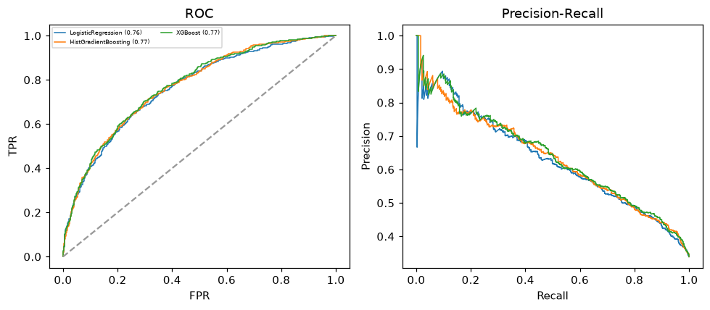

Selected final model — XGBoost (combined=0.7063)
Among 3 candidate models, XGBoost achieved the highest combined score, with an area under the receiver operating characteristic curve of 0.7725 and area under the precision-recall curve of 0.6401.

Threshold analysis (0.1-0.9)
threshold | TP | TN | FP | FN | sensitivity | specificity | PPV | NPV | f1 | accuracy
0.1 | 598.0 | 208.0 | 981.0 | 13.0 | 0.979 | 0.175 | 0.379 | 0.941 | 0.546 | 0.448
0.2 | 540.0 | 552.0 | 637.0 | 71.0 | 0.884 | 0.464 | 0.459 | 0.886 | 0.604 | 0.607
0.3 | 448.0 | 786.0 | 403.0 | 163.0 | 0.733 | 0.661 | 0.526 | 0.828 | 0.613 | 0.686
0.4 | 361.0 | 948.0 | 241.0 | 250.0 | 0.591 | 0.797 | 0.6 | 0.791 | 0.595 | 0.727
0.5 | 276.0 | 1059.0 | 130.0 | 335.0 | 0.452 | 0.891 | 0.68 | 0.76 | 0.543 | 0.742
0.6 | 182.0 | 1123.0 | 66.0 | 429.0 | 0.298 | 0.944 | 0.734 | 0.724 | 0.424 | 0.725
0.7 | 112.0 | 1155.0 | 34.0 | 499.0 | 0.183 | 0.971 | 0.767 | 0.698 | 0.296 | 0.704
0.8 | 54.0 | 1182.0 | 7.0 | 557.0 | 0.088 | 0.994 | 0.885 | 0.68 | 0.161 | 0.687
0.9 | 6.0 | 1188.0 | 1.0 | 605.0 | 0.01 | 0.999 | 0.857 | 0.663 | 0.019 | 0.663

Calibration
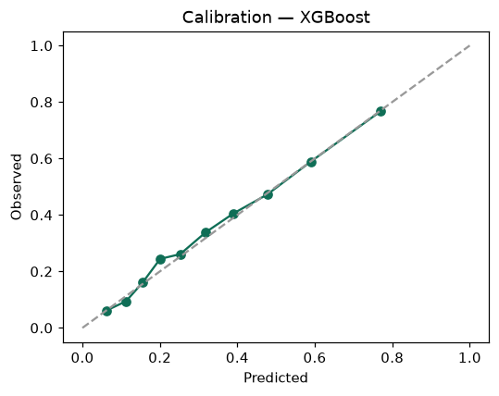

SHAP feature contributions
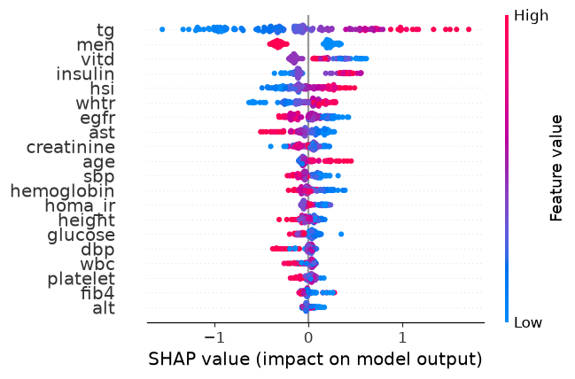

Partial dependence (PDP)
