Machine Learning Prediction Model Report
Outcome: MASLD · KNHANES · 3 models compared · tuning, full metrics, threshold, SHAP, PDP
[ML] outcome = masld

Data summary
Item | Value
N | 6000
Outcome prevalence (%) | 21.2
Features | 16
Models compared | 3
Train/test | 4200/1800 (70/30 stratified)
Auto-excluded leakage | None

Hyperparameter search space
Model | Search space
LogisticRegression | {'C': [0.01, 0.1, 1, 10], 'penalty': ['l1', 'l2']}
HistGradientBoosting | {'learning_rate': [0.03, 0.1], 'max_iter': [200, 400], 'max_depth': [3, 6, None]}
XGBoost | {'n_estimators': [300, 500], 'max_depth': [3, 5], 'learning_rate': [0.03, 0.1], 'subsample': [0.8, 1.0]}

Tuning results — best parameters and CV auROC
model | CV_auROC | best_params
LogisticRegression | 0.6882 | {'penalty': 'l1', 'C': 0.1}
HistGradientBoosting | 0.7149 | {'max_iter': 400, 'max_depth': 3, 'learning_rate': 0.03}
XGBoost | 0.7208 | {'subsample': 0.8, 'n_estimators': 500, 'max_depth': 3, 'learning_rate': 0.03}

Full performance metrics (test set)
model | TP | TN | FP | FN | sensitivity | specificity | PPV | NPV | accuracy | balanced_accuracy | f1 | MCC | kappa | auROC | auPRC | logloss | brier | combined
HistGradientBoosting | 59 | 1380 | 38 | 323 | 0.1545 | 0.9732 | 0.6082 | 0.8103 | 0.7994 | 0.5638 | 0.2463 | 0.2312 | 0.1755 | 0.7265 | 0.4212 | 0.4599 | 0.1482 | 0.5738
XGBoost | 63 | 1367 | 51 | 319 | 0.1649 | 0.964 | 0.5526 | 0.8108 | 0.7944 | 0.5645 | 0.254 | 0.2165 | 0.1734 | 0.724 | 0.4199 | 0.4621 | 0.1487 | 0.572
LogisticRegression | 21 | 1406 | 12 | 361 | 0.055 | 0.9915 | 0.6364 | 0.7957 | 0.7928 | 0.5233 | 0.1012 | 0.1418 | 0.0698 | 0.6871 | 0.3721 | 0.4801 | 0.1547 | 0.5296

ROC · Precision-Recall
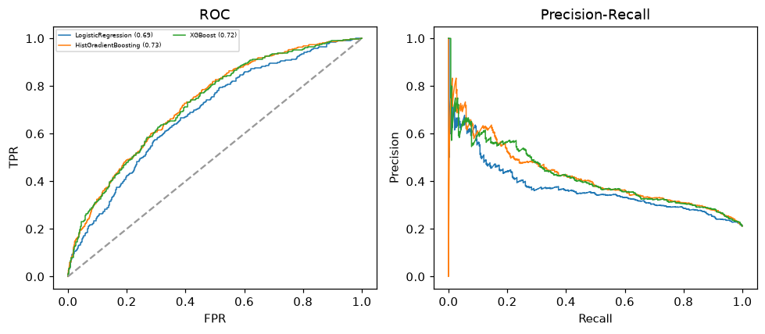

Selected final model — HistGradientBoosting (combined=0.5738)
Among 3 candidate models, HistGradientBoosting achieved the highest combined score, with an area under the receiver operating characteristic curve of 0.7265 and area under the precision-recall curve of 0.4212.

Threshold analysis (0.1-0.9)
threshold | TP | TN | FP | FN | sensitivity | specificity | PPV | NPV | f1 | accuracy
0.1 | 354.0 | 455.0 | 963.0 | 28.0 | 0.927 | 0.321 | 0.269 | 0.942 | 0.417 | 0.449
0.2 | 268.0 | 874.0 | 544.0 | 114.0 | 0.702 | 0.616 | 0.33 | 0.885 | 0.449 | 0.634
0.3 | 164.0 | 1185.0 | 233.0 | 218.0 | 0.429 | 0.836 | 0.413 | 0.845 | 0.421 | 0.749
0.4 | 92.0 | 1319.0 | 99.0 | 290.0 | 0.241 | 0.93 | 0.482 | 0.82 | 0.321 | 0.784
0.5 | 59.0 | 1380.0 | 38.0 | 323.0 | 0.154 | 0.973 | 0.608 | 0.81 | 0.246 | 0.799
0.6 | 32.0 | 1399.0 | 19.0 | 350.0 | 0.084 | 0.987 | 0.627 | 0.8 | 0.148 | 0.795
0.7 | 15.0 | 1412.0 | 6.0 | 367.0 | 0.039 | 0.996 | 0.714 | 0.794 | 0.074 | 0.793
0.8 | 1.0 | 1417.0 | 1.0 | 381.0 | 0.003 | 0.999 | 0.5 | 0.788 | 0.005 | 0.788
0.9 | 0.0 | 1418.0 | 0.0 | 382.0 | 0.0 | 1.0 | nan | 0.788 | 0.0 | 0.788

Calibration
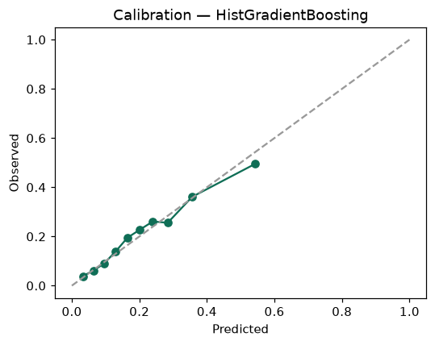

SHAP feature contributions
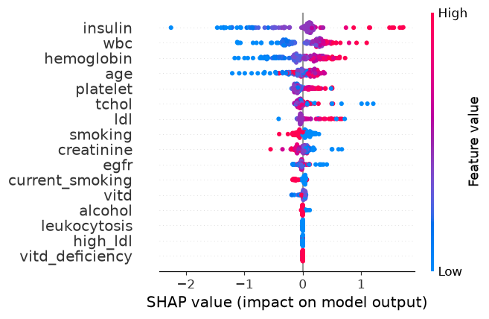

Partial dependence (PDP)
