Machine Learning Prediction Model Report
Outcome: Metabolic syndrome · KNHANES · 3 models compared · tuning, full metrics, threshold, SHAP, PDP
[ML] outcome = mets

Data summary
Item | Value
N | 6000
Outcome prevalence (%) | 28.3
Features | 32
Models compared | 3
Train/test | 4200/1800 (70/30 stratified)
Auto-excluded leakage | None

Hyperparameter search space
Model | Search space
LogisticRegression | {'C': [0.01, 0.1, 1, 10], 'penalty': ['l1', 'l2']}
HistGradientBoosting | {'learning_rate': [0.03, 0.1], 'max_iter': [200, 400], 'max_depth': [3, 6, None]}
XGBoost | {'n_estimators': [300, 500], 'max_depth': [3, 5], 'learning_rate': [0.03, 0.1], 'subsample': [0.8, 1.0]}

Tuning results — best parameters and CV auROC
model | CV_auROC | best_params
LogisticRegression | 0.8687 | {'penalty': 'l1', 'C': 1}
HistGradientBoosting | 0.87 | {'max_iter': 400, 'max_depth': 3, 'learning_rate': 0.03}
XGBoost | 0.8721 | {'subsample': 1.0, 'n_estimators': 300, 'max_depth': 3, 'learning_rate': 0.03}

Full performance metrics (test set)
model | TP | TN | FP | FN | sensitivity | specificity | PPV | NPV | accuracy | balanced_accuracy | f1 | MCC | kappa | auROC | auPRC | logloss | brier | combined
XGBoost | 288 | 1184 | 107 | 221 | 0.5658 | 0.9171 | 0.7291 | 0.8427 | 0.8178 | 0.7415 | 0.6372 | 0.5255 | 0.5181 | 0.8789 | 0.7369 | 0.3838 | 0.1252 | 0.8079
HistGradientBoosting | 283 | 1185 | 106 | 226 | 0.556 | 0.9179 | 0.7275 | 0.8398 | 0.8156 | 0.7369 | 0.6303 | 0.5185 | 0.5103 | 0.8769 | 0.7352 | 0.3854 | 0.1257 | 0.8061
LogisticRegression | 281 | 1175 | 116 | 228 | 0.5521 | 0.9101 | 0.7078 | 0.8375 | 0.8089 | 0.7311 | 0.6203 | 0.502 | 0.4952 | 0.8764 | 0.7275 | 0.3886 | 0.1268 | 0.802

ROC · Precision-Recall
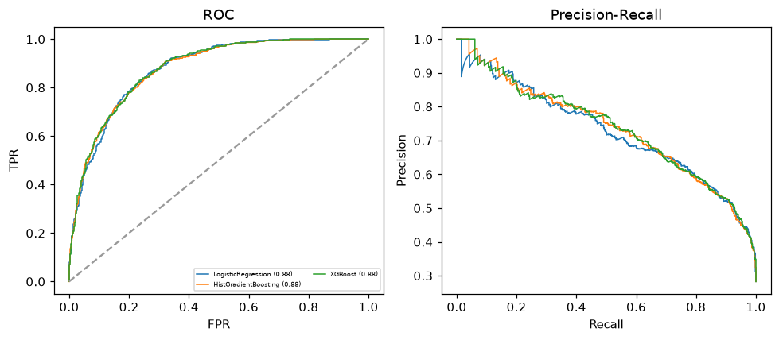

Selected final model — XGBoost (combined=0.8079)
Among 3 candidate models, XGBoost achieved the highest combined score, with an area under the receiver operating characteristic curve of 0.8789 and area under the precision-recall curve of 0.7369.

Threshold analysis (0.1-0.9)
threshold | TP | TN | FP | FN | sensitivity | specificity | PPV | NPV | f1 | accuracy
0.1 | 492.0 | 660.0 | 631.0 | 17.0 | 0.967 | 0.511 | 0.438 | 0.975 | 0.603 | 0.64
0.2 | 462.0 | 873.0 | 418.0 | 47.0 | 0.908 | 0.676 | 0.525 | 0.949 | 0.665 | 0.742
0.3 | 406.0 | 1014.0 | 277.0 | 103.0 | 0.798 | 0.785 | 0.594 | 0.908 | 0.681 | 0.789
0.4 | 349.0 | 1113.0 | 178.0 | 160.0 | 0.686 | 0.862 | 0.662 | 0.874 | 0.674 | 0.812
0.5 | 288.0 | 1184.0 | 107.0 | 221.0 | 0.566 | 0.917 | 0.729 | 0.843 | 0.637 | 0.818
0.6 | 223.0 | 1230.0 | 61.0 | 286.0 | 0.438 | 0.953 | 0.785 | 0.811 | 0.562 | 0.807
0.7 | 159.0 | 1260.0 | 31.0 | 350.0 | 0.312 | 0.976 | 0.837 | 0.783 | 0.455 | 0.788
0.8 | 95.0 | 1277.0 | 14.0 | 414.0 | 0.187 | 0.989 | 0.872 | 0.755 | 0.307 | 0.762
0.9 | 35.0 | 1289.0 | 2.0 | 474.0 | 0.069 | 0.998 | 0.946 | 0.731 | 0.128 | 0.736

Calibration
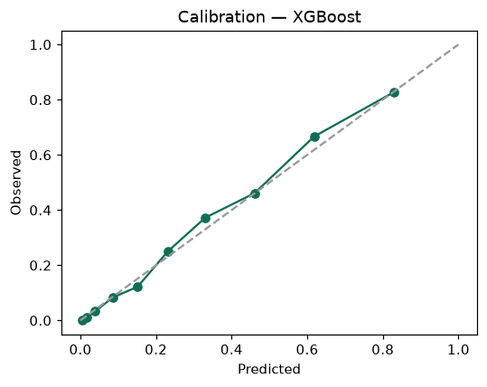

SHAP feature contributions
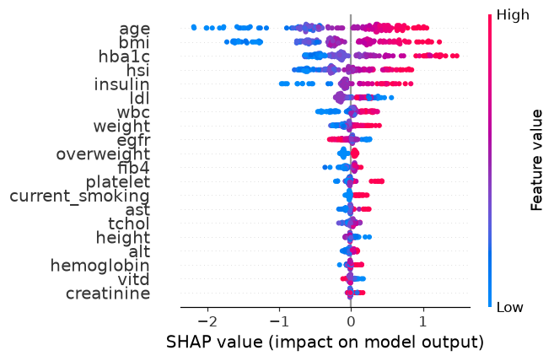

Partial dependence (PDP)
