Machine Learning Prediction Model Report
Outcome: Obesity (KSSO >=25 / WHO >=30, country-specific) · KNHANES · 3 models compared · tuning, full metrics, threshold, SHAP, PDP
[ML] outcome = obesity

Data summary
Item | Value
N | 6000
Outcome prevalence (%) | 34.1
Features | 43
Models compared | 3
Train/test | 4200/1800 (70/30 stratified)
Auto-excluded leakage | None

Hyperparameter search space
Model | Search space
LogisticRegression | {'C': [0.01, 0.1, 1, 10], 'penalty': ['l1', 'l2']}
HistGradientBoosting | {'learning_rate': [0.03, 0.1], 'max_iter': [200, 400], 'max_depth': [3, 6, None]}
XGBoost | {'n_estimators': [300, 500], 'max_depth': [3, 5], 'learning_rate': [0.03, 0.1], 'subsample': [0.8, 1.0]}

Tuning results — best parameters and CV auROC
model | CV_auROC | best_params
LogisticRegression | 0.784 | {'penalty': 'l2', 'C': 0.01}
HistGradientBoosting | 0.7919 | {'max_iter': 400, 'max_depth': 3, 'learning_rate': 0.03}
XGBoost | 0.7956 | {'subsample': 0.8, 'n_estimators': 500, 'max_depth': 3, 'learning_rate': 0.03}

Full performance metrics (test set)
model | TP | TN | FP | FN | sensitivity | specificity | PPV | NPV | accuracy | balanced_accuracy | f1 | MCC | kappa | auROC | auPRC | logloss | brier | combined
HistGradientBoosting | 336 | 1029 | 158 | 277 | 0.5481 | 0.8669 | 0.6802 | 0.7879 | 0.7583 | 0.7075 | 0.607 | 0.4407 | 0.4355 | 0.8099 | 0.6901 | 0.4972 | 0.1637 | 0.75
XGBoost | 336 | 1035 | 152 | 277 | 0.5481 | 0.8719 | 0.6885 | 0.7889 | 0.7617 | 0.71 | 0.6104 | 0.4478 | 0.4419 | 0.8095 | 0.6877 | 0.4977 | 0.1637 | 0.7486
LogisticRegression | 333 | 1024 | 163 | 280 | 0.5432 | 0.8627 | 0.6714 | 0.7853 | 0.7539 | 0.703 | 0.6005 | 0.4305 | 0.4255 | 0.8013 | 0.6802 | 0.5148 | 0.1678 | 0.7408

ROC · Precision-Recall
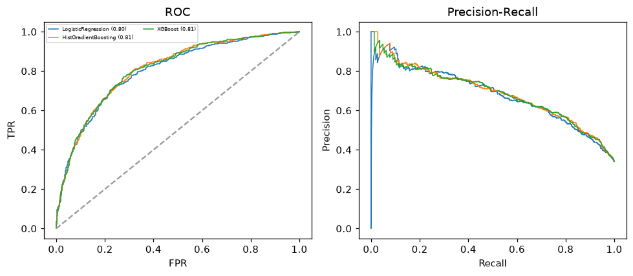

Selected final model — HistGradientBoosting (combined=0.75)
Among 3 candidate models, HistGradientBoosting achieved the highest combined score, with an area under the receiver operating characteristic curve of 0.8099 and area under the precision-recall curve of 0.6901.

Threshold analysis (0.1-0.9)
threshold | TP | TN | FP | FN | sensitivity | specificity | PPV | NPV | f1 | accuracy
0.1 | 595.0 | 246.0 | 941.0 | 18.0 | 0.971 | 0.207 | 0.387 | 0.932 | 0.554 | 0.467
0.2 | 549.0 | 583.0 | 604.0 | 64.0 | 0.896 | 0.491 | 0.476 | 0.901 | 0.622 | 0.629
0.3 | 474.0 | 831.0 | 356.0 | 139.0 | 0.773 | 0.7 | 0.571 | 0.857 | 0.657 | 0.725
0.4 | 401.0 | 959.0 | 228.0 | 212.0 | 0.654 | 0.808 | 0.638 | 0.819 | 0.646 | 0.756
0.5 | 336.0 | 1029.0 | 158.0 | 277.0 | 0.548 | 0.867 | 0.68 | 0.788 | 0.607 | 0.758
0.6 | 252.0 | 1101.0 | 86.0 | 361.0 | 0.411 | 0.928 | 0.746 | 0.753 | 0.53 | 0.752
0.7 | 162.0 | 1144.0 | 43.0 | 451.0 | 0.264 | 0.964 | 0.79 | 0.717 | 0.396 | 0.726
0.8 | 80.0 | 1171.0 | 16.0 | 533.0 | 0.131 | 0.987 | 0.833 | 0.687 | 0.226 | 0.695
0.9 | 19.0 | 1186.0 | 1.0 | 594.0 | 0.031 | 0.999 | 0.95 | 0.666 | 0.06 | 0.669

Calibration
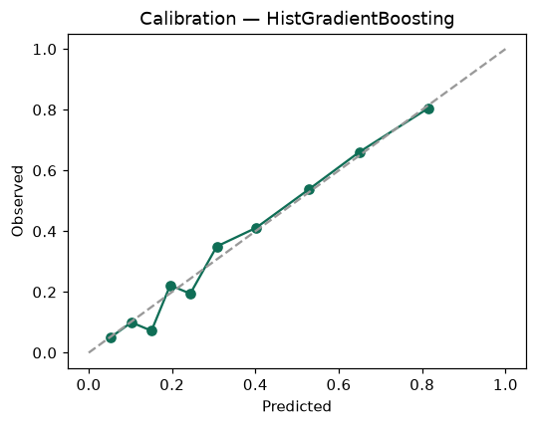

SHAP feature contributions
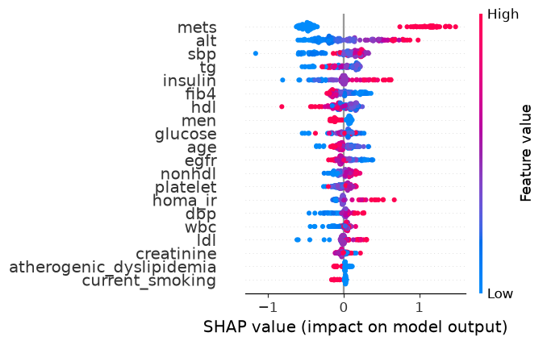

Partial dependence (PDP)
