Machine Learning Prediction Model Report
Outcome: Osteoporosis (T-score<=-2.5, age>=50) · KNHANES · 3 models compared · tuning, full metrics, threshold, SHAP, PDP
[ML] outcome = osteoporosis

Data summary
Item | Value
N | 6000
Outcome prevalence (%) | 33.8
Features | 59
Models compared | 3
Train/test | 4200/1800 (70/30 stratified)
Auto-excluded leakage | None

Hyperparameter search space
Model | Search space
LogisticRegression | {'C': [0.01, 0.1, 1, 10], 'penalty': ['l1', 'l2']}
HistGradientBoosting | {'learning_rate': [0.03, 0.1], 'max_iter': [200, 400], 'max_depth': [3, 6, None]}
XGBoost | {'n_estimators': [300, 500], 'max_depth': [3, 5], 'learning_rate': [0.03, 0.1], 'subsample': [0.8, 1.0]}

Tuning results — best parameters and CV auROC
model | CV_auROC | best_params
LogisticRegression | 0.8459 | {'penalty': 'l1', 'C': 0.1}
HistGradientBoosting | 0.8382 | {'max_iter': 400, 'max_depth': 3, 'learning_rate': 0.03}
XGBoost | 0.84 | {'subsample': 1.0, 'n_estimators': 300, 'max_depth': 3, 'learning_rate': 0.03}

Full performance metrics (test set)
model | TP | TN | FP | FN | sensitivity | specificity | PPV | NPV | accuracy | balanced_accuracy | f1 | MCC | kappa | auROC | auPRC | logloss | brier | combined
LogisticRegression | 357 | 1069 | 123 | 251 | 0.5872 | 0.8968 | 0.7438 | 0.8098 | 0.7922 | 0.742 | 0.6562 | 0.5176 | 0.5103 | 0.8407 | 0.7432 | 0.463 | 0.1481 | 0.7919
XGBoost | 354 | 1063 | 129 | 254 | 0.5822 | 0.8918 | 0.7329 | 0.8071 | 0.7872 | 0.737 | 0.6489 | 0.506 | 0.4992 | 0.835 | 0.7309 | 0.4683 | 0.1506 | 0.7829
HistGradientBoosting | 353 | 1063 | 129 | 255 | 0.5806 | 0.8918 | 0.7324 | 0.8065 | 0.7867 | 0.7362 | 0.6477 | 0.5045 | 0.4976 | 0.8313 | 0.729 | 0.4743 | 0.1519 | 0.7802

ROC · Precision-Recall
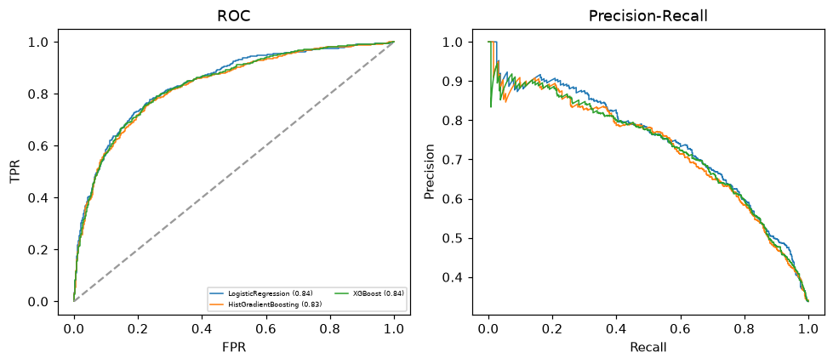

Selected final model — LogisticRegression (combined=0.7919)
Among 3 candidate models, LogisticRegression achieved the highest combined score, with an area under the receiver operating characteristic curve of 0.8407 and area under the precision-recall curve of 0.7432.

Threshold analysis (0.1-0.9)
threshold | TP | TN | FP | FN | sensitivity | specificity | PPV | NPV | f1 | accuracy
0.1 | 579.0 | 450.0 | 742.0 | 29.0 | 0.952 | 0.378 | 0.438 | 0.939 | 0.6 | 0.572
0.2 | 536.0 | 669.0 | 523.0 | 72.0 | 0.882 | 0.561 | 0.506 | 0.903 | 0.643 | 0.669
0.3 | 496.0 | 839.0 | 353.0 | 112.0 | 0.816 | 0.704 | 0.584 | 0.882 | 0.681 | 0.742
0.4 | 441.0 | 969.0 | 223.0 | 167.0 | 0.725 | 0.813 | 0.664 | 0.853 | 0.693 | 0.783
0.5 | 357.0 | 1069.0 | 123.0 | 251.0 | 0.587 | 0.897 | 0.744 | 0.81 | 0.656 | 0.792
0.6 | 286.0 | 1115.0 | 77.0 | 322.0 | 0.47 | 0.935 | 0.788 | 0.776 | 0.589 | 0.778
0.7 | 214.0 | 1153.0 | 39.0 | 394.0 | 0.352 | 0.967 | 0.846 | 0.745 | 0.497 | 0.759
0.8 | 124.0 | 1179.0 | 13.0 | 484.0 | 0.204 | 0.989 | 0.905 | 0.709 | 0.333 | 0.724
0.9 | 44.0 | 1187.0 | 5.0 | 564.0 | 0.072 | 0.996 | 0.898 | 0.678 | 0.134 | 0.684

Calibration
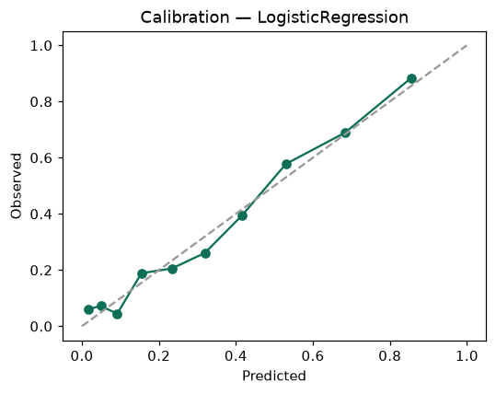

SHAP feature contributions
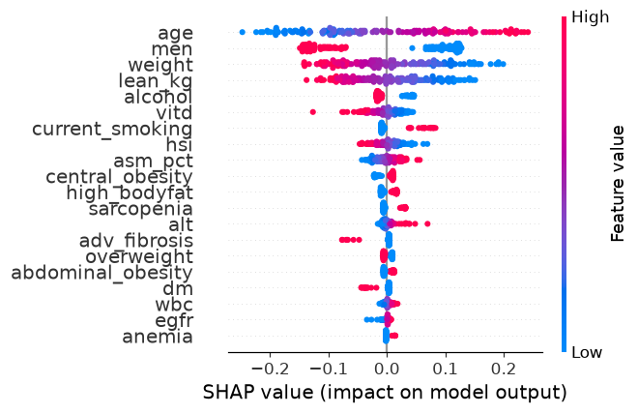

Partial dependence (PDP)
