Machine Learning Prediction Model Report
Outcome: Prediabetes · KNHANES · 3 models compared · tuning, full metrics, threshold, SHAP, PDP
[ML] outcome = prediabetes

Data summary
Item | Value
N | 6000
Outcome prevalence (%) | 32.9
Features | 45
Models compared | 3
Train/test | 4200/1800 (70/30 stratified)
Auto-excluded leakage | None

Hyperparameter search space
Model | Search space
LogisticRegression | {'C': [0.01, 0.1, 1, 10], 'penalty': ['l1', 'l2']}
HistGradientBoosting | {'learning_rate': [0.03, 0.1], 'max_iter': [200, 400], 'max_depth': [3, 6, None]}
XGBoost | {'n_estimators': [300, 500], 'max_depth': [3, 5], 'learning_rate': [0.03, 0.1], 'subsample': [0.8, 1.0]}

Tuning results — best parameters and CV auROC
model | CV_auROC | best_params
LogisticRegression | 0.7003 | {'penalty': 'l1', 'C': 10}
HistGradientBoosting | 0.6883 | {'max_iter': 200, 'max_depth': 3, 'learning_rate': 0.1}
XGBoost | 0.6974 | {'subsample': 0.8, 'n_estimators': 500, 'max_depth': 3, 'learning_rate': 0.03}

Full performance metrics (test set)
model | TP | TN | FP | FN | sensitivity | specificity | PPV | NPV | accuracy | balanced_accuracy | f1 | MCC | kappa | auROC | auPRC | logloss | brier | combined
LogisticRegression | 181 | 1086 | 123 | 410 | 0.3063 | 0.8983 | 0.5954 | 0.7259 | 0.7039 | 0.6023 | 0.4045 | 0.2564 | 0.2335 | 0.7035 | 0.5253 | 0.5746 | 0.1959 | 0.6144
XGBoost | 168 | 1069 | 140 | 423 | 0.2843 | 0.8842 | 0.5455 | 0.7165 | 0.6872 | 0.5842 | 0.3737 | 0.2101 | 0.192 | 0.6942 | 0.498 | 0.5797 | 0.1989 | 0.5961
HistGradientBoosting | 183 | 1055 | 154 | 408 | 0.3096 | 0.8726 | 0.543 | 0.7211 | 0.6878 | 0.5911 | 0.3944 | 0.2194 | 0.2048 | 0.689 | 0.4896 | 0.5862 | 0.2012 | 0.5893

ROC · Precision-Recall
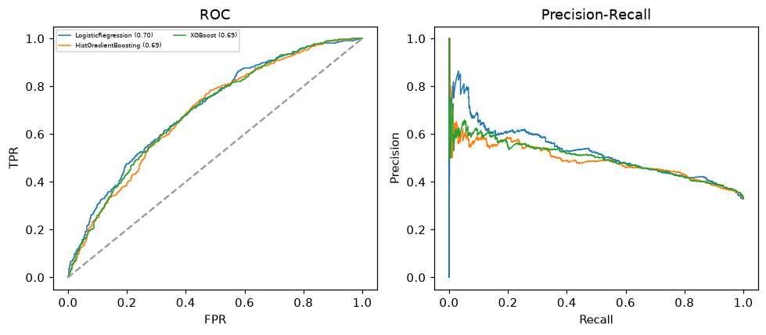

Selected final model — LogisticRegression (combined=0.6144)
Among 3 candidate models, LogisticRegression achieved the highest combined score, with an area under the receiver operating characteristic curve of 0.7035 and area under the precision-recall curve of 0.5253.

Threshold analysis (0.1-0.9)
threshold | TP | TN | FP | FN | sensitivity | specificity | PPV | NPV | f1 | accuracy
0.1 | 583.0 | 96.0 | 1113.0 | 8.0 | 0.986 | 0.079 | 0.344 | 0.923 | 0.51 | 0.377
0.2 | 531.0 | 395.0 | 814.0 | 60.0 | 0.898 | 0.327 | 0.395 | 0.868 | 0.549 | 0.514
0.3 | 426.0 | 677.0 | 532.0 | 165.0 | 0.721 | 0.56 | 0.445 | 0.804 | 0.55 | 0.613
0.4 | 306.0 | 921.0 | 288.0 | 285.0 | 0.518 | 0.762 | 0.515 | 0.764 | 0.516 | 0.682
0.5 | 181.0 | 1086.0 | 123.0 | 410.0 | 0.306 | 0.898 | 0.595 | 0.726 | 0.404 | 0.704
0.6 | 72.0 | 1167.0 | 42.0 | 519.0 | 0.122 | 0.965 | 0.632 | 0.692 | 0.204 | 0.688
0.7 | 23.0 | 1203.0 | 6.0 | 568.0 | 0.039 | 0.995 | 0.793 | 0.679 | 0.074 | 0.681
0.8 | 2.0 | 1208.0 | 1.0 | 589.0 | 0.003 | 0.999 | 0.667 | 0.672 | 0.007 | 0.672
0.9 | 0.0 | 1208.0 | 1.0 | 591.0 | 0.0 | 0.999 | 0.0 | 0.671 | 0.0 | 0.671

Calibration
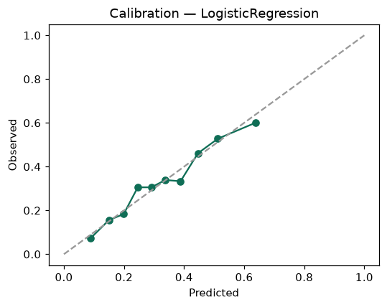

SHAP feature contributions
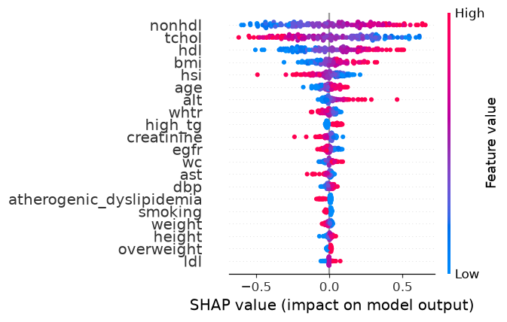

Partial dependence (PDP)
