Machine Learning Prediction Model Report
Outcome: Vitamin D deficiency (<20 ng/mL) · KNHANES · 3 models compared · tuning, full metrics, threshold, SHAP, PDP
[ML] outcome = vitd_deficiency

Data summary
Item | Value
N | 6000
Outcome prevalence (%) | 67.4
Features | 61
Models compared | 3
Train/test | 4200/1800 (70/30 stratified)
Auto-excluded leakage | None

Hyperparameter search space
Model | Search space
LogisticRegression | {'C': [0.01, 0.1, 1, 10], 'penalty': ['l1', 'l2']}
HistGradientBoosting | {'learning_rate': [0.03, 0.1], 'max_iter': [200, 400], 'max_depth': [3, 6, None]}
XGBoost | {'n_estimators': [300, 500], 'max_depth': [3, 5], 'learning_rate': [0.03, 0.1], 'subsample': [0.8, 1.0]}

Tuning results — best parameters and CV auROC
model | CV_auROC | best_params
LogisticRegression | 0.6502 | {'penalty': 'l1', 'C': 0.1}
HistGradientBoosting | 0.661 | {'max_iter': 400, 'max_depth': 3, 'learning_rate': 0.03}
XGBoost | 0.6648 | {'subsample': 1.0, 'n_estimators': 300, 'max_depth': 3, 'learning_rate': 0.03}

Full performance metrics (test set)
model | TP | TN | FP | FN | sensitivity | specificity | PPV | NPV | accuracy | balanced_accuracy | f1 | MCC | kappa | auROC | auPRC | logloss | brier | combined
HistGradientBoosting | 1116 | 135 | 452 | 97 | 0.92 | 0.23 | 0.7117 | 0.5819 | 0.695 | 0.575 | 0.8026 | 0.2099 | 0.1778 | 0.6746 | 0.7881 | 0.5914 | 0.2013 | 0.7313
XGBoost | 1134 | 127 | 460 | 79 | 0.9349 | 0.2164 | 0.7114 | 0.6165 | 0.7006 | 0.5756 | 0.808 | 0.2227 | 0.1816 | 0.6693 | 0.7836 | 0.5924 | 0.202 | 0.7264
LogisticRegression | 1137 | 102 | 485 | 76 | 0.9373 | 0.1738 | 0.701 | 0.573 | 0.6883 | 0.5556 | 0.8021 | 0.1745 | 0.1355 | 0.6489 | 0.7712 | 0.6007 | 0.206 | 0.7101

ROC · Precision-Recall
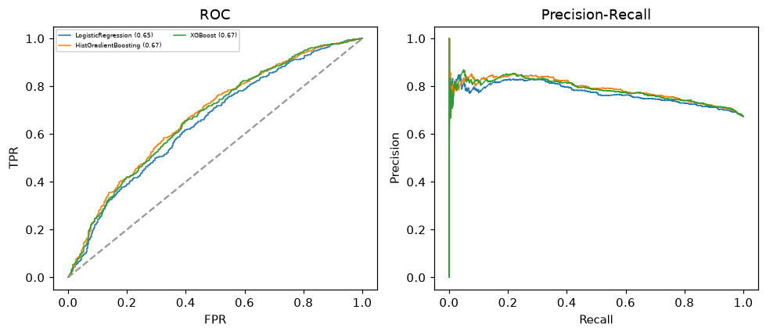

Selected final model — HistGradientBoosting (combined=0.7313)
Among 3 candidate models, HistGradientBoosting achieved the highest combined score, with an area under the receiver operating characteristic curve of 0.6746 and area under the precision-recall curve of 0.7881.

Threshold analysis (0.1-0.9)
threshold | TP | TN | FP | FN | sensitivity | specificity | PPV | NPV | f1 | accuracy
0.1 | 1213.0 | 0.0 | 587.0 | 0.0 | 1.0 | 0.0 | 0.674 | nan | 0.805 | 0.674
0.2 | 1213.0 | 2.0 | 585.0 | 0.0 | 1.0 | 0.003 | 0.675 | 1.0 | 0.806 | 0.675
0.3 | 1209.0 | 9.0 | 578.0 | 4.0 | 0.997 | 0.015 | 0.677 | 0.692 | 0.806 | 0.677
0.4 | 1185.0 | 59.0 | 528.0 | 28.0 | 0.977 | 0.101 | 0.692 | 0.678 | 0.81 | 0.691
0.5 | 1116.0 | 135.0 | 452.0 | 97.0 | 0.92 | 0.23 | 0.712 | 0.582 | 0.803 | 0.695
0.6 | 938.0 | 276.0 | 311.0 | 275.0 | 0.773 | 0.47 | 0.751 | 0.501 | 0.762 | 0.674
0.7 | 634.0 | 422.0 | 165.0 | 579.0 | 0.523 | 0.719 | 0.793 | 0.422 | 0.63 | 0.587
0.8 | 339.0 | 525.0 | 62.0 | 874.0 | 0.279 | 0.894 | 0.845 | 0.375 | 0.42 | 0.48
0.9 | 70.0 | 573.0 | 14.0 | 1143.0 | 0.058 | 0.976 | 0.833 | 0.334 | 0.108 | 0.357

Calibration
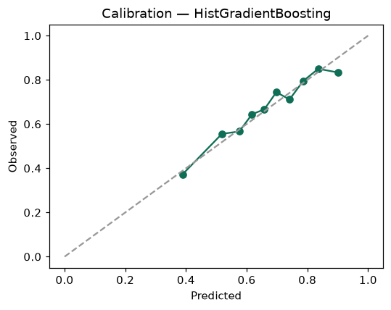

SHAP feature contributions
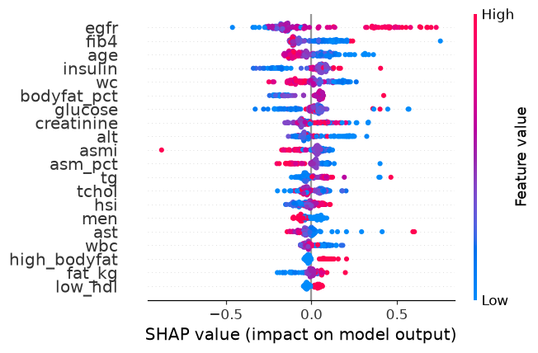

Partial dependence (PDP)
