Incidence/Prevalence Trend Report
Abdominal obesity · KNHANES · 2007-2024 · survey-weighted

Figure. Incidence/prevalence trend
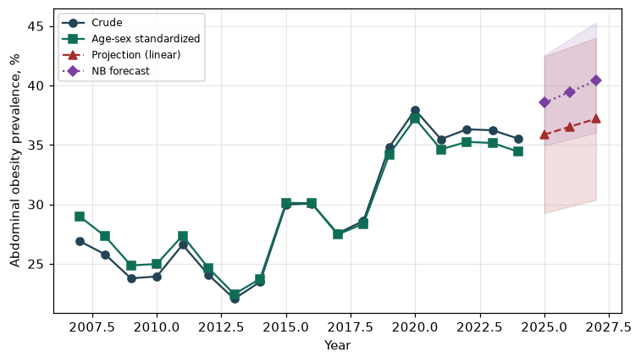

Counts by period
period | count
2007 | 916
2008 | 1923
2009 | 1933
2010 | 1568
2011 | 1720
2012 | 1521
2013 | 1332
2014 | 1405
2015 | 1781
2016 | 1928
2017 | 1771
2018 | 1855
2019 | 2258
2020 | 2319
2021 | 2097
2022 | 1853
2023 | 2131
2024 | 2095

Crude and age-sex standardized rate (%)
year | crude | standardized
2007.00 | 26.92 | 29.00
2008.00 | 25.79 | 27.32
2009.00 | 23.77 | 24.86
2010.00 | 23.93 | 24.98
2011.00 | 26.60 | 27.37
2012.00 | 24.07 | 24.64
2013.00 | 22.05 | 22.44
2014.00 | 23.48 | 23.73
2015.00 | 29.98 | 30.12
2016.00 | 30.07 | 30.09
2017.00 | 27.54 | 27.46
2018.00 | 28.61 | 28.37
2019.00 | 34.82 | 34.20
2020.00 | 37.93 | 37.22
2021.00 | 35.48 | 34.62
2022.00 | 36.31 | 35.25
2023.00 | 36.23 | 35.15
2024.00 | 35.52 | 34.42

Projection (linear, standardized rate)
year | forecast | lo95 | hi95
2025.00 | 35.86 | 29.27 | 42.44
2026.00 | 36.53 | 29.83 | 43.22
2027.00 | 37.19 | 30.38 | 44.01

Stratified trend by sex (%)
year | men | women
2007.00 | 26.26 | 27.57
2008.00 | 26.17 | 25.40
2009.00 | 24.40 | 23.16
2010.00 | 24.48 | 23.40
2011.00 | 27.79 | 25.44
2012.00 | 23.48 | 24.64
2013.00 | 23.61 | 20.52
2014.00 | 26.22 | 20.79
2015.00 | 32.12 | 27.88
2016.00 | 31.59 | 28.56
2017.00 | 31.85 | 23.27
2018.00 | 33.84 | 23.42
2019.00 | 38.88 | 30.79
2020.00 | 45.08 | 30.80
2021.00 | 40.83 | 30.14
2022.00 | 43.23 | 29.39
2023.00 | 41.65 | 30.84
2024.00 | 42.75 | 28.34

Joinpoint regression — segment APC (%) with bootstrap 95% CI
segment | period | APC(%) | lo95 | hi95
1 | 2007-2014 | -2.73 | -4.00 | -1.05
2 | 2014-2024 | 3.41 | 1.92 | 5.32

Negative binomial (NB) forecast (%)
year | NB_forecast | lo95 | hi95
2025.00 | 38.55 | 34.94 | 42.53
2026.00 | 39.46 | 35.48 | 43.90
2027.00 | 40.40 | 36.02 | 45.31

Interpretation
The age-sex standardized prevalence of Abdominal obesity showed an annual percent change of 3.41% (95% CI 1.92 to 5.32) in the latest segment.

