Incidence/Prevalence Trend Report
Advanced liver fibrosis (FIB-4>2.67) · KNHANES · 2008-2024 · survey-weighted

Figure. Incidence/prevalence trend
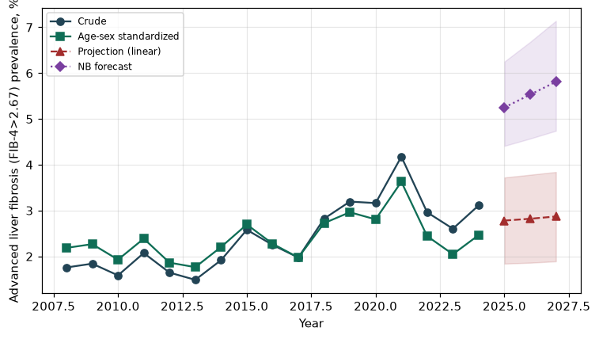

Counts by period
period | count
2008 | 145
2009 | 181
2010 | 119
2011 | 161
2012 | 144
2013 | 105
2014 | 138
2015 | 195
2016 | 179
2017 | 169
2018 | 236
2019 | 264
2020 | 270
2021 | 336
2022 | 217
2023 | 197
2024 | 249

Crude and age-sex standardized rate (%)
year | crude | standardized
2008.00 | 1.76 | 2.18
2009.00 | 1.84 | 2.27
2010.00 | 1.58 | 1.93
2011.00 | 2.07 | 2.39
2012.00 | 1.64 | 1.86
2013.00 | 1.49 | 1.76
2014.00 | 1.92 | 2.20
2015.00 | 2.58 | 2.69
2016.00 | 2.25 | 2.28
2017.00 | 1.97 | 1.97
2018.00 | 2.82 | 2.72
2019.00 | 3.19 | 2.96
2020.00 | 3.16 | 2.81
2021.00 | 4.18 | 3.63
2022.00 | 2.96 | 2.44
2023.00 | 2.60 | 2.05
2024.00 | 3.11 | 2.46

Projection (linear, standardized rate)
year | forecast | lo95 | hi95
2025.00 | 2.78 | 1.84 | 3.72
2026.00 | 2.82 | 1.86 | 3.78
2027.00 | 2.87 | 1.89 | 3.84

Stratified trend by sex (%)
year | men | women
2008.00 | 2.20 | 1.30
2009.00 | 2.39 | 1.28
2010.00 | 1.74 | 1.43
2011.00 | 2.74 | 1.40
2012.00 | 2.11 | 1.17
2013.00 | 1.83 | 1.13
2014.00 | 2.21 | 1.62
2015.00 | 3.05 | 2.10
2016.00 | 2.42 | 2.07
2017.00 | 1.88 | 2.07
2018.00 | 3.46 | 2.18
2019.00 | 3.25 | 3.14
2020.00 | 3.08 | 3.24
2021.00 | 4.08 | 4.28
2022.00 | 2.79 | 3.13
2023.00 | 2.69 | 2.51
2024.00 | 3.16 | 3.07

Joinpoint regression — segment APC (%) with bootstrap 95% CI
segment | period | APC(%) | lo95 | hi95
1 | 2008-2018 | 1.34 | -1.21 | 4.20
2 | 2018-2024 | -4.13 | -11.66 | 2.40

Negative binomial (NB) forecast (%)
year | NB_forecast | lo95 | hi95
2025.00 | 5.25 | 4.41 | 6.25
2026.00 | 5.53 | 4.57 | 6.68
2027.00 | 5.81 | 4.74 | 7.14

Interpretation
The age-sex standardized prevalence of Advanced liver fibrosis (FIB-4>2.67) showed an annual percent change of -4.13% (95% CI -11.66 to 2.4) in the latest segment.

