Incidence/Prevalence Trend Report
Anemia (WHO) · KNHANES · 2007-2024 · survey-weighted

Figure. Incidence/prevalence trend
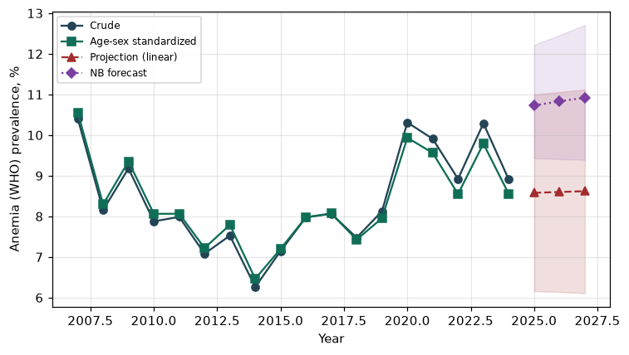

Counts by period
period | count
2007 | 359
2008 | 640
2009 | 750
2010 | 533
2011 | 531
2012 | 452
2013 | 434
2014 | 374
2015 | 447
2016 | 549
2017 | 529
2018 | 514
2019 | 575
2020 | 690
2021 | 666
2022 | 556
2023 | 683
2024 | 619

Crude and age-sex standardized rate (%)
year | crude | standardized
2007.00 | 10.41 | 10.56
2008.00 | 8.16 | 8.29
2009.00 | 9.18 | 9.35
2010.00 | 7.88 | 8.06
2011.00 | 7.99 | 8.06
2012.00 | 7.08 | 7.22
2013.00 | 7.53 | 7.79
2014.00 | 6.26 | 6.46
2015.00 | 7.15 | 7.20
2016.00 | 7.98 | 7.98
2017.00 | 8.06 | 8.07
2018.00 | 7.48 | 7.43
2019.00 | 8.13 | 7.96
2020.00 | 10.31 | 9.94
2021.00 | 9.91 | 9.56
2022.00 | 8.92 | 8.55
2023.00 | 10.29 | 9.79
2024.00 | 8.91 | 8.55

Projection (linear, standardized rate)
year | forecast | lo95 | hi95
2025.00 | 8.58 | 6.16 | 11.00
2026.00 | 8.60 | 6.14 | 11.06
2027.00 | 8.62 | 6.11 | 11.12

Stratified trend by sex (%)
year | men | women
2007.00 | 2.80 | 17.95
2008.00 | 2.35 | 13.97
2009.00 | 3.03 | 15.42
2010.00 | 2.64 | 13.14
2011.00 | 2.60 | 13.34
2012.00 | 2.71 | 11.53
2013.00 | 2.83 | 12.38
2014.00 | 2.49 | 10.11
2015.00 | 3.50 | 10.83
2016.00 | 3.17 | 12.85
2017.00 | 3.37 | 12.81
2018.00 | 2.87 | 12.13
2019.00 | 3.70 | 12.52
2020.00 | 4.54 | 16.04
2021.00 | 4.68 | 15.13
2022.00 | 4.17 | 13.66
2023.00 | 5.46 | 15.09
2024.00 | 3.97 | 13.88

Joinpoint regression — segment APC (%) with bootstrap 95% CI
segment | period | APC(%) | lo95 | hi95
1 | 2007-2015 | -4.49 | -6.55 | -2.16
2 | 2015-2024 | 2.61 | 1.05 | 4.63

Negative binomial (NB) forecast (%)
year | NB_forecast | lo95 | hi95
2025.00 | 10.73 | 9.43 | 12.22
2026.00 | 10.83 | 9.41 | 12.46
2027.00 | 10.92 | 9.39 | 12.71

Interpretation
The age-sex standardized prevalence of Anemia (WHO) showed an annual percent change of 2.61% (95% CI 1.05 to 4.63) in the latest segment.

