Incidence/Prevalence Trend Report
Atherogenic dyslipidemia (high TG + low HDL) · KNHANES · 2007-2024 · survey-weighted

Figure. Incidence/prevalence trend
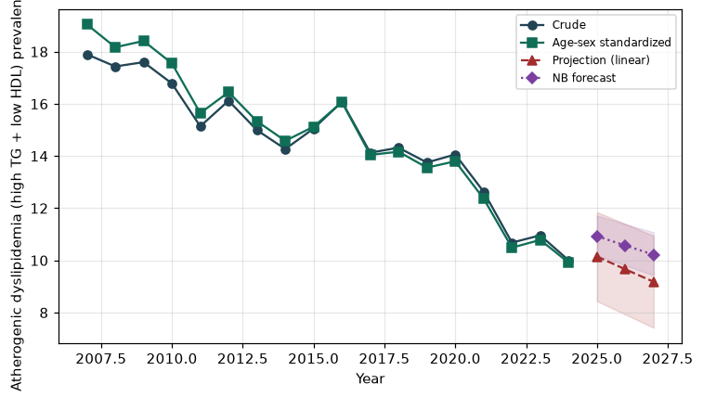

Counts by period
period | count
2007 | 529
2008 | 1188
2009 | 1289
2010 | 1004
2011 | 954
2012 | 929
2013 | 790
2014 | 748
2015 | 814
2016 | 951
2017 | 860
2018 | 878
2019 | 831
2020 | 798
2021 | 687
2022 | 545
2023 | 591
2024 | 543

Crude and age-sex standardized rate (%)
year | crude | standardized
2007.00 | 17.90 | 19.04
2008.00 | 17.43 | 18.17
2009.00 | 17.60 | 18.41
2010.00 | 16.78 | 17.55
2011.00 | 15.14 | 15.65
2012.00 | 16.12 | 16.45
2013.00 | 14.99 | 15.33
2014.00 | 14.27 | 14.58
2015.00 | 15.05 | 15.12
2016.00 | 16.08 | 16.07
2017.00 | 14.13 | 14.04
2018.00 | 14.32 | 14.17
2019.00 | 13.75 | 13.56
2020.00 | 14.06 | 13.80
2021.00 | 12.64 | 12.37
2022.00 | 10.68 | 10.49
2023.00 | 10.96 | 10.79
2024.00 | 10.01 | 9.92

Projection (linear, standardized rate)
year | forecast | lo95 | hi95
2025.00 | 10.15 | 8.44 | 11.85
2026.00 | 9.66 | 7.93 | 11.40
2027.00 | 9.18 | 7.42 | 10.94

Stratified trend by sex (%)
year | men | women
2007.00 | 16.80 | 18.97
2008.00 | 18.75 | 16.14
2009.00 | 19.20 | 16.00
2010.00 | 19.40 | 14.20
2011.00 | 15.98 | 14.31
2012.00 | 14.67 | 17.58
2013.00 | 14.65 | 15.34
2014.00 | 15.02 | 13.51
2015.00 | 16.51 | 13.58
2016.00 | 16.84 | 15.31
2017.00 | 15.40 | 12.85
2018.00 | 15.39 | 13.25
2019.00 | 14.09 | 13.42
2020.00 | 15.81 | 12.33
2021.00 | 13.76 | 11.52
2022.00 | 12.10 | 9.28
2023.00 | 12.98 | 8.98
2024.00 | 11.73 | 8.28

Joinpoint regression — segment APC (%) with bootstrap 95% CI
segment | period | APC(%) | lo95 | hi95
1 | 2007-2021 | -2.62 | -2.99 | -2.09
2 | 2021-2024 | -6.15 | -15.19 | 2.82

Negative binomial (NB) forecast (%)
year | NB_forecast | lo95 | hi95
2025.00 | 10.93 | 10.20 | 11.72
2026.00 | 10.57 | 9.81 | 11.39
2027.00 | 10.22 | 9.43 | 11.08

Interpretation
The age-sex standardized prevalence of Atherogenic dyslipidemia (high TG + low HDL) showed an annual percent change of -6.15% (95% CI -15.19 to 2.82) in the latest segment.

