Incidence/Prevalence Trend Report
Central obesity (WHtR>=0.5) · KNHANES · 2007-2024 · survey-weighted

Figure. Incidence/prevalence trend
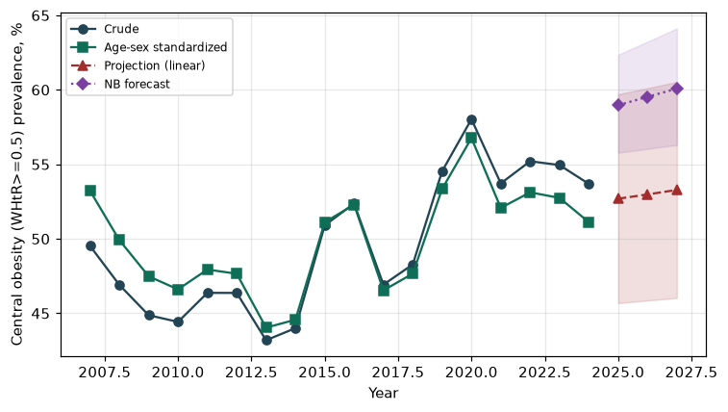

Counts by period
period | count
2007 | 1680
2008 | 3512
2009 | 3695
2010 | 3005
2011 | 3118
2012 | 3043
2013 | 2669
2014 | 2769
2015 | 3130
2016 | 3413
2017 | 3126
2018 | 3178
2019 | 3617
2020 | 3545
2021 | 3202
2022 | 2891
2023 | 3281
2024 | 3269

Crude and age-sex standardized rate (%)
year | crude | standardized
2007.00 | 49.52 | 53.23
2008.00 | 46.91 | 49.91
2009.00 | 44.87 | 47.48
2010.00 | 44.42 | 46.60
2011.00 | 46.37 | 47.94
2012.00 | 46.37 | 47.65
2013.00 | 43.19 | 44.04
2014.00 | 44.00 | 44.57
2015.00 | 50.91 | 51.11
2016.00 | 52.37 | 52.29
2017.00 | 46.92 | 46.54
2018.00 | 48.28 | 47.66
2019.00 | 54.53 | 53.35
2020.00 | 58.03 | 56.76
2021.00 | 53.72 | 52.07
2022.00 | 55.21 | 53.12
2023.00 | 54.95 | 52.75
2024.00 | 53.69 | 51.12

Projection (linear, standardized rate)
year | forecast | lo95 | hi95
2025.00 | 52.69 | 45.68 | 59.70
2026.00 | 52.98 | 45.86 | 60.11
2027.00 | 53.28 | 46.03 | 60.53

Stratified trend by sex (%)
year | men | women
2007.00 | 48.37 | 50.67
2008.00 | 45.95 | 47.85
2009.00 | 43.85 | 45.87
2010.00 | 44.16 | 44.68
2011.00 | 46.42 | 46.33
2012.00 | 44.82 | 47.89
2013.00 | 44.47 | 41.93
2014.00 | 44.58 | 43.43
2015.00 | 51.81 | 50.03
2016.00 | 53.85 | 50.89
2017.00 | 50.05 | 43.82
2018.00 | 53.03 | 43.56
2019.00 | 57.64 | 51.44
2020.00 | 64.51 | 51.51
2021.00 | 58.12 | 49.30
2022.00 | 62.03 | 48.36
2023.00 | 59.78 | 50.11
2024.00 | 60.01 | 47.36

Joinpoint regression — segment APC (%) with bootstrap 95% CI
segment | period | APC(%) | lo95 | hi95
1 | 2007-2014 | -2.15 | -2.97 | -1.04
2 | 2014-2024 | 1.15 | 0.10 | 2.44

Negative binomial (NB) forecast (%)
year | NB_forecast | lo95 | hi95
2025.00 | 58.97 | 55.78 | 62.35
2026.00 | 59.53 | 56.04 | 63.23
2027.00 | 60.08 | 56.30 | 64.12

Interpretation
The age-sex standardized prevalence of Central obesity (WHtR>=0.5) showed an annual percent change of 1.15% (95% CI 0.1 to 2.44) in the latest segment.

