Incidence/Prevalence Trend Report
Chronic kidney disease (KDIGO: eGFR<60 or ACR>=30) · KNHANES · 2011-2024 · survey-weighted

Figure. Incidence/prevalence trend
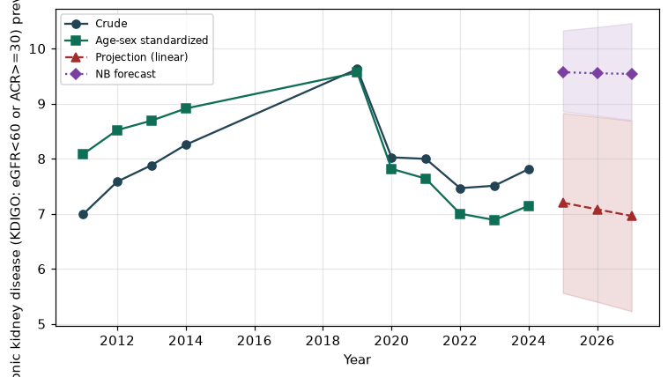

Counts by period
period | count
2011 | 540
2012 | 580
2013 | 487
2014 | 524
2019 | 672
2020 | 565
2021 | 579
2022 | 461
2023 | 522
2024 | 541

Crude and age-sex standardized rate (%)
year | crude | standardized
2011.00 | 6.99 | 8.08
2012.00 | 7.58 | 8.52
2013.00 | 7.88 | 8.69
2014.00 | 8.25 | 8.91
2019.00 | 9.63 | 9.56
2020.00 | 8.02 | 7.82
2021.00 | 8.00 | 7.64
2022.00 | 7.46 | 7.00
2023.00 | 7.51 | 6.89
2024.00 | 7.81 | 7.15

Projection (linear, standardized rate)
year | forecast | lo95 | hi95
2025.00 | 7.20 | 5.56 | 8.83
2026.00 | 7.08 | 5.40 | 8.76
2027.00 | 6.96 | 5.23 | 8.69

Stratified trend by sex (%)
year | men | women
2011.00 | 6.70 | 7.27
2012.00 | 6.68 | 8.49
2013.00 | 8.16 | 7.60
2014.00 | 8.08 | 8.43
2019.00 | 9.36 | 9.89
2020.00 | 8.17 | 7.88
2021.00 | 8.18 | 7.81
2022.00 | 8.18 | 6.75
2023.00 | 8.03 | 6.99
2024.00 | 8.25 | 7.37

Joinpoint regression — segment APC (%) with bootstrap 95% CI
segment | period | APC(%) | lo95 | hi95
1 | 2011-2019 | 1.93 | 1.51 | 3.71
2 | 2019-2024 | -5.35 | -10.07 | -1.31

Negative binomial (NB) forecast (%)
year | NB_forecast | lo95 | hi95
2025.00 | 9.57 | 8.86 | 10.33
2026.00 | 9.55 | 8.78 | 10.39
2027.00 | 9.54 | 8.70 | 10.46

Interpretation
The age-sex standardized prevalence of Chronic kidney disease (KDIGO: eGFR<60 or ACR>=30) showed an annual percent change of -5.35% (95% CI -10.07 to -1.31) in the latest segment.

