Incidence/Prevalence Trend Report
Diabetes mellitus · KNHANES · 2007-2024 · survey-weighted

Figure. Incidence/prevalence trend
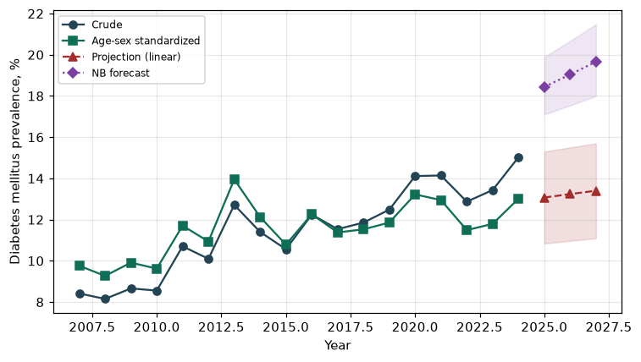

Counts by period
period | count
2007 | 279
2008 | 600
2009 | 708
2010 | 590
2011 | 757
2012 | 738
2013 | 751
2014 | 711
2015 | 719
2016 | 861
2017 | 838
2018 | 841
2019 | 895
2020 | 969
2021 | 948
2022 | 783
2023 | 904
2024 | 1014

Crude and age-sex standardized rate (%)
year | crude | standardized
2007.00 | 8.42 | 9.76
2008.00 | 8.15 | 9.27
2009.00 | 8.66 | 9.91
2010.00 | 8.55 | 9.62
2011.00 | 10.70 | 11.71
2012.00 | 10.10 | 10.94
2013.00 | 12.71 | 13.95
2014.00 | 11.40 | 12.12
2015.00 | 10.56 | 10.78
2016.00 | 12.24 | 12.26
2017.00 | 11.53 | 11.38
2018.00 | 11.85 | 11.53
2019.00 | 12.48 | 11.86
2020.00 | 14.11 | 13.22
2021.00 | 14.14 | 12.95
2022.00 | 12.87 | 11.49
2023.00 | 13.43 | 11.79
2024.00 | 15.02 | 13.01

Projection (linear, standardized rate)
year | forecast | lo95 | hi95
2025.00 | 13.07 | 10.84 | 15.30
2026.00 | 13.24 | 10.97 | 15.50
2027.00 | 13.40 | 11.09 | 15.70

Stratified trend by sex (%)
year | men | women
2007.00 | 9.80 | 7.04
2008.00 | 8.55 | 7.76
2009.00 | 9.41 | 7.91
2010.00 | 9.72 | 7.40
2011.00 | 12.27 | 9.15
2012.00 | 10.21 | 9.98
2013.00 | 13.90 | 11.50
2014.00 | 12.81 | 9.97
2015.00 | 11.41 | 9.72
2016.00 | 13.25 | 11.23
2017.00 | 12.84 | 10.22
2018.00 | 13.45 | 10.24
2019.00 | 13.74 | 11.23
2020.00 | 15.84 | 12.39
2021.00 | 16.33 | 11.96
2022.00 | 14.57 | 11.17
2023.00 | 15.81 | 11.07
2024.00 | 17.53 | 12.50

Joinpoint regression — segment APC (%) with bootstrap 95% CI
segment | period | APC(%) | lo95 | hi95
1 | 2007-2014 | 4.95 | 2.75 | 8.68
2 | 2014-2024 | 0.83 | -0.26 | 2.06

Negative binomial (NB) forecast (%)
year | NB_forecast | lo95 | hi95
2025.00 | 18.44 | 17.10 | 19.89
2026.00 | 19.04 | 17.54 | 20.67
2027.00 | 19.66 | 17.99 | 21.48

Interpretation
The age-sex standardized prevalence of Diabetes mellitus showed an annual percent change of 0.83% (95% CI -0.26 to 2.06) in the latest segment.

