Incidence/Prevalence Trend Report
Dyslipidemia (KSoLA composite) · KNHANES · 2007-2024 · survey-weighted

Figure. Incidence/prevalence trend
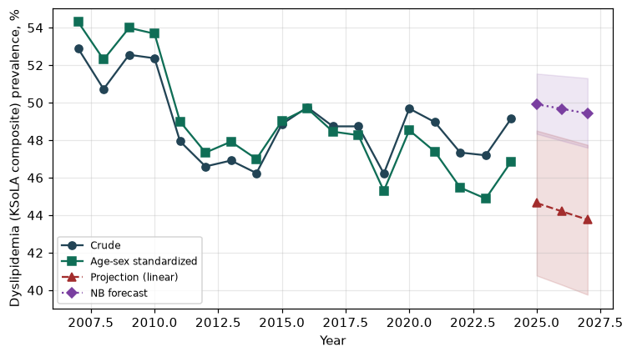

Counts by period
period | count
2007 | 1670
2008 | 3648
2009 | 3975
2010 | 3265
2011 | 3035
2012 | 2819
2013 | 2582
2014 | 2478
2015 | 2779
2016 | 3103
2017 | 3094
2018 | 3139
2019 | 3015
2020 | 3045
2021 | 2900
2022 | 2577
2023 | 2899
2024 | 2989

Crude and age-sex standardized rate (%)
year | crude | standardized
2007.00 | 52.89 | 54.30
2008.00 | 50.73 | 52.30
2009.00 | 52.56 | 53.99
2010.00 | 52.37 | 53.68
2011.00 | 47.94 | 48.99
2012.00 | 46.60 | 47.34
2013.00 | 46.91 | 47.92
2014.00 | 46.25 | 47.00
2015.00 | 48.86 | 49.02
2016.00 | 49.76 | 49.69
2017.00 | 48.74 | 48.46
2018.00 | 48.74 | 48.27
2019.00 | 46.22 | 45.30
2020.00 | 49.69 | 48.53
2021.00 | 48.97 | 47.39
2022.00 | 47.34 | 45.47
2023.00 | 47.19 | 44.88
2024.00 | 49.15 | 46.86

Projection (linear, standardized rate)
year | forecast | lo95 | hi95
2025.00 | 44.65 | 40.78 | 48.51
2026.00 | 44.20 | 40.28 | 48.13
2027.00 | 43.76 | 39.76 | 47.75

Stratified trend by sex (%)
year | men | women
2007.00 | 45.21 | 60.38
2008.00 | 45.12 | 56.29
2009.00 | 46.72 | 58.43
2010.00 | 48.70 | 56.05
2011.00 | 43.70 | 52.13
2012.00 | 39.00 | 54.27
2013.00 | 42.66 | 51.28
2014.00 | 44.15 | 48.37
2015.00 | 46.82 | 50.90
2016.00 | 48.20 | 51.33
2017.00 | 46.69 | 50.79
2018.00 | 46.36 | 51.13
2019.00 | 43.37 | 49.05
2020.00 | 48.64 | 50.72
2021.00 | 46.89 | 51.03
2022.00 | 47.93 | 46.76
2023.00 | 46.78 | 47.61
2024.00 | 49.57 | 48.74

Joinpoint regression — segment APC (%) with bootstrap 95% CI
segment | period | APC(%) | lo95 | hi95
1 | 2007-2011 | -1.78 | -5.25 | 1.31
2 | 2011-2024 | -0.42 | -0.75 | -0.10

Negative binomial (NB) forecast (%)
year | NB_forecast | lo95 | hi95
2025.00 | 49.92 | 48.34 | 51.55
2026.00 | 49.67 | 47.97 | 51.43
2027.00 | 49.42 | 47.60 | 51.31

Interpretation
The age-sex standardized prevalence of Dyslipidemia (KSoLA composite) showed an annual percent change of -0.42% (95% CI -0.75 to -0.1) in the latest segment.

