Incidence/Prevalence Trend Report
Elevated ALT (>40 IU/L) · KNHANES · 2007-2024 · survey-weighted

Figure. Incidence/prevalence trend
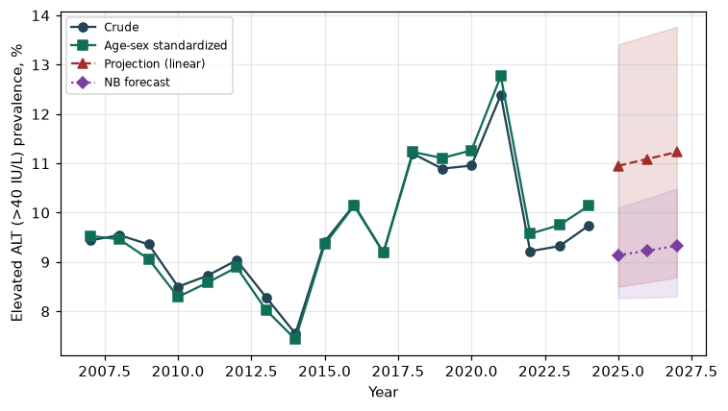

Counts by period
period | count
2007 | 242
2008 | 549
2009 | 577
2010 | 426
2011 | 424
2012 | 401
2013 | 375
2014 | 333
2015 | 422
2016 | 516
2017 | 487
2018 | 569
2019 | 594
2020 | 561
2021 | 565
2022 | 414
2023 | 450
2024 | 463

Crude and age-sex standardized rate (%)
year | crude | standardized
2007.00 | 9.44 | 9.53
2008.00 | 9.54 | 9.46
2009.00 | 9.36 | 9.06
2010.00 | 8.50 | 8.29
2011.00 | 8.72 | 8.58
2012.00 | 9.04 | 8.89
2013.00 | 8.29 | 8.03
2014.00 | 7.55 | 7.43
2015.00 | 9.42 | 9.36
2016.00 | 10.16 | 10.14
2017.00 | 9.19 | 9.19
2018.00 | 11.20 | 11.23
2019.00 | 10.89 | 11.11
2020.00 | 10.95 | 11.26
2021.00 | 12.39 | 12.77
2022.00 | 9.22 | 9.57
2023.00 | 9.32 | 9.75
2024.00 | 9.74 | 10.14

Projection (linear, standardized rate)
year | forecast | lo95 | hi95
2025.00 | 10.95 | 8.50 | 13.41
2026.00 | 11.09 | 8.59 | 13.59
2027.00 | 11.23 | 8.69 | 13.77

Stratified trend by sex (%)
year | men | women
2007.00 | 14.83 | 4.09
2008.00 | 14.94 | 4.17
2009.00 | 14.60 | 4.07
2010.00 | 13.64 | 3.35
2011.00 | 13.58 | 3.90
2012.00 | 13.59 | 4.41
2013.00 | 13.05 | 3.36
2014.00 | 11.48 | 3.55
2015.00 | 14.43 | 4.38
2016.00 | 15.40 | 4.87
2017.00 | 14.72 | 3.61
2018.00 | 17.74 | 4.60
2019.00 | 17.10 | 4.73
2020.00 | 17.79 | 4.17
2021.00 | 18.25 | 6.52
2022.00 | 13.97 | 4.48
2023.00 | 14.44 | 4.23
2024.00 | 15.24 | 4.18

Joinpoint regression — segment APC (%) with bootstrap 95% CI
segment | period | APC(%) | lo95 | hi95
1 | 2007-2015 | -1.60 | -3.56 | 0.74
2 | 2015-2024 | 0.64 | -2.01 | 3.71

Negative binomial (NB) forecast (%)
year | NB_forecast | lo95 | hi95
2025.00 | 9.14 | 8.27 | 10.10
2026.00 | 9.23 | 8.28 | 10.29
2027.00 | 9.33 | 8.30 | 10.49

Interpretation
The age-sex standardized prevalence of Elevated ALT (>40 IU/L) showed an annual percent change of 0.64% (95% CI -2.01 to 3.71) in the latest segment.

